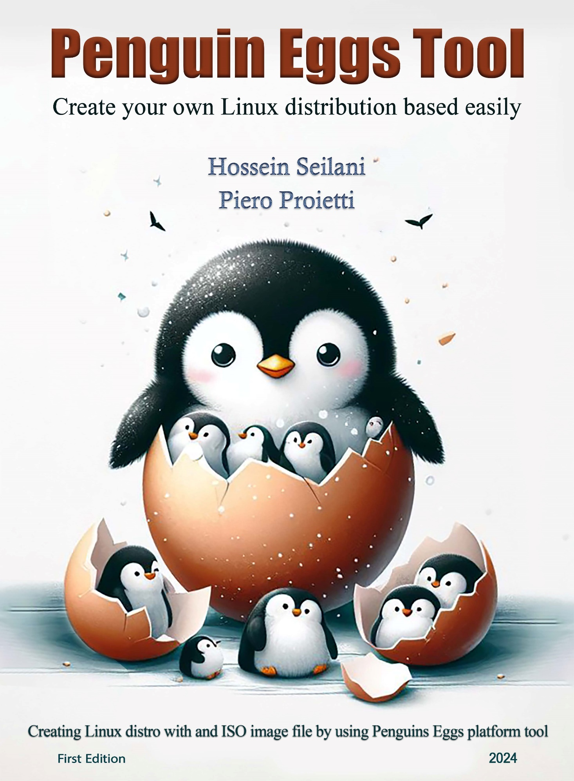

**Penguins Eggs Tool**

**Create your own Linux distribution based easily**

First Edition

**Hossein Seilani**

**Piero Proietti**

Creating Linux distro with and ISO image file by using Penguins**-**eggs platform tool

January

2024

# What is the Penguins-eggs book?

This book serves as a comprehensive guide to Penguins**-**eggs tool, covering its purpose, installation process in Linux, and the creation of installable ISO images from your existing Linux system using Penguins**-**eggs**.** Penguins**-**eggs itself is a dynamic console tool that empowers users to remaster their operating systems, allowing for customization distribution as live images via USB sticks or through PXE**.** With Penguins**-**eggs, users gain the ability to tailor their Linux distributions to their specific needs, making it a valuable resource for those seeking to create and share their customized Linux experiences**.**

**Selected topics included**:

* Pre-build and concepts
* Installing Eggs tool
* Eggs Configurations
* Producing ISO image file
* After Producing the ISO file
* Remastering
* Privacy and cleaning
* Testing ISO image file

About the Author

**Hossein Seilani**

**🎓 M.S. in Computer Science**

**About Me:** I am a passionate and versatile professional with a strong background in computer science. My expertise spans various domains, from Linux/Windows SysAdmin, UX/UI, Front-End web design, RectJS, SEO, Graphic Designer.

**Notable Projects:**

1. **Predator-OS Linux:**
   * A specialized Linux distribution designed for penetration testing, ethical hacking, and privacy.
   * Contributed to its development and security enhancements.
2. **Emperor-OS Linux**
   * An ambitious project focused on creating an all-in-one operating system for programming, design, and data science.
   * Collaborated on feature development and stability improvements.
3. **Little-Psycho Linux:**
   * A project centered around destructive and stress testing of software and hardware.
   * Developed tools for overclocking and health testing.
4. **Hubuntu Linux:**
   * Hubuntu, short for “Hardened Ubuntu,” is a security-focused Ubuntu distribution.
   * Implemented over 800 security controls and comprehensive configurations to protect against various attacks.

**My website:**

<https://seilany.ir/>

About the Technical Editor

**Piero Proietti**

🌐 **Network Manager | Programmer | Administrator**

About Me: I am Piero Proietti with extensive experience in developing and managing managerial applications, I specialize in serving user bases ranging from 100 to 500. My journey has been a blend of collaboration, innovation, and technical progress.

🔧 **Key Highlights:**

* **Clipper**: management of different activities on DOS;

* **Database**: management software of different activities implemented on Windows with SQL backend and VB6 frontend;

* **Collaboration**:Collaboration for adoption an IT protocol public source based on Zope and Python, on institutional workflows. Collaboration for development of products based on JBoss and Oracle technologies;

* **Open Source Virtualization**: I started using Proxmox VE from version 0.7.x, progressively following all versions until the current one. Over the years, I began to use it as a main workstation as well, for development by making my own live installable version;

* **Dart and JavaScript Enthusiast**: I followed Google's Dart project a lot in its infancy, switching, however, to using the more popular JavaScript, using it mostly with nodejs: server-side or for system utility development to facilitate my work as an IT infrastructure manager.

* **Linux Enthusiast**: Since the beginning of the millennium, I have been immersed in the Linux ecosystem. Started with Red Hat, to Debian, then mostly or the others, I now support my own project, Penguins' Eggs. This Linux remastering software - built initially with JavaScript, then switched to TypeScript - allows users to create custom ISO images, perform backups and clone the system. Whether using Debian, Devuan, Ubuntu, Arch or their derivatives, Penguins' Eggs can cover all amd64, i386 and arm64 architectures.

**Contact me**:

piero.proietti@gmail.com



# Introduction

The concept behind Penguins**’** Eggs stems from the idea of **“**reproduction**”** and **“**population selection**”** applied to operating systems**.** During the era of popular remastering programs like Remastersys and Systemback, both of which experienced maintenance issues and were eventually abandoned, the need for a new, modern tool became evident**.** The inspiration for Penguins**’** Eggs led to the development of a new tool written in a modern, cross**-**distribution language, utilizing its own packaging system**.** Initially built with node**.**js and later transitioning to Typescript as the primary development language, the tool**’**s design resembles an egg production process, consisting of operations such as **“**produce**”** for creating the eggs, and other commands like **“**kill**”** for removing produced ISOs, **“**update**”** for software updates, and **“**install**”** for configuring the graphical installer**.** It also has prerequisites to install the **.**deb packages necessary for the process, namely, calamares**.**

The eggs tool written primarily in TypeScript, Penguins**’** Eggs is designed to be compatible with various Linux distributions, despite differences in package managers, file paths, and more**.** The tool currently supports Debian, Devuan, Ubuntu, Arch, Manjaro, and their derivatives, across multiple architectures including amd64, i386, and arm64**.** With the release of version 9**.**6**.**x, Penguins**’** Eggs is now available as a Debian package, catering to a wide range of systems including PCs, older machines, and single**-**board ARM systems like the Raspberry Pi, across amd64, i386, and arm64 architectures**.** For more information and updates, visit the Penguins**’** Eggs official website**.**

### ***Penguins' eggs are generated and new birds are ready to fly...***

# Contents

What is the Penguins-eggs book? 3

Introduction 7

Contents at a Glance 8

Contents **Error! Bookmark not defined.**

The road map of this book 15

Chapter 1 18

What is Penguins-eggs? 18

Why Penguins-eggs? 19

Top Penguins-eggs features 19

fast and efficient 19

Supports Compression Algorithm 19

Supports Clone 20

Cuckoo and PXE boot 20

Supports Both TUI/GUI Installer 20

Repository lists 21

Wardrobe 21

Supporting Multiple Distributions 21

Supports hardware architectures 23

Supports privacy and security 23

Chapter 2 25

Pre-build and concept 25

Live ISO images 25

Understanding Live ISO Images 25

Benefits of Live ISO Images 25

Creating Live ISO Images in Linux 26

Remastering 26

Building process 27

The ISO image file 27

ISO-9660 28

Universal Disk Format (UDF) 29

Live system file 29

Introduction to SquashFS 29

File Compression 30

Structure of SquashFS 30

Read-Only Nature 30

Use Cases 30

Handling Compression 31

Customization and Optimization 32

Compatibility and Performance 32

Mksquashfs 32

Introduction to UEFI Boot 36

Key Advantages of UEFI Boot 36

UEFI Boot Process 37

Compatibility with Legacy BIOS 37

UEFI Boot Components 38

Secure Boot and UEFI 38

UEFI Shell 38

UEFI Variables 38

Vendor-specific UEFI Features 39

Legacy BIOS 39

Operating Principles of Legacy BIOS 39

Key Characteristics of Legacy BIOS 39

Legacy and Modern Computing Environments 40

ISOLINUX 40

Syslinux 41

Mkisofs 42

Genisoimage 43

Isohybrid 45

Host.conf 45

language: 'en_US.UTF-8' 45

Background and Significance 46

Implementation and Configuration 46

Language Support and Internationalization 46

Impact on Software Development and Localization 47

User Experience and Text Handling 47

Maintenance and System Administration 47

Chapter 3 49

Unnecessary tools and files 49

Cleaning 49

how to create a privacy-focused Linux environment? 50

Exclude File and directory 55

Cleaning Tools 59

BleachBit 60

Stacer 60

Sweeper 60

Chapter 4 63

Necessary file and tools 63

Filesystem Hierarchy Standard (FHS) 70

Necessary tools and packages 71

Isolinux 71

Live-boot 72

Live-boot-doc 72

Live-boot-initramfs-tools 73

Squashfs-tools 74

Syslinux 74

Syslinux-common 75

Cryptsetup 76

Dosfstools 76

Dpkg-dev 77

Coreutils 77

Genisoimage 78

Whoami 79

Cryptsetup 79

Curl 80

Dosfstools 81

Dpkg-dev 81

lsb-release 82

lvm2 83

parted 83

pxelinux 84

rsync 85

Squashfs-tools 85

sshfs 86

syslinux-common 87

Genisoimage 87

Chapter 5 89

Installing Eggs 89

Installing Nodejs 89

DEB Supported Versions 89

Removing Nodejs 93

RPM Installation Instructions 94

Method1: 98

Install from source 98

Method2: 101

penguins-eggs-ppa 101

Method4: eggs package (Debian based) 103

Method5: installing on Arch Linux 107

Method6: Installing on Manjaro Linux 110

Method7: installing by npm command 111

installing node.js 111

Debian-based (e.g., Ubuntu, Linux Mint): 111

Arch-based (e.g., Arch Linux, Manjaro): 112

Red Hat-based (e.g., CentOS, RHEL): 112

Fedora-based (e.g., Fedora): 113

Method 8: Installing Eggs from npm source 115

Updating the eggs 116

eggs version 120

Chapter 6 124

Eggs Installer 124

1.Calamares Installer (GUI): 124

2.Krill Installer (TUI): 124

Method 1. Calamares installer (GUI) 125

What is calamares 125

Calamares modules 125

Calamares installation 127

Step 1:  installing Calamares using the distribution's repository 127

Step 2: installing calamares with eggs 130

Calamares settings 132

settings.conf 133

Branding 135

modules 140

Method2: The Krill installer (TUI) 142

Config krill manually: 143

The content of krill.yaml 144

Chapter 7 148

Eggs Configuration 148

Part1: configuration automatically 148

Eggs adaptive resolutions 152

eggs analyze 155

Eggs Config 156

eggs dad 160

Eggs Configuration 163

Part2: configuration manually 163

Krill config file 165

Tools.yaml 166

Exclude.list files 167

Part3: Configuration status 171

eggs status 171

Eggs Change log notes 172

penguins-eggs-9.6.x 172

penguins-eggs-10.0.13 173

penguins-eggs-10.0.11-2 173

penguins-eggs-10.0.11-1 173

penguins-eggs-10.0.10-1 173

penguins-eggs-10.0.9-1 174

penguins-eggs-10.0.8-2 174

penguins-eggs-10.0.8-1 174

penguins-eggs-10.0.7-1 174

penguins-eggs-10.0.6-3 175

Note about bionic version 175

penguins-eggs-10.0.6-1 175

penguins-eggs-10.0.5-2 175

penguins-eggs-10.0.4 176

penguins-eggs-10.0.3 176

penguins-eggs-10.0.2 176

penguins-eggs-10.0.0 176

penguins-eggs-9.8.3 177

penguins-eggs-9.8.2 177

penguins-eggs-9.8.1 177

penguins-eggs-9.8.0 177

Chapter 8 179

Producing ISO image file 179

Step 1: cleaning the system 180

Cleaning with eggs 180

sudo eggs tools clean -v 180

Cleaning with bleachbit 182

Bleachbit help 186

Step2: show the status 189

Step3: preparing the skel folder 190

eggs tools skel 190

Step 4: prepare ISO for offline installation 195

Step 5: eggs produce 196

eggs produce command 196

Chapter 9 210

After Producing 210

eggs syncto command 210

eggs syncfrom command 212

Testing the ISO 214

Testing the installation 215

Test Functionality 216

Test Customizations 218

Perform Regression Testing 219

Document and Report Issues 221

Eggs tools stat 222

Wardrobe users' guide 226

Appendix 1 238

Penguins Eggs Terms 238

# The road map of this book

A live image, also known as a live CD or live DVD, is a complete, bootable computer installation including an operating system that runs directly from a CD/DVD or USB flash drive, rather than from a hard disk drive. It allows users to run an operating system for any purpose without installing it or making any changes to the computer's configuration. The key point here is that this live image is created without including any personal data. This means that the image does not contain any user-specific information like usernames, passwords, or files. This is important for privacy and security reasons, as it ensures that sensitive user information is not accidentally exposed or accessed when the live image is used on other computers. The process of creating such a live image involves several steps, which might include configuring the operating system, installing the necessary software, setting up user accounts, and then creating an image of the system that can be burned to a CD/DVD or written to a USB flash drive. This image can then be used to boot up and run the operating system on any compatible computer, without needing to install anything on the computer's hard drive**.**

**Here's an overview of the process:**

1. Selecting a Linux Distribution: Choose a Linux distribution that supports creating live images. Popular choices include Debian, Ubuntu, Fedora and Arch**.**
2. Preparing the System: Ensure that the system you're using to create the live image is up to date and free from any personal or sensitive data**.** It's recommended to use a clean environment or a virtual machine for this purpose**.**
3. Installing Required Tools: Install the necessary tools for creating the live image**.** This may include packages like live**-**build, livecd**-**tools, or distribution**-**specific tools like Ubuntu Customization Kit for Ubuntu**-**based distributions**.** Refer to the documentation of your chosen distribution for specific instructions**.**
4. Customizing the System: Customize the system by installing or removing packages, configuring settings, and applying any desired changes**.** This step allows you to create a tailored experience for users of the live image**.**
5. Cleaning Personal Data: Remove any personal data and sensitive information from the system**.** This includes clearing browser history, deleting user accounts, removing personal files, and clearing system logs**.** Pay attention to directories like **/**home and **/**var**/**log that may contain user**-**specific data**.**
6. Creating the Live Image: Use the appropriate tool or command provided by your chosen distribution to create the live image**.** This typically involves specifying the source system, desired configurations, and output format **(**ISO, USB, etc**.).** The process may take some time, depending on the size and complexity of the system**.**
7. Testing the Live Image: Once the image creation process is complete, test the live image by booting it on different computers**.** Ensure that the system boots successfully and that all desired customizations and configurations are present**.**
8. Distributing the Live Image: If the live image meets your requirements, you can distribute it to others**.** Make the image available for download or share it on physical media like USB drives or DVDs**.** Provide clear instructions on how to use the live image and any additional information users might need**.**

Remember, creating a live image without personal data requires careful attention to detail and following security best practices**.** Always double**-**check the image to ensure that no personal data is included before distributing it to others**.**



# Chapter 1

# What is Penguins-eggs?

Penguins’ Eggs stands out as a versatile command-line tool, offering the capability to transform your existing distro into a redistributable live ISO image. Notably, the tool also extends its support to Debian/Ubuntu flavors, making it compatible with variations such as Xubuntu, Kubuntu, and beyond, in addition to Linux distributions derived from these, such as Devuan, Linux Mint. Upon harnessing the power of Penguins’ Eggs, users gain the ability to fashion an installable live ISO embodying their Debian/Devuan/Ubuntu-based, Arch Linux, or Manjaro system, complete with all installed applications and personalized configurations housed within the home folder.

Penguins' Eggs goes beyond creating live ISOs. It allows you to configure the generated ISO for offline installation, useful for environments without internet access. It also offers a scripting mode for managing ISOs through custom scripts. You can even personalize the look and feel of the live CD and Calamares installer with images. This customization power is driven by "penguins-wardrobe," a repository that provides tools to tailor Linux systems, even for minimal command-line installations. It lets you create customized live ISOs based on Debian, Ubuntu, and their derivatives. You can even use it to generate a complete backup of your existing Debian/Ubuntu system, including user data, all rolled into a bootable ISO. Using Penguins' Eggs simplifies these tasks and gives you full control over the content and distribution of your custom Linux environments. To learn more, explore the official Penguins' Eggs website and its community resources

Penguins' Eggs takes the complexity out of remastering Linux systems. It offers a user-friendly interface with powerful features, making customization and distribution a breeze. The tool works across various systems based on Debian, Ubuntu, Arch Linux, and Manjaro. This means you can create live ISOs tailored to your specific needs, no matter your preferred base distro. Penguins' Eggs also supports derivatives of these popular distributions, giving you even more options. Here's the real benefit: you can not only preserve your current system setup and applications but also easily share them with others. Penguins' Eggs cleverly removes user and system data from the ISOs it creates. This ensures a clean starting point for new users, while still allowing you to curate a unique Linux experience for them.

# Why Penguins-eggs?

Penguins**-**eggs is a versatile tool that offers an array of features and benefits for Linux users**.** Whether you want to create an installable ISO from your current Linux system or explore various customization options, Penguins**-**eggs has got you covered**.** To get started with Penguins**-**eggs, you'll need to install it on your Linux distribution**.** The tool supports a wide range of Linux distributions and their major derivatives, including Arch, Debian, Devuan, Manjaro, Ubuntu, and more**.** Additionally, you can easily add support for additional derivatives, expanding the tool's capabilities even further**.**

# Top Penguins-eggs features

## fast and efficient

Penguins**-**eggs is designed to be fast and efficient**.** Unlike traditional methods that involve copying the entire file system, Penguins**-**eggs utilizes livefs, which allows for instant acquisition of the live system**.** By default, the tool :

## Supports Compression Algorithm

Employs the compression algorithm, significantly reducing the time required for the process when creating an installable ISO**.**

**Notes:**

Fast: by default, eggs use the zstd compression algorithm, reducing the time up to 10 times!

Penguins**-**eggs Linux, with its innovative utilization of the xz compression algorithm as the default, is poised to revolutionize the realm of Linux distributions by redefining the parameters of speed and efficiency**.** This cutting**-**edge approach to compression stands as a testament to the relentless pursuit of optimization and performance enhancements, enabling users to experience unparalleled gains in speed and responsiveness**.**

## Supports Clone

Penguins**-**eggs provides various options to suit your needs**.** With the **--**clone flag, you can preserve the data and accounts of unencrypted users, ensuring a seamless experience for users accessing the live system**.** Moreover, you can opt for a crypted clone, where user data and accounts are saved in an encrypted LUKS volume within the ISO image, enhancing security and privacy**.**

**Notes:**

Crypted clone: you can save user data and accounts in an encrypted LUKS volume within the ISO image

Penguins**-**Eggs Linux introduces a groundbreaking feature in the form of

Crypted Clone, setting a new standard of security and data protection within the realm of Linux distributions**.** By default, Penguins**-**Eggs tool empowers users to safeguard their sensitive user data and accounts by encapsulating them within an encrypted LUKS **(**Linux Unified Key Setup**)** volume, seamlessly integrated within the ISO image**.**

## Cuckoo and PXE boot

In addition to ISO creation, Penguins**-**eggs offers a unique feature called Cuckoo**.** By starting Cuckoo from the live system, you can set up a PXE boot server, making it accessible to all computers on the network**.** This functionality opens up possibilities for network booting and streamlined deployment**.** The activation of Cuckoo from live as the default setting within Penguins Eggs heralds a transformative leap in the domain of Linux distributions, affording users the ability to harness the unparalleled potential of PXE booting and network**-**wide deployment with ease**.**

## Supports Both TUI/GUI Installer

To simplify the installation process, Penguins**-**eggs provides its own system installer called krill**.** This installer is particularly useful when a GUI **(**Graphical User Interface**)** is not available, allowing for installation in various situations**.** However, if you are using a desktop system, Penguins**-**eggs recommends and configures the calamares GUI installer, ensuring a seamless and user**-**friendly experience**.**

Penguins Eggs Linux spearheads a transformative revolution in the realm of system installation with the incorporation of its TUI **(**Text**-**based User Interface**)** **/** GUI **(**Graphical User Interface**)** installer, setting a new standard of versatility and accessibility within the landscape of Linux distributions**.** The integration of these installation mechanisms underscores Penguins Eggs Linux**’**s unwavering commitment to accommodating diverse user needs and streamlining installation workflows with unparalleled flexibility and user**-**centric design**.**

## Repository lists

One of the key advantages of Penguins**-**eggs is its commitment to utilizing only the original distro's packages**.** This means that no modifications are made to your repository lists, ensuring a safe and reliable environment**.** Penguins**-**eggs prioritizes maintaining the integrity and authenticity of your Linux distribution**.**

## Wardrobe

To enhance customization options, Penguins**-**eggs introduces the concept of Wardrobe**.** With Wardrobe and its various components, such as costumes, you can easily organize and manage your customizations, samples, and more**.** This feature enables a streamlined and efficient workflow, allowing you to tailor your Linux system to your preferences**.**

## Supporting Multiple Distributions

Eggs supporting multiple distributions and their derivatives.

**Supports**: Arch, Debian, Devuan, Manjaro, Ubuntu and major derivatives: Linuxmint, KDE neon, EndeavourOS, Garuda, etc**.** You can easily add more derivatives**.**

Arch Linux is a popular Linux distribution known for its simplicity, flexibility, and rolling release model. Unlike many distros that come pre-loaded with software, Arch starts with a minimal base system. This gives you complete control over what is installed, letting you build a system that perfectly suits your needs. This minimalist approach is ideal for users who want a clean and efficient system without any unnecessary extras. Arch's popularity has led to the creation of several derivative distributions, each with its take on the Arch philosophy. Manjaro, for example, is a user-friendly version of Arch that offers easier installation, pre-configured desktops, and a graphical package manager for a smoother experience.

Debian derivatives is a godfather in the Linux world. This highly respected distro, known for its rock-solid stability, security, and dedication to free software, has been around since the early days. However, Debian's impact goes beyond its own desktop. It is the foundation for countless other distributions, including the ever-popular Ubuntu and its many offshoots. In short, Debian is a major reason why Linux is so diverse and successful today.

Ubuntu, is a giant in the Linux world, known for being easy to use. It comes in many flavors, each with a different desktop environment to suit your taste. The company behind Ubuntu, Canonical, is all about making Linux user-friendly and stable. They also heavily involve the community in development. This focus on users has made Ubuntu a favorite among all kinds of people looking for a polished and versatile Linux experience.

Linux Mint is a popular Linux distro built on top of Ubuntu but with some key differences. Mint adds its features and a unique desktop environment, like Cinnamon or MATE, to provide a more polished and user-friendly experience right out of the box. This focus on user experience makes Mint a popular choice for people who want a Linux system that is easy to use and works well without a lot of tinkering.

## Supports hardware architectures

Supports a wide range of hardware architectures**.**

Supports: i386, amd64 and arm64 architecture, from old PCs, common PCs to single board computers like Raspberry Pi 4**/**5

The i386 architecture, originating from the Intel 80386 microprocessor, has long been a stalwart in the domain of personal computing**.** Initially serving as the cornerstone for many early PCs, the i386 architecture laid the groundwork for the evolution of consumer computing devices, providing the processing power and framework for the burgeoning digital revolution**.**

In parallel to the x86**-**64 architecture, the arm64 architecture stands as a testament to the dynamism of computing, catering to a diverse array of devices, ranging from smartphones and tablets to embedded systems, IoT devices, and single**-**board computers**.**

## Supports privacy and security

Safe: Penguins Eggs Linux embarks on a steadfast commitment to user security and system integrity through its default practice of exclusively utilizing original distributions’ packages without any modifications in the repository lists.

<https://github.com/pieroproietti/penguins-eggs/tree/master/changelog.d>



# Chapter 2

# Pre-build and concept

Creating Live ISO Images in Linux: A Comprehensive Guide

# Live ISO images

In the world of Linux, Live ISO images play a crucial role in providing users with a versatile and portable means to experience and utilize different distributions without the need for installation**.** These Live ISO images are bootable media that allow users to test, use, and sometimes install Linux distributions directly from the ISO file without making any changes to their existing system**.** In this article, we will explore the concept of Live ISO images, their significance, and the process of creating them in Linux**.**

## Understanding Live ISO Images

A Live ISO image is a snapshot of a bootable operating system that can be run directly from a CD, DVD, USB drive, or other bootable media without the need for installation**.** It enables users to explore and interact with a Linux distribution without affecting their current system setup**.** Live environments are particularly useful for testing hardware compatibility, trying out different Linux distributions, troubleshooting system issues, and performing various administrative tasks**.** Linux distributions often provide official Live ISO images for users to download and use**.** These images typically include a fully functional desktop environment, a set of pre**-**installed applications, and tools for installation and system maintenance**.** Additionally, users can create their own customized Live ISO images to tailor the environment to their specific needs**.**

## Benefits of Live ISO Images

Live ISO images offer several advantages to both casual users and system administrators**.** These benefits include:

1. Portability: Live ISO images can be carried on a USB drive and used on different computers without requiring installation, making them highly portable and convenient**.**
2. Testing and Evaluation: Users can test and evaluate different Linux distributions and their features without committing to a permanent installation**.**
3. System Recovery: Live environments provide tools for system recovery, data backup, and disk partitioning, making them invaluable for troubleshooting and maintenance**.**
4. Customization: Users can create personalized Live ISO images with specific applications, configurations, and settings tailored to their requirements**.**

## Creating Live ISO Images in Linux

Creating a Live ISO image in Linux involves customizing a base Linux distribution and packaging it into a bootable ISO file**.** Here**’**s a step**-**by**-**step guide to creating a Live ISO image using popular open**-**source tools such as Ubuntu Customization Kit **(**UCK**)** and the command**-**line tool mkisofs**.**

1. Choose a Base Distribution: Select a base Linux distribution such as Ubuntu, Fedora, or Debian to serve as the foundation for your Live ISO image**.**
2. Install Custom Software: Customize the base distribution by installing additional software packages, tools, and applications to meet your specific requirements**.**
3. Configure Settings: Adjust system settings, desktop environment configurations, and other parameters to reflect your desired environment**.**
4. Install Optional tools: If using your own distro you can customization process through a user**-**friendly interface**.**
5. Use Command**-**line Tools: Alternatively, use command**-**line tools such as chroot to create a chroot environment, modify the filesystem, and subsequently create the Live ISO image using the mkisofs tool**.**
6. Test the Live ISO Image: Once the customization is complete, test the Live ISO image in a virtual machine or by writing it to a USB drive for booting on physical hardware**.**

# Remastering

Remastering a Linux system is like taking a pre-built computer and customizing it to your liking. You start with an existing Linux distribution (the operating system), but you can add new software packages to make it more functional for you. You can also remove programs that come pre-installed but you don't need, making the system leaner and faster. This process is called remastering, and it gives you a lot of control over your Linux experience.

# Building process

Building a customized Linux ISO image involves creating a customized version of a Linux distribution**’**s installation image**.** This allows you to pre**-**configure the system with specific software, settings, and customizations tailored to your needs**.** To build a customized Linux ISO image, you typically start with the base ISO image of the Linux distribution you want to customize**.** You then modify the image by adding or removing software packages, setting custom configurations, adding scripts or additional files, and making any other necessary adjustments**.**

Tools like Cubic, Ubuntu Customization Kit, and SUSE Studio are useful for customizing Ubuntu and SUSE Linux**-**based distributions, respectively**.** These tools provide a graphical interface for modifying the ISO image without requiring extensive knowledge of the command line**.** Once you have made all the desired customizations, you can build the new ISO image using the appropriate tools provided by the customization software or by utilizing command**-**line tools like mkisofs or genisoimage**.** Building a customized Linux ISO image can be useful for creating a system with specific software configurations for deployment across multiple machines or for distributing custom Linux distributions tailored to particular use cases**.**

# The ISO image file

The **.**iso file extension denotes an uncompressed archive disk image file that mirrors the entire data content of an optical disc, such as a CD or DVD**.** Adhering to the ISO**-**9660 standard, the ISO image file format embodies the disc data along with its associated filesystem information, allowing ISO files to house precise replicas of content and make perfect copies of CDs**/**DVDs for bootable data storage and installation**.** These files are usually burned onto USB**/**CD**/**DVD for booting during installation and are identified by the MIME type application**/**x**-**iso9660**-**image**.**

The ISO file format is unique, as it encapsulates specified data content within a binary file accurately representing the content and filesystem structure**.** ISO images, regardless of the standard, can be created from optical discs, a collection of files, or by conversion from another disk image file, and can be written onto optical discs like CDs, DVDs, and Blue**-**Rays**.** They store user data from each optical disc sector, excluding control headers and error correction data, yielding slightly smaller file sizes**.** Aside from ISO 9660 media, an ISO image may also contain a UDF file system, often utilized by DVDs and Blu**-**ray Discs, including the data in binary format as it was stored on the disc**.** The **.**iso file extension is the most common for this type of disc image, while the **.**img extension is found in some ISO image files with slightly different contents**.** ISO files store only the user data from each sector on an optical disc, rendering them substantially smaller than raw optical disc images**.** ISO images can be opened with almost every multi**-**format file archiver and, with the appropriate driver software, can be **“**mounted**”** to interface with it as if it were a physical optical disc**.** Most Unix**-**based operating systems and versions of Windows have built**-**in capabilities for handling ISO images, allowing files to be copied or transferred over any data link or removable storage medium**.** The ISO 9660 standard specifies three levels of interchange, each with specific limits on filenames, directory names, and the depth and length of the directory hierarchy and path length of files**.** The standard ensures the efficient organization and access of data within the ISO 9660 directory structure**.**

ISO-9660  
 ISO**-**9660 is a standard file system for optical disc media, such as CD**-**ROMs and DVDs**.** It was developed by the International Organization for Standardization **(**ISO**)** and is widely used for storing data on these types of discs**.** The ISO**-**9660 file system has certain limitations, such as a maximum file size of 4GB and a maximum directory depth of 8 levels**.** It also has restrictions on file and directory naming, limiting them to certain character sets and lengths**.** Despite its limitations, ISO**-**9660 is widely supported across different operating systems, making it a popular choice for distributing software and other data on optical discs**.** It allows for cross**-**platform compatibility, as most modern computers and other devices can read ISO-9660 discs**.**

## Universal Disk Format (UDF)

UDF is a file system standard for optical disc media, as well as for other types of storage devices such as flash drives and hard drives**.** UDF was developed to address the limitations of ISO**-**9660 and provide more flexibility and features for storing and organizing data**.** UDF supports larger file sizes, longer file names, and deeper directory structures compared to ISO**-**9660**.** It also includes features such as support for metadata, file versioning, and resizable volumes**.** UDF is designed to be more adaptable to different types of storage media and is intended to be a more future**-**proof file system standard**.**

UDF has gained wide adoption, particularly in the context of DVD and Blu**-**ray discs, where it is often used as the primary file system**.** It is also supported by most modern operating systems, making it a versatile choice for data storage and distribution**.** In summary, ISO**-**9660 is an older file system standard primarily used for optical disc media, while UDF is a more modern and flexible file system standard that is widely supported across different types of storage devices**.** Both standards have their own specific features and limitations, and the choice between them depends on the specific use case and compatibility requirements**.**

# Live system file

The SquashFS **(**SQUASH File System**)** is a read**-**only, compressed file system widely used in Linux**-**based operating systems**.** It is designed to be a space**-**efficient file system that can be mounted and accessed as a normal file system, while also providing compression to minimize the storage requirements**.** Here**’**s an in**-**depth explanation of SquashFS:

## Introduction to SquashFS

SquashFS was originally developed and is released under the GNU General Public License**.** It is known for its high compression ratio and read**-**only nature, making it particularly useful for embedding into operating system images, live CDs, and other scenarios where read**-**only access to compressed file systems is required**.**

## File Compression

One of the key features of SquashFS is its built-in file compression. It uses various compression algorithms, including zstd. xz, and lzo, to compress files and directories within the file system. This allows for significant reduction in the size of the file system image, making it advantageous for distributions where storage space is a concern**.**

## Structure of SquashFS

SquashFS consists of multiple components, including the main file system image, an associated meta**-**data block, and an optional index table**.** The file system image contains the compressed data, while the meta**-**data block stores information about files, directories, and their attributes, facilitating quick file lookup and access**.** The index table, if present, improves access performance by providing a sorted listing of file system components**.**

## Read-Only Nature

SquashFS is intended to be a read**-**only file system and does not support write operations**.** This is beneficial for scenarios where a file system needs to be distributed as a read**-**only image, ensuring that its contents remain unchanged**.** While this makes SquashFS unsuitable for use as a general**-**purpose read**-**write file system, its focus on read**-**only access aligns with its primary use cases**.**

## Use Cases

SquashFS is commonly employed in scenarios where efficient, read**-**only access to a compressed file system is necessary**.** Some prominent use cases include:

* Live CDs and bootable USB drives: Many Linux distributions use SquashFS to store the root file system of live environments, allowing users to boot into a fully operational system without needing to install it on their hard drive**.**
* Embedded systems: SquashFS is often used in embedded devices, such as routers, set**-**top boxes, and other appliances, where space**-**efficient storage and read**-**only access are essential**.**
* Software distribution: software vendors to create compressed file system images for distributing applications or data in a compact and secure manner utilize it**.**
* Customized Linux distributions: Many custom Linux distributions and derivatives use SquashFS to package the file system, enabling efficient distribution and consumption of the distribution**’**s contents**.**

## Handling Compression

SquashFS employs various compression techniques to minimize the storage footprint of the file system**.** It leverages the power of established compression algorithms to efficiently encode files and directories, reducing the amount of storage space required**.** This contributes to faster data transfer and efficient resource utilization**.** The selection of multiple compression algorithms, including gzip, lzo, lz4, xz, and zstd, in the SquashFS**-**tools Makefile showcases the versatility and adaptability of the SquashFS file system**.** Each of these compression algorithms offers distinct features and trade**-**offs, enabling users to choose the most suitable compression method based on their specific requirements and constraints**.**

1. **gzip:** This is a widely used compression algorithm known for its balance between compression ratio and speed**.** It is well**-**suited for general**-**purpose compression and compatibility but may not provide the highest compression ratios or fastest decompression speeds**.**
2. **lzo:** LZO is known for its fast compression and decompression speeds, making it suitable for scenarios where rapid file access is essential**.** While it may not achieve the highest compression ratios, it excels in performance**-**critical applications**.**
3. **lz4:** LZ4 is another fast compression algorithm, known for its exceptional compression and decompression speeds, making it ideal for use cases that prioritize speed over maximum compression**.** It is commonly used in scenarios where quick access to compressed data is paramount**.**
4. **xz:** XZ, based on the LZMA compression algorithm, offers excellent compression ratios at the cost of slightly slower compression and decompression speeds**.** It is well**-**suited for scenarios where optimal compression is a priority, such as archival and distribution purposes**.**
5. **zstd:** Zstandard is a relatively newer compression algorithm designed to provide both high compression ratios and fast compression and decompression speeds**.** It offers a good balance between compression performance and efficiency, making it suitable for a wide range of applications**.**

## Customization and Optimization

SquashFS offers several customization and optimization options, allowing for tailored deployments based on specific requirements**.** These include the ability to configure compression options, optimize file access patterns through the use of the index table, and control meta**-**data storage to suit different use cases and workloads**.**

## Compatibility and Performance

SquashFS is highly compatible with major Linux distributions and is supported by the Linux kernel**.** It provides fast native access to file data, benefiting from optimizations to facilitate efficient read operations**.** Through its integration with the Linux kernel, it delivers robust performance and seamless interoperability with the broader Linux ecosystem**.**

# Mksquashfs

Mksquashfs is a command**-**line tool used for creating squashfs filesystem images on Unix**-**like operating systems**.** Squashfs is a compressed read**-**only file system that can be used for embedded systems, live CDs, and other similar scenarios**.** Mksquashfs enables users to generate squashfs file system images from a designated directory structure, preserving file attributes, ownership, and metadata**.** The tool allows users to customize the creation of squashfs images, including specifying compression options, excluding specific files or directories, and more**.**

Mksquashfs supports various compression algorithms, such as gzip, lzma, lz4, and xz, allowing users to choose the most suitable compression method for their specific needs**.**

The compression feature of mksquashfs reduces the space required by the file system, making it suitable for efficient storage and distribution**.** By integrating mksquashfs with other tools and processes, users can automate the creation of squashfs images, streamlining repetitive tasks and workflows**.**

The hierarchical file and directory structures can be preserved within the squashfs image, ensuring the fidelity and organization of the source data**.** Mksquashfs is widely used for creating compressed file system images for embedded devices, where storage and resource constraints are a consideration**.** The robust error handling and feedback mechanisms in mksquashfs aid in identifying and resolving potential issues during the creation of squashfs images**.** Documentation and community support for mksquashfs provide users with the necessary resources and guidance to effectively utilize its features and address potential challenges**.**

Mksquashfs allows the creation of multiple squashfs images, each tailored to specific use cases, such as embedded systems, live environments, and data distribution**.** The command**-**line interface of mksquashfs allows for precise and granular control over squashfs image creation, facilitating automation and scripting**.** The resilience of mksquashfs in efficiently processing and compressing file and directory structures contributes to the timely generation of squashfs images**.** Mksquashfs**’** support for integrating additional metadata and annotations into squashfs images enhances their informational and organizational value**.**

The validation and verification mechanisms provided by mksquashfs aid in confirming the integrity and completeness of squashfs images, promoting trust and reliability in their use**.** Mksquashfs**’**s adherence to well**-**established conventions and best practices fosters compatibility and predictability in squashfs image creation, contributing to a dependable user experience**.**

By accommodating long file names, deep directory trees, and complex file attributes, mksquashfs ensures the creation of comprehensive squashfs images suitable for diverse scenarios**.**

The tool**’**s efficiency in handling a wide variety of file attributes and metadata ensures the faithful representation of the source data within the squashfs image**.** The comprehensive options provided by mksquashfs for fine**-**tuning the squashfs image generation process enable users to tailor the output to specific requirements and preferences**.** The facilitation of squashfs image creation through the efficient processing and compression of source file systems streamlines the archiving and distribution of data**.**

The integration of resource forks, extended attributes, and special file types into squashfs images by mksquashfs preserves the richness and complexity of the source file system**.** Mksquashfs**’**s support for hierarchical directory structures and symbolic links ensures the accurate representation and traversal of complex file systems in the squashfs image**.** The streamlined integration of mksquashfs with other tools and processes enables the creation of squashfs images as part of broader build systems and workflows**.**

The comprehensive error reporting and feedback mechanisms of mksquashfs contribute to the transparency and comprehensibility of the squashfs image creation process**.** When creating squashfs images, mksquashfs ensures the resilience and stability of the resulting file system, promoting consistency and predictability in its use**.** The documentation and community support for mksquashfs assist users in effectively utilizing its features and resolving potential challenges**.** The continuous improvement and adaptation of mksquashfs to emerging technologies and standards reflect its commitment to remaining relevant and effective in modern computing environments**.**

The seamless integration of squashfs images created with mksquashfs with various operating systems and virtualization platforms ensures broad compatibility**.** Mksquashfs**’**s validation capabilities for ensuring the structural and content integrity of squashfs images instill confidence in the reliability of the output**.**

The efficient handling of file system**-**specific features and limitations ensures that squashfs images created with mksquashfs adhere to industry standards and are readily accessible on various platforms**.**

The mksquashfs command in Linux is used to create a compressed read**-**only file system in squashfs format**.** It is a useful tool for creating efficient and space**-**saving file systems, commonly used in embedded systems, Live CDs, and other scenarios where space is at a premium**.**

The command has the following syntax:

$sudo mksquashfs <source_directory> <output_file> [options...]

Where:

* **<**source_directory**>** is the directory that will be converted into a squashfs file system**.**
* **<**output_file**>** is the name of the resulting squashfs image**.**
* [options**...**] are the various compression options and settings that can be applied to the squashfs image**.**

Now, let**’**s discuss the compression **options** available for mksquashfs:

1. gzip: This is the default compression algorithm used by mksquashfs**.** It provides a good balance between compression ratio and speed**.**
2. lzma: This option uses the LZMA **(**Lempel**-**Ziv**-**Markov chain algorithm**)** compression algorithm**.** It offers high compression ratio and is suitable for scenarios where minimizing space usage is critical**.**
3. lzo: LZO is a fast compression algorithm that provides relatively lower compression ratio compared to other algorithms, but it excels in terms of speed**.**
4. lz4: LZ4 is another fast compression algorithm that provides both good compression ratio and speed**.** It is often used in scenarios where both performance and compression are important**.**
5. xz: This uses the LZMA2 compression algorithm, similar to lzma, but with improved compression and memory usage characteristics**.** It provides high compression ratio at the cost of increased processing time**.**
6. zstd: This option uses the Zstandard compression algorithm, which offers a good balance between compression ratio and speed, often outperforming other algorithms in certain scenarios**.**

The sudo mksquashfs command is used to create a SquashFS file system image in Linux**.** SquashFS is a compressed read**-**only file system that is commonly used in embedded systems and Live CDs**.** To use the sudo mksquashfs command, you need to replace **<**source_directory**>** with the directory you want to create an image of, and **<**output_file**>** with the desired name and path for the resulting SquashFS image**.**

Here's an example command:

sudo mksquashfs source_directory output_file.squashfs

Make sure to replace /path/to/source_directory with the actual path to the directory you want to create an image of, and /path/to/output_file.squashfs with the desired path and name for the SquashFS image file. Note that the sudo command is used to run the mksquashfs command with administrative privileges, as it may require root access to access certain files and directories.

# Introduction to UEFI Boot

The Unified Extensible Firmware Interface **(**UEFI**)** is a modern firmware interface that has largely replaced the traditional BIOS **(**Basic Input**/**Output System**)** firmware found in older computer systems**.** UEFI offers several advantages over BIOS, including support for larger hard drives, faster boot times, improved security, and greater flexibility in boot management**.**

## Key Advantages of UEFI Boot

1. **Support for GPT:** UEFI supports the GUID Partition Table **(**GPT**)** partitioning scheme, which allows for larger partition sizes and more partitions than the older MBR **(**Master Boot Record**)** scheme used with BIOS**.** This is particularly beneficial for modern high**-**capacity storage devices**.**
2. **Faster Boot Times:** UEFI boot offers faster start**-**up times compared to traditional BIOS systems**.** UEFI firmware initializes hardware components in a more streamlined manner, leading to quicker system boot**-**up**.**
3. **Secure Boot:** UEFI introduces the concept of Secure Boot, which helps protect the boot process from malware and unauthorized operating systems**.** It verifies the digital signature of boot loaders, kernel modules, and other firmware components before allowing them to execute**.**
4. **UEFI Shell:** UEFI includes a built**-**in shell environment, providing a command**-**line interface that allows for advanced system management tasks, such as troubleshooting and diagnosing boot issues, managing UEFI settings, and running UEFI applications**.**
5. **Network Booting:** UEFI supports network booting, enabling computers to boot from network resources using protocols such as PXE **(**Preboot Execution Environment**).** This is especially useful in enterprise environments for deploying and managing large numbers of computers**.**
6. **Unified Interface:** UEFI provides a standardized interface for booting operating systems, regardless of whether they are Windows, Linux, or other operating systems**.** This allows for a consistent boot experience across different platforms**.**
7. **Improved Hardware Support:** UEFI firmware provides better support for modern hardware technologies, such as USB 3**.**0, NVMe storage devices, and advanced graphics cards, ensuring compatibility with the latest hardware innovations**.**

# UEFI Boot Process

The UEFI boot process involves several stages, including firmware initialization, execution of the UEFI boot manager, loading and executing the bootloader, and ultimately launching the operating system**.** This process is controlled by UEFI firmware, which manages the boot sequence and invokes the appropriate boot loader based on system configuration**.**

# Compatibility with Legacy BIOS

UEFI systems often include a Compatibility Support Module **(**CSM**)** that allows them to boot legacy BIOS**-**based operating systems and bootloaders**.** This ensures backward compatibility with older software that may not be UEFI**-**aware**.**

## UEFI Boot Components

1. **UEFI Firmware:** The UEFI firmware, which resides on the motherboard**’**s firmware flash memory, initializes hardware components and launches the UEFI boot manager**.**
2. **UEFI Boot Manager:** The UEFI boot manager, part of the UEFI firmware, is responsible for locating and launching the UEFI bootloader for the installed operating system**.**
3. **UEFI Bootloader:** The UEFI bootloader, such as GRUB 2 for Linux or Windows Boot Manager for Windows, is stored on the EFI system partition and is responsible for loading the operating system kernel and initializing the OS environment**.**
4. **EFI System Partition (ESP):** The EFI System Partition contains the UEFI bootloader and related files**.** It is a specially formatted partition on GPT disks where UEFI firmware looks for bootloaders of installed operating systems**.**

# Secure Boot and UEFI

Secure Boot is a UEFI feature that helps prevent the loading of unauthorized or malicious software during the boot process**.** It verifies the digital signatures of bootloaders and their components, ensuring that only trusted firmware, drivers, and operating systems are executed**.**

## UEFI Shell

UEFI provides a built**-**in shell environment known as the UEFI Shell**.** This command**-**line interface allows advanced system management tasks, such as diagnosing boot issues, updating UEFI settings, and running UEFI applications for configuration or troubleshooting purposes**.**

## UEFI Variables

UEFI defines a standard for storing system configuration data known as UEFI variables**.** These variables can be used to store boot settings, system configuration parameters, and other firmware**-**related data that can be accessed and modified by the UEFI firmware and UEFI applications**.**

## Vendor-specific UEFI Features

Various hardware vendors and system builders often provide additional UEFI features and utilities tailored to their specific platforms**.** These may include advanced system diagnostics, firmware update tools, and UEFI configuration interfaces designed to enhance the user experience and manage system settings**.**

# Legacy BIOS

The Basic Input**/**output System **(**BIOS**)**, colloquially referred to as Legacy BIOS, traces its origins back to the early days of personal computing**.** Initially introduced by IBM in the 1980s, BIOS served as the fundamental firmware interface for initializing hardware components, managing system configurations, and initiating the boot process**.**

## Operating Principles of Legacy BIOS

1. **Firmware Initialization:** Legacy BIOS is responsible for initializing hardware components such as the CPU, memory, storage devices, and peripherals during the system**’**s power**-**on sequence**.**
2. **Boot Process Management:** It executes the boot sequence by loading the operating system**’**s bootloader from the Master Boot Record **(**MBR**)** of the storage device, thereby launching the operating system**.**
3. **System Configuration:** BIOS provides a user**-**accessible interface, allowing users to configure various system settings, such as boot order, date and time, and hardware parameters**.**

## Key Characteristics of Legacy BIOS

1. **16-bit Real Mode:** Legacy BIOS operates in a 16**-**bit real mode, reflecting its origins in the early era of x86 computing**.** This mode limits access to system memory and imposes certain constraints on system operations**.**
2. **Partitioning Scheme:** BIOS traditionally relies on the Master Boot Record **(**MBR**)** partitioning scheme, which has limitations in terms of maximum partition size and the number of partitions, hindering support for modern storage devices**.**
3. **Lack of Security Features:** Unlike the Secure Boot feature of UEFI, Legacy BIOS lacks native security features to validate the authenticity of the bootloader and protect against unauthorized code execution during the boot process**.**
4. **Boot Time and Hardware Support:** while providing a reliable and established boot environment, Legacy BIOS tends to have longer boot times, limited support for contemporary hardware interfaces, and technologies compared to UEFI**.**

## Legacy and Modern Computing Environments

Despite the evolution towards UEFI as the dominant firmware interface for modern computer systems, Legacy BIOS continues to maintain relevance, particularly in legacy hardware environments and for compatibility with older operating systems and bootloaders**.** Many modern systems offer a Compatibility Support Module **(**CSM**)** to enable Legacy BIOS mode for booting legacy software**.**

# ISOLINUX

ISOLINUX is a boot loader for Linux that is used to boot operating systems from optical media, such as CDs, DVDs, and Blu**-**ray discs**.** It is part of the Syslinux project, which provides boot loaders for various file systems and media types, including hard drives, USB drives, and network booting**.** ISOLINUX is specifically designed for use with ISO 9660 file systems, which are commonly used for creating bootable discs**.**

One of the key advantages of ISOLINUX is its compatibility with a wide range of hardware, making it suitable for booting on different computer systems**.** Additionally, ISOLINUX provides a user**-**friendly interface for selecting and booting Linux distributions from optical media, which can be particularly useful for users who need to install or troubleshoot Linux**-**based systems**.** In summary, ISOLINUX is a boot loader designed for booting Linux**-**based operating systems from ISO 9660 file systems on optical media**.** It provides a customizable boot menu and offers compatibility with various hardware configurations, making it a valuable tool for creating bootable discs for Linux**.**

# Syslinux

Syslinux is a popular collection of boot loaders for starting up operating systems on a wide range of devices**.** Initially developed by H**.** Peter Anvin, Syslinux aims to provide efficient and reliable booting solutions for various platforms and file systems**.**

1. One of the key components of Syslinux is SYSLINUX, a family of boot loaders specifically designed for booting from FAT, NTFS, and ext file systems, as well as from CD**-**ROMs using the ISO 9660 file system**.**
2. ISOLINUX is a part of the Syslinux family and is used for booting from optical media, such as CDs, DVDs, and Blu**-**ray discs, using the ISO 9660 file system**.**
3. PXELINUX is another member of Syslinux, focusing on booting from a network server, enabling diskless systems to boot from a remote image using the Preboot eXecution Environment **(**PXE**)** protocol**.**
4. EXTLINUX, tailored for the ext file system, is designed to boot from devices formatted with the Extended File System **(**ext**).**
5. Syslinux**’**s compatibility with various file systems and boot media makes it a versatile choice for booting Linux**-**based operating systems and utilities**.**
6. Syslinux is known for its lightweight nature, making it ideal for embedded systems, rescue disks, and other scenarios where resource utilization and boot speed are crucial**.**
7. The boot menu provided by Syslinux is customizable, allowing users to configure boot options, default entries, and appearance to suit specific needs**.**
8. Syslinux**’**s flexibility extends to its support for both BIOS**-**based and UEFI**-**based systems, making it suitable for modern hardware while offering backward compatibility**.**
9. Configuring Syslinux is relatively straightforward, with options to customize boot parameters, define boot time**-**out values, and create a visually distinct boot menu**.**
10. The Syslinux Project continues to be maintained and expanded by the community, with ongoing updates and enhancements to ensure compatibility and performance**.**

# Mkisofs

mkisofs is a command**-**line tool used to create ISO 9660 file system images, commonly known as ISO images, from a given directory structure on Unix**-**like operating systems**.**

1. By ensuring, the inclusion of file attributes, permissions, and ownership information, mkisofs maintains the integrity and authenticity of the source data within the ISO image**.**
2. Mkisofs empowers users to embed additional metadata, such as publisher information, copyright notices, and volume labels, into the ISO image, enhancing its informational and organizational value**.**
3. The wide range of customization options offered by mkisofs allows for the creation of ISO images tailored to specific use cases, such as software distribution, data backup or archival storage**.**
4. The comprehensive documentation and community support for mkisofs provide users with the necessary resources and guidance to effectively utilize its features and resolve potential challenges**.**
5. Mkisofs**’** capability to produce ISO images compliant with various standards and specifications ensures interoperability and compatibility with different operating systems and devices**.**
6. The clear and concise command**-**line interface of mkisofs facilitates the creation of ISO images through precise specification of parameters and options, allowing for granular control over the output**.**
7. For automation and scripting purposes, mkisofs can be integrated into batch processes and workflows to streamline the generation of ISO images in a reproducible manner**.**
8. mkisofs**’** robust error handling and feedback mechanisms contribute to a reliable and informative image creation process, aiding in the identification and resolution of potential issues**.**
9. The continuous maintenance and improvement of mkisofs by its developers and the open**-**source community ensure its adaptation to evolving standards and technologies**.**
10. By adhering to well**-**established conventions and best practices, mkisofs fosters consistency and predictability in ISO image creation, contributing to a dependable user experience**.**
11. The performance optimizations incorporated into mkisofs enable efficient processing of large data sets and complex directory structures, resulting in timely generation of ISO images**.**
12. The Unicode support and internationalization capabilities of mkisofs cater to a diverse user base, accommodating various character sets and languages in the ISO file system**.**
13. mkisofs**’** resilience in handling a wide variety of file attributes and metadata ensures the faithful representation of source data within the ISO image**.**

# Genisoimage

Genisoimage is a command**-**line tool used for creating ISO 9660 file system images, commonly known as ISO images, on Unix**-**like operating systems**.** Genisoimage provides extensive functionality to generate ISO images from a specified directory structure, preserving the file attributes, ownership, and directory information**.** The tool allows users to customize ISO image creation by specifying volume attributes, boot information, and other metadata using command**-**line options**.**

1. The incorporation of volume labels, version information, and application**-**specific metadata into ISO images by genisoimage enhances their organization and informative value**.**
2. The thorough validation and verification mechanisms provided by genisoimage aid in confirming the integrity and completeness of ISO images, promoting trust and reliability in their use**.**
3. The clear and comprehensive syntax of genisoimage contributes to a predictable and consistent ISO image creation process, fostering user confidence and ease of use**.**
4. Genisoimage**’**s continuous maintenance and adaptation to evolving standards and technologies ensure its relevance and compatibility in modern computing environments**.**
5. The documentation and extensive testing of genisoimage across different hardware and software configurations ensure its robustness and compatibility**.**
6. The active community support and development of genisoimage contribute to ongoing improvement and address emerging challenges, ensuring its effectiveness and utility**.**
7. Genisoimage**’**s flexibility and adaptability make it a valuable tool for creating ISO images tailored to specific use cases, such as software distribution, data backup, or archival storage**.**
8. The efficient handling of file system**-**specific features and limitations ensures that ISO images created with genisoimage adhere to industry standards and are readily accessible on various platforms**.**
9. The facilitation of ISO image creation through the efficient processing and organization of source file systems by genisoimage streamlines the archiving and distribution of data**.**
10. The integration of advanced features such as symbolic links, device files, and special permissions into ISO images by genisoimage allows for the accurate preservation of file system characteristics**.**
11. Genisoimage**’**s support for hierarchical directory structures and symbolic links ensures the accurate representation and traversal of complex file systems in the ISO image**.**
12. The comprehensive options provided by genisoimage for fine**-**tuning the ISO image generation process enable users to tailor the output to specific requirements and preferences**.**
13. The streamlined integration of boot loader code into ISO images using genisoimage facilitates the creation of bootable media for various platforms and architectures**.**
14. The user**-**friendly syntax and comprehensive help documentation accompanying genisoimage lower the barrier to entry for users seeking to create ISO images effectively**.**
15. The seamless handling of resource forks, extended attributes, and special file types by genisoimage preserves the richness and complexity of the source file system**.**
16. The robust support for managing long file names, extended attributes, and diverse file system features by genisoimage accommodates modern data structures and ensures the fidelity of the ISO image**.**
17. Genisoimage**’**s validation capabilities for ensuring the structural and content integrity of ISO images instill confidence in the reliability of the output**.**
18. The incorporation of file system**-**specific extensions and metadata into ISO images by genisoimage ensures broad compatibility with different platforms and environments**.**
19. The continuous evolution and adaptation of genisoimage to emerging technologies and standards reflect its commitment to remaining relevant and effective in contemporary computing environments**.**
20. The seamless integration of file system**-**specific extensions and metadata into ISO images by genisoimage ensures broad compatibility with different platforms and systems**.**

# Isohybrid

ISOHybrid is a technology that allows optical discs, such as CDs and DVDs, to function not only in legacy CD**/**DVD players, but also be booted as a USB drive or other removable media, effectively making the disc **“**hybrid**”** in nature**.** ISOHybrid bridges the traditional compatibility of optical discs with modern booting methods, enabling users to create discs that are not only readable in standard CD**/**DVD players but also bootable in newer UEFI**-**based and legacy BIOS**-**based systems**.** The technology involves adding a Master Boot Record **(**MBR**)** to the beginning of the ISO 9660 file system, making it recognizable as a bootable media for computers**.**

# Host.conf

The hosts**.**conf file, also known as **“**hosts file,**”** is a critical configuration file in Unix**-**like operating systems, including Linux**.** It plays a pivotal role in mapping hostnames to IP addresses and is instrumental in local hostname resolution**.** Understanding the structure, purpose, and management of the hosts**.**conf file is crucial for ensuring efficient networking and host identification within a Linux environment**.** Here**’**s a comprehensive overview of the hosts**.**conf file and its significance**.** The hosts**.**conf file is typically located at **/**etc**/**hosts**.** It is a plain**-**text file that can be edited using a text editor or command**-**line tools**.** Each line within the file contains an IP address followed by one or more hostnames associated with that address**.**

# language: 'en_US.UTF-8'

The **‘**en_US**.**UTF**-**8**’** locale represents the American English language and character encoding using UTF**-**8**.** It plays a crucial role in defining language**-**related settings and text encoding in Unix**-**like systems, including Linux**.** Understanding the significance, implementation, and impact of the **‘**en_US**.**UTF**-**8**’** locale is essential for ensuring language support and text handling within a diverse range of applications and environments**.** Here**’**s an in**-**depth exploration of the **‘**en_US**.**UTF**-**8**’** locale and its practical applications**.**

## Background and Significance

1. The **‘**en_US**.**UTF**-**8**’** locale is a specific configuration that defines language and cultural conventions associated with American English, including date and time formats, currency symbols, and text sorting rules**.**
2. The UTF**-**8 encoding ensures compatibility with a wide range of characters, enabling support for diverse linguistic requirements and multilingual content handling within the American English context**.**
3. This locale setting is fundamental for applications, command**-**line interfaces, and user interfaces to render and interpret English text accurately and to facilitate seamless communication and interaction in an English**-**centric environment**.**

## Implementation and Configuration

1. The **‘**en_US**.**UTF**-**8**’** locale is implemented by specifying it as the system default or user**-**specific locale setting, ensuring that English language and UTF**-**8 character encoding are used for text processing and display**.**
2. System administrators and users can configure the locale using utilities such as **‘**locale**-**gen**’** and **‘**update**-**locale**’** in Linux, setting the language, character encoding, and related locale parameters**.**
3. The locale settings can be defined at the system**-**wide level, per user, or within individual processes, allowing for precise control over language support and text encoding across the entire system or in specific contexts**.**

## Language Support and Internationalization

1. The **‘**en_US**.**UTF**-**8**’** locale facilitates internationalization efforts within English**-**speaking communities, enabling seamless integration of multilingual content and diverse character sets while maintaining English language standards**.**
2. Applications and frameworks that adhere to the **‘**en_US**.**UTF**-**8**’** locale can effectively handle multilingual user input, display localized content, and ensure consistent text processing across various language environments**.**

## Impact on Software Development and Localization

1. Software developers and localizers utilize the **‘**en_US**.**UTF**-**8**’** locale as a reference for creating English language resources, ensuring linguistic accuracy, cultural relevance, and seamless integration with internationalized applications**.**
2. By adhering to the **‘**en_US**.**UTF**-**8**’** locale standards, developers can create English language interfaces and content that align with established language conventions, enabling streamlined localization efforts for diverse target audiences**.**

## User Experience and Text Handling

1. The **‘**en_US**.**UTF**-**8**’** locale significantly affects the user experience by enabling consistent and accurate rendering of English text, supporting advanced typography, character sets, and specialized symbols within the American English context**.**
2. Users benefit from a wide range of language**-**specific capabilities, including proper date and time formatting, currency display, and text sorting, ensuring a seamless and familiar experience when interacting with English**-**language content**.**

## Maintenance and System Administration

1. System administrators are responsible for managing and configuring the **‘**en_US**.**UTF**-**8**’** locale settings across the system, ensuring consistent language support and text handling for all users and applications**.**
2. Maintenance tasks include updating locale definitions, verifying language compatibility, and addressing any issues related to character encoding, text display, or language**-**specific functionality within the system environment**.**



# Chapter 3

# Unnecessary tools and files

## Cleaning

**Building a Privacy-Focused Linux Environment: Protecting Your Digital Footprint**

In an age where digital privacy is of paramount concern, individuals and organizations are increasingly turning to privacy**-**focused Linux environments to safeguard their sensitive information and ensure secure computing experiences**.** A privacy**-**focused Linux environment encompasses a range of practices, tools, and methodologies aimed at protecting user privacy, minimizing data exposure, and preserving confidentiality while using Linux**-**based operating systems**.** From robust encryption and secure communication tools to transparent data policies and user**-**controlled settings, a privacy**-**focused Linux environment is constructed with the singular intention of safeguarding the user**’**s digital footprint**.** In this article, we delve into the essential characteristics and components of a privacy**-**focused Linux environment, exploring the foundational principles and measures that underpin the protection of user privacy and data security**.** One of the fundamental principles of privacy**-**focused Linux environments is the use of open**-**source software**.** Open**-**source software allows users to inspect, modify, and redistribute the code, which enhances transparency and helps to identify potential vulnerabilities**.** By relying on open**-**source software, privacy**-**focused Linux environments empower users to take control of their digital privacy and security**.** Moreover, privacy**-**focused Linux environments often come pre**-**configured with privacy**-**enhancing tools and technologies**.** These tools may include encryption software, anonymous web browsing tools, and privacy**-**focused search engines**.** The goal is to provide users with the means to protect their personal information, communication, and online activities from unauthorized access and surveillance**.**

## how to create a privacy-focused Linux environment?

1. Choose a privacy**-**oriented Linux distribution**.**
2. Install the operating system using full disk encryption to ensure that all data on your device is secure**.**
3. Utilize a strong and unique passphrase for encrypting your disk and securing your user account**.**
4. Configure your system to automatically lock the screen when idle to prevent unauthorized access**.**
5. Use a privacy**-**focused web browser like Firefox with privacy**-**enhancing extensions such as uBlock Origin, HTTPS Everywhere, and Privacy Badger**.**
6. Opt for a search engine that prioritizes privacy, like DuckDuckGo, over traditional ones that may track your search history**.**
7. Consider using a virtual private network **(**VPN**)** to encrypt your internet traffic and mask your IP address**.**
8. Enable the built**-**in firewall on your Linux system to control incoming and outgoing network traffic**.**
9. Regularly update your system and applications to patch security vulnerabilities and protect against known exploits**.**
10. Disable any unnecessary services and daemons to minimize potential attack surfaces**.**
11. Utilize strong, unique passwords for all user accounts and consider using a password manager to securely store them**.**
12. Configure your system to automatically lock and require a password when accessing sensitive files or applications**.**
13. Use encrypted messaging applications like Signal or Element for secure communication**.**
14. Configure your email client to use encrypted connections **(**SSL**/**TLS**)** for both incoming and outgoing mail**.**
15. When handling sensitive data, consider creating and utilizing encrypted containers or volumes with tools like VeraCrypt**.**
16. Adjust privacy settings within your desktop environment to limit data collection and telemetry**.**
17. Disable location services and other tracking features on your device to maintain your location privacy**.**
18. Consider using a privacy**-**conscious DNS resolver like Cloudflare**’**s 1**.**1**.**1**.**1 or Quad9 for enhanced privacy and security**.**
19. Utilize a password**-**protected screensaver to prevent unauthorized access to your desktop**.**
20. Regularly review and audit the installed applications and services on your system to ensure no unnecessary software is running**.**
21. Utilize full**-**disk backup solutions with encryption to securely store copies of your data**.**
22. Encrypt external storage devices and limit their use to trusted systems to prevent data exposure**.**
23. Utilize secure and encrypted communication protocols for remote access, such as SSH for secure shell connections**.**
24. If utilizing cloud storage, ensure encryption is enabled for data at rest and in transit**.**
25. Regularly review and audit access controls and permissions to limit unnecessary user access to files and system resources**.**
26. When disposing of old hardware, securely wipe the storage devices to prevent data recovery**.**
27. Maintain a minimal software footprint by only installing necessary applications and removing unused or outdated software**.**
28. Consider utilizing encryption for your user home directory to add an additional layer of security for your data**.**
29. When using public Wi**-**Fi networks, employ a VPN to secure your internet traffic from potential eavesdropping**.**
30. Utilize privacy**-**enhancing add**-**ons like Privacy Redirect to prevent tracking and enhance browser privacy**.**
31. Regularly audit and configure system logs to ensure that sensitive information is not inadvertently stored or exposed**.**
32. Consider utilizing secure and privacy**-**focused messaging platforms for voice and video communication, such as Jitsi or Linphone**.**
33. Utilize encrypted and password**-**protected archives for sharing sensitive files, such as using GPG to encrypt and sign compressed files**.**
34. Employ strong encryption algorithms and key sizes for any cryptographic operations, including securing email and files**.**
35. Regularly review and update your password policies to enforce strong and unique passwords across all user accounts**.**
36. Consider using privacy**-**enhancing networking tools like Tor for anonymous browsing and communication**.**
37. Utilize secure and reliable software repositories to ensure the safety of installed packages and updates**.**
38. Routinely audit the permissions and access controls for sensitive system directories and files to prevent unauthorized access**.**
39. Consider using off**-**the**-**record **(**OTR**)** messaging for private and secure instant messaging sessions**.**
40. Encrypt cloud**-**based email and data storage using end**-**to**-**end encryption solutions to ensure data privacy**.**
41. Utilize secure and privacy**-**focused settings for virtual conferencing software to prevent unauthorized access and data leakage**.**
42. Regularly review and audit system logs for any signs of unauthorized access or suspicious activities on your system**.**
43. Disable remote assistance and remote desktop access unless required, to prevent unauthorized access to your system**.**
44. Use secure and validated repositories for installing software to avoid potential intrusion via compromised packages**.**
45. Utilize file integrity checking tools like Tripwire to detect unauthorized changes to critical system files**.**
46. Regularly review and update your privacy and security policies to adapt to changes in technology and emerging threats**.**
47. Employ secure and privacy**-**conscious file**-**sharing solutions, such as Nextcloud, to control access to shared data**.**
48. Utilize encrypted and anonymized email services for enhanced privacy and security, like ProtonMail or Tutanota**.**
49. Regularly monitor and audit your network traffic for any signs of suspicious or unauthorized connections**.**
50. Practice secure and privacy**-**conscious coding practices when developing software or scripts on your system**.**
51. Utilize secure and privacy**-**focused password recovery options to prevent unauthorized access to your accounts**.**
52. Regularly review access logs and user activity to detect and respond to any potentially malicious activities on your system**.**
53. When using web services, limit the amount of personal information shared and utilize enhanced privacy settings when available**.**
54. Utilize encrypted and authenticated connections for accessing remote services and resources, such as SSH and VPNs**.**
55. Regularly review and enforce privacy and security policies for all users and devices accessing your network**.**
56. Employ secure and privacy**-**focused practices for software development, including adherence to secure coding standards and practices**.**
57. Utilize secure and privacy**-**focused development tools and environments to protect sensitive code and data**.**
58. Regularly audit and update SSL**/**TLS certificates for secure and encrypted communication across your environment**.**
59. When implementing web applications, employ secure authentication and session management practices to protect user privacy and data**.**
60. Utilize privacy**-**enhancing web development frameworks and practices to limit data collection and tracking of users**.**
61. Regularly review and audit privacy and security policies for third**-**party services and providers used within your environment**.**
62. When deploying IoT devices, prioritize privacy and security features to protect sensitive data and user privacy**.**
63. Utilize secure and privacy**-**focused hosting and infrastructure providers for deploying web services and applications**.**
64. Regularly review and enforce privacy and security policies across all layers of your cloud infrastructure and services**.**
65. Employ secure and privacy**-**focused monitoring and logging solutions to detect and respond to potential security and privacy incidents**.**
66. When managing user identities, utilize privacy**-**enhancing authentication and multi**-**factor authentication methods**.**
67. Regularly review and enforce data retention and deletion policies to protect user privacy and sensitive data**.**
68. Employ secure and privacy**-**conscious data processing and analytics practices to protect sensitive user information**.**
69. Utilize secure and privacy**-**focused data storage and encryption solutions to protect sensitive user information**.**
70. Regularly audit and enforce privacy and security policies for third**-**party integrations and data sharing within your environment**.**
71. When managing access controls and permissions, prioritize the privacy and security of user data and resources**.**
72. Utilize secure and privacy**-**focused software development methodologies to protect sensitive user information**.**
73. Regularly review and enforce privacy and security policies for data sharing and integration within your environment**.**
74. When managing network traffic and communication, prioritize secure and privacy**-**focused protocols and encryption methods**.**
75. Utilize secure and privacy**-**focused incident response and reporting practices to protect user privacy and data**.**
76. Regularly review and enforce privacy and security policies for data storage and retention within your environment**.**
77. Employ secure and privacy**-**conscious data analytics and processing practices to protect sensitive user information**.**
78. Utilize secure and privacy**-**focused data sharing and integration practices to protect user privacy and data**.**
79. Regularly review and enforce privacy and security policies for data processing and analytics within your environment**.**
80. Employ secure and privacy**-**focused identity management and authentication practices to protect user privacy and data**.**
81. Utilize secure and privacy**-**aware access controls and permissions to protect user privacy and data**.**
82. Regularly review and enforce privacy and security policies for managing third**-**party integrations and data sharing within your environment**.**
83. Employ secure and privacy**-**conscious infrastructure and deployment practices to protect user privacy and data**.**
84. Utilize secure and privacy**-**focused monitoring and incident response practices to protect user privacy and data**.**
85. Regularly review and enforce privacy and security policies for data retention and deletion within your environment**.**
86. Employ secure and privacy**-**focused data processing, storage, and analytics practices to protect user privacy and data**.**
87. Utilize secure and privacy**-**aware data sharing and integration practices to protect user privacy and data**.**
88. Regularly review and enforce privacy and security policies for data storage and retention within your environment**.**
89. Employ secure and privacy**-**conscious software development methodologies to protect sensitive user information**.**
90. Utilize secure and privacy**-**focused incident response and reporting practices to protect user privacy and data**.**
91. Regularly review and enforce privacy and security policies for managing network traffic and data communication within your environment**.**
92. Employ secure and privacy**-**conscious access controls and permissions to protect user privacy and data**.**
93. Utilize secure and privacy**-**focused identity management practices to protect sensitive user information**.**
94. Regularly review and enforce privacy and security policies for data processing and analytics within your environment**.**
95. Employ secure and privacy**-**aware data processing and analytics practices to protect sensitive user information**.**
96. Utilize secure and privacy**-**focused incident response and reporting practices to protect user privacy and information**.**
97. Regularly review and enforce privacy and security policies for managing user identities and authentication within your environment**.**
98. Employ secure and privacy**-**conscious infrastructure and deployment practices to protect sensitive user information**.**
99. Utilize secure and privacy**-**focused access controls and permissions to protect user privacy and information**.**
100. Regularly review and enforce privacy and security policies for managing third**-**party integrations and data sharing within your environment**.**

# Exclude File and directory

**“**Exclude file systems from building ISO file in Linux**”** refers to the process of specifying which file systems or directories should not be included when creating an ISO image in a Linux environment**.** When building an ISO **(**an optical disc image file**)** in Linux, it may be necessary to exclude certain file systems or directories from being included in the final ISO file for various reasons such as reducing the size of the image, excluding sensitive information, or omitting unnecessary data**.** This process typically involves specifying exclusion rules or parameters, which instruct the ISO creation tool to skip specific file systems or directories during the image creation process**.** This ensures that only the required data is included in the final ISO file, streamlining its contents and optimizing its size and contents for its intended use**.** Excluding file systems from the ISO building process can be useful in scenarios where specific files or directories are not needed on the ISO image, or when the inclusion of certain data may be undesirable or irrelevant**.** By excluding unnecessary file systems or directories, users can tailor the ISO image to their specific requirements, ensuring that it contains only the essential data for its intended purpose**.**

The file system in Linux plays a crucial role in organizing and structuring data, providing a framework for storing and managing files and directories**.** Understanding the various directories within the file system is essential for effectively navigating and utilizing the capabilities of the operating system**.** Let**’**s delve into a detailed exploration of each directory:

1. **/cdrom**:  
   The **/**cdrom directory serves as the mount point for CD**-**ROM drives, providing access to the contents of the inserted CD**-**ROM**.** It plays a pivotal role in enabling users to interact with and retrieve data from CD**-**ROM media within the Linux environment**.**
2. **/dev**:  
   Within the **/**dev directory, device files representing physical and virtual devices are housed, encompassing hardware components such as hard drives, USB devices, and network interfaces**.** These device files facilitate communication and interaction between the operating system and connected devices**.**
3. **/media**:  
   As a mount point for removable media devices such as USB drives, external hard drives, and flash drives, the **/**media directory enables users to seamlessly access and manage data residing on these removable storage devices**.**
4. **/mnt**:  
   System administrators often leverage the **/**mnt directory as a temporary mount point for mounting filesystems**.** It serves as a transient location for mounting temporary storage devices and network shares, facilitating data transfer and management**.**
5. **/proc**:  
   The **/**proc directory represents a virtual filesystem providing real**-**time information about processes and certain system parameters**.** It offers dynamic insights into the system**’**s running processes, enabling interaction with process**-**related data in a real**-**time context**.**
6. **/swapfile**:  
   In instances where the system does not utilize a separate partition for swap space, the **/**swapfile directory may host a file used for swap space, a critical component for managing memory usage and system performance**.**
7. **/sys**:  
   As a virtual filesystem, the **/**sys directory furnishes detailed information about the system, encompassing hardware devices, drivers, and system settings**.** It acts as a conduit for accessing system and device**-**related data**.**
8. **/tmp**:  
   The **/**tmp directory serves as a repository for temporary files, providing transient storage for data utilized by various system processes and applications**.** It is designed for temporary data storage, typically cleared upon system startup or at regular intervals**.**
9. **/etc/udev/rules.d**:  
   Containing rules files used by udev, the device manager for the Linux kernel, the **/**etc**/**udev**/**rules**.**d directory regulates the management of device nodes in **/**dev**.** These rules play a pivotal role in the recognition and management of devices by the system**.**
10. **/lib/live/**:  
    The **/**lib**/**live**/** directory may encompass files pertinent to live Linux distributions, comprising configuration files and resources utilized during live sessions**.** It underpins the functionality of live Linux environments, housing essential resources for live sessions**.**
11. **/var/lib/live/config/**:  
    This directory likely houses configuration data specific to a live Linux environment, encompassing user settings and system configurations tailored for live sessions**.**
12. **/etc/fstab**:  
    Encompassing static information about the filesystems mounted at boot time, the **/**etc**/**fstab file defines the manner in which storage devices and partitions are mounted into the filesystem**.** It provides a comprehensive blueprint for the system**’**s storage configuration**.**
13. **/var/cache/**:  
    The **/**var**/**cache**/** directory serves as a repository for cached data from applications and packages, aiding in optimizing access speeds to frequently used data and mitigating redundant data retrieval**.**
14. **/etc/initramfs-tools**:  
    Hosting configuration and scripting files for initramfs, a temporary file system loaded into memory during the Linux startup process, the **/**etc**/**initramfs**-**tools directory plays a crucial role in system initialization and recovery functions**.**
15. **/etc/popularity-contest.conf**:  
    The popularity**-**contest application, responsible for collecting basic information about installed packages and transmitting it to the Debian project, likely derives its configuration from the **/**etc**/**popularity**-**contest**.**conf file**.**
16. **/lost+found**:  
    During a system crash or file system error, lost and orphaned files are relocated to the **/**lost**+**found directory**.** It serves as a repository for recovered files during file system repairs, aiding in the restoration of lost data**.**
17. **/usr/share/doc/**:  
    Comprising documentation files for various installed packages in formats such as HTML, PDF, or plain text, the **/**usr**/**share**/**doc**/** directory provides a comprehensive repository of documentation for installed software**.**
18. **/var/backups/**:  
    This directory may be utilized for storing system backup files, representing a critical component for system recovery and restoration in scenarios involving data loss or system failure**.**
19. **/var/log/**:  
    Hosting log files that record system activities and events, encompassing system, security, and package**-**related logs, the **/**var**/**log directory is instrumental for system monitoring, troubleshooting, and security auditing**.**
20. **/var/spool/**:  
    Supporting the queuing of files for processing, including print jobs, email messages, and other deferred tasks, the **/**var**/**spool directory serves as a transient repository for files awaiting processing at a later time**.**
21. **/home//.cache**:Located within individual users**’** home directories, the cache directories housed under **/**home**//.**cache store cache data for applications pertinent to each user, aiding in optimizing application performance**.**
22. **/home//.config**:Within individual users**’** home directories, the **/**home**//.**config directory hosts configuration files specific to users**’** applications, offering a means to customize and tailor application settings for individual users**.**
23. **/var/tmp/**:  
    Similar to the **/**tmp directory, the **/**var**/**tmp directory serves as a repository for storing temporary files**.** However, the contents within **/**var**/**tmp persist across reboots and are not automatically cleared, providing persistent temporary storage for system data**.**
24. **root/.temp/**: This directory likely represents a temporary directory within the root user**’**s home directory**.** It may be used for storing temporary files or data that needs to be retained across sessions**.**
25. **root/env01/**: This directory could potentially be a specific environment directory or configuration folder located in the root user**’**s home directory**.** It might be related to environmental settings or specific configurations for a particular use case or application**.**
26. **usr/share/gtk-doc/html/**: This directory is typically found in the system**-**wide shared directory structure under **/**usr**/**share**.** It may contain HTML documentation related to the GTK toolkit or related libraries, providing resources for developers and users**.**
27. **home/user/.local/share/**: This path refers to a directory within a user**’**s home directory **(/**home**/**user**)** where local or user**-**specific data, configuration files, and application**-**specific settings are stored**.**
28. **var/lib/snapd/**: This directory is related to the snap package management system in Linux, specifically the storage location for snap package data, including installed snaps and related resources**.**
29. **usr/share/doc/**: The usr**/**share**/**doc directory typically houses documentation files for various installed packages**.** The asterisk **()** at the end indicates that it refers to a range of subdirectories or files under usr**/**share**/**doc**.**

# Cleaning Tools

Linux provides several cleaning tools that can help enhance privacy by removing unnecessary or sensitive data from your system**.** Here are a few popular privacy**-**focused cleaning tools for Linux:

## BleachBit

1. Website: You can find BleachBit at [https:**//**www**.**bleachbit**.**org**/**](https://www.bleachbit.org/)**.**
2. Advantage: BleachBit is a popular open**-**source cleaning tool that helps free up disk space and maintain privacy**.** It offers a user**-**friendly interface and supports a wide range of applications for cleaning**.** It can delete temporary files, clear browser history, remove cookies, clean up application caches, and more**.**
3. Usage: After installing BleachBit, you can launch the application and select the specific cleaning options you want to use**.** It provides checkboxes for different categories of files and data that can be cleaned**.** You can also configure additional settings, such as custom file and folder exclusions**.** Once configured, click the **“**Clean**”** button to start the cleaning process**.**

## Stacer

1. Website: Stacer can be installed from its GitHub repository at [https:**//**github**.**com**/**oguzhaninan**/**Stacer](https://github.com/oguzhaninan/Stacer)**.**
2. Advantage: Stacer is a multipurpose system optimizer for Linux that includes a cleaning feature**.** It provides a clean and intuitive user interface, making it easy to manage system resources and optimize performance**.** Stacer allows you to clean up system caches, application caches, logs, and other unnecessary files, helping to free up disk space and enhance system performance**.**
3. Usage: After installing Stacer, launch the application and navigate to the **“**System Cleaner**”** section**.** From there, you can select the specific cleaning options you want to use**.** Stacer provides checkboxes for different categories of files, such as caches, logs, and package manager cache**.** Once you've made your selections, click the **“**Clean**”** button to initiate the cleaning process**.**

## Sweeper

1. Website: Sweeper is a part of the KDE project and is usually pre**-**installed with KDE desktop environments**.** If it's not already installed, you can find Sweeper in your distribution's software repositories**.**
2. Advantage: Sweeper is a lightweight cleaning tool designed specifically for the KDE desktop environment**.** It offers a simple and easy**-**to**-**use interface for removing unnecessary files and data related to KDE applications**.** Sweeper allows you to clean browser caches, temporary files, clipboard history, recently used documents, and more, helping to free up disk space and maintain privacy**.**
3. Usage: Launch Sweeper from your application menu or by searching for it in your desktop environment**.** Once opened, select the categories you want to clean by checking the corresponding checkboxes**.** You can customize the cleaning process by clicking on the **“**Configure Sweeper**”** button**.** When you're ready, click the **“**Clean**”** button to start the cleaning process**.**



# Chapter 4

## Necessary file and tools

The /etc directory, short for **“**et cetera,**”** is a crucial component of Unix and Unix**-**like operating systems, including Linux**.** It houses a variety of system configuration files that are essential for the proper functioning of the operating system and its installed software**.** In this article, we **will** explore the significance of the **/**etc directory and the files it contains**.**

1. Introduction to **/**etc: The **/**etc directory is a standard part of Unix**-**like operating systems, serving as a repository for system**-**wide configuration files**.**
2. Centralized Configuration: It acts as a centralized location for storing configuration files that govern the behavior of the operating system and installed applications**.**
3. Core System Files: **/**etc contains system configuration files that are integral to the proper functioning of the operating system**.**
4. Hierarchical Structure: The **/**etc directory follows a hierarchical structure, organizing configuration files into subdirectories based on their respective functions**.**
5. System**-**Wide Settings: Configuration files within **/**etc typically define system**-**wide settings rather than user**-**specific preferences**.**
6. Root**-**Level Access: Most files within **/**etc require root**-**level access for modification due to their critical role in system operations**.**
7. Fundamental Configuration Files: **/**etc houses fundamental configuration files such as **/**etc**/**passwd for user account information and **/**etc**/**group for group membership data**.**
8. Network Configuration: It contains files for configuring network**-**related settings, including **/**etc**/**network**/**interfaces for network interface configuration**.**
9. Boot Configuration: Crucial boot configuration files, such as **/**etc**/**fstab for defining file systems and **/**etc**/**default**/**grub for configuring the GRUB bootloader, reside in this directory**.**
10. Service Management: System service management is facilitated through configuration files in **/**etc, such as those for init system **(**e**.**g**.**, **/**etc**/**init**.**d**)** or systemd **(**e**.**g**.**, **/**etc**/**systemd**).**
11. Package Management: Many package managers place configuration files in the **/**etc directory to control how software packages are installed and updated**.**
12. Web Server Configuration: Web servers like Apache and Nginx store their configuration files in **/**etc, defining server behavior, virtual hosts, and security settings**.**
13. Database Configuration: Software like MySQL and PostgreSQL place configuration files in **/**etc to specify database settings, access controls, and storage locations**.**
14. Customization: Although primarily used for system**-**wide configurations, some applications may also store their own configuration files within **/**etc for easier management and access control**.**
15. User Access Restrictions: The **/**etc**/**security directory holds files for configuring system**-**level security policies to control user access and authentication**.**
16. Logging and Monitoring: Configuration files for system logging and monitoring software, such as rsyslog or syslog**-**ng, are often located within **/**etc**.**
17. Timezone and Localization: The **/**etc directory holds files that determine system timezone **(**e**.**g**.**, **/**etc**/**timezone**)** and language settings **(**e**.**g**.**, **/**etc**/**default**/**locale**).**
18. Mail Server Configuration: Mail server software, like Postfix or Sendmail, utilizes **/**etc to store configuration details, including mail forwarding and delivery rules**.**
19. System Initialization: Init and systemd configuration files govern the boot process and system initialization, defining the sequence of services to launch**.**
20. Backup and Restore: Configuration files for backup and restoration tools, such as **/**etc**/**rsnapshot**.**conf for rsnapshot or **/**etc**/**rdiff**-**backup**.**conf for rdiff**-**backup, are commonly found here**.**
21. User Shell Settings: Configuration files like **/**etc**/**profile and **/**etc**/**bash**.**bashrc establish system**-**wide shell settings for user accounts**.**
22. System Service Configuration: Many system services, including SSH **(**e**.**g**.**, **/**etc**/**ssh**/**sshd_config**)** and FTP **(**e**.**g**.**, **/**etc**/**vsftpd**.**conf**)**, are configured via files in **/**etc**.**
23. Printer Configuration: Printer management and configuration settings, such as device connection details and print queue assignments, reside under **/**etc**/**cups**.**
24. Device Management: Configurations for Bluetooth, input devices, and monitor settings are managed through corresponding files in **/**etc**.**
25. Backup and Error Logs: Some system and service log files are located within **/**etc, enabling configuration of log rotation, retention, and error handling settings**.**
26. Local Hostname Definitions: Standard files, such as **/**etc**/**hostname, store the system**’**s local hostname**.**
27. Firewall and IP Tables: Network security settings, including firewall and IP tables rules, are configured and stored in **/**etc**.**
28. SSL Certificate Management: SSL certificate files for secure communication, including server certificates and private keys, are maintained within **/**etc**.**
29. Kernel Modules and Parameters: Configuration files in **/**etc manage kernel module loading and generic system parameters, offering system**-**level customization and optimization**.**
30. Custom Scripts: Administrators can place custom system startup or maintenance scripts within **/**etc**/**init**.**d or **/**etc**/**cron**.**\* subdirectories for automated execution**.**
31. Periodic Maintenance: Configuration files in **/**etc control the execution schedule and behavior of system maintenance tasks, such as backup archiving and log rotation**.**
32. Virtualization Configuration: Virtualization platforms, such as KVM or VirtualBox, store their configuration files and settings within **/**etc for efficient management**.**
33. Real**-**time Clock Settings: Settings for real**-**time clock synchronization and calibration are often stored within **/**etc for system**-**wide timekeeping accuracy**.**
34. Software Repositories: Package manager configuration files within **/**etc define details for software repositories, including package sources and update intervals**.**
35. Web Proxy Management: Proxy server settings and rules are established and regulated via configuration files under **/**etc, ensuring efficient network traffic management**.**
36. Scheduling and Cron Jobs: The **/**etc**/**cron**.**\* subdirectories host configuration files for scheduling system and user tasks via cron and anacron**.**
37. Automated Package Updates: Files within **/**etc detail the frequency and methods for automated package updates, ensuring system security and software currency**.**
38. Shell Environment Variables: User shell environment variables are defined by configuration files within **/**etc**/**profile**.**d and **/**etc**/**environment**.**
39. User and Group Configuration: Files such as **/**etc**/**passwd, **/**etc**/**group, and **/**etc**/**shadow manage user and group account details and access control policies**.**
40. User Authorization Policies: User access authorization rules and restrictions are defined within **/**etc**/**security**/**access**.**conf and similar files**.**
41. Authentication and Authorization: Configuration files in **/**etc**/**pam**.**d provide guidelines for pluggable authentication modules **(**PAM**)** and auth**-**related settings**.**
42. Network Proxy Configuration: Proxy server settings for system**-**wide and application**-**specific network traffic are established within **/**etc**.**
43. System Hosts and Networks: The **/**etc**/**hosts and **/**etc**/**networks files correspondingly map hostnames and IP addresses, governing network addressing resolutions**.**
44. Hardware Device Configuration: Files within **/**etc establish system**-**wide hardware device configuration settings, including rules and access permissions**.**
45. Virtual Terminal Settings: Configuration files define virtual terminal settings, keyboard layouts, and language preferences, ensuring a consistent user experience**.**
46. Global Shell Configuration: Global shell environments, such as bash and zsh, are governed by settings within **/**etc**/**bash**.**bashrc and **/**etc**/**zshrc**.**
47. DNS Resolvers and Domain Names: Configuration files under **/**etc establish system DNS resolvers and search domains for name resolution**.**
48. Automated Boot Tasks: The **/**etc**/**rc**.**\* subdirectories contain files for configuring startup scripts, services, and system initialization tasks**.**
49. System Kernel Parameters: Configuration files in **/**etc**/**sysctl**.**d regulate kernel parameters and tunable system variables for performance and resource management**.**
50. Package Manager Preferences: Files in **/**etc**/**apt and **/**etc**/**yum**.**repos**.**d dictate package management preferences, repository sources, and software install policies**.**
51. Remote Filesystem Mounts: Settings within **/**etc**/**fstab and **/**etc**/**nfs**.**conf define remote filesystem mounts and network file sharing preferences**.**
52. Window Manager Configuration: Window manager behavior, desktop settings, and windowing preferences are governed by files within **/**etc**.**
53. User Privileges and Access: User and group access rights, including sudo policies and user**-**specific access rules, are managed through configuration files under **/**etc**.**
54. Network Name Resolution: The **/**etc**/**resolv**.**conf file controls domain name resolution, DNS server preferences, and host lookup behavior**.**
55. Integrated Security Modules: Configuration files under **/**etc**/**security provide guidelines for integrated security modules and access control restrictions**.**
56. User Environment Initialization: Settings in **/**etc**/**profile and **/**etc**/**profile**.**d establish global user environment variables and resource allocations**.**
57. Secure Shell Configuration: SSH server settings and security parameters are defined through files within **/**etc**/**ssh**.**
58. System Startup Services: Configuration files in **/**etc**/**init**.**d and **/**etc**/**rc**.**\* dictate system startup processes, service execution, and initialization orders**.**
59. Filesystem Check Preferences: The **/**etc**/**fstab file configures filesystem check and repair settings, defining automatic filesystem checking and mount behaviors**.**
60. Mail Transfer Agent Configuration: Mail server settings, relay paths, and delivery rules are managed through files within **/**etc**/**mail**.**
61. System Hardware Configuration: configuration files in /etc govern Hardware-specific settings, device drivers, and peripherals**.**
62. Dynamic Host Configuration: files within /etc control DHCP client preferences and network addressing settings**.**
63. Custom System Scripts: Custom scripts for system maintenance, cleanup tasks, and automated actions are placed within **/**etc for scheduled execution**.**
64. Bootloader Settings: The **/**etc**/**default**/**grub and related files configure bootloader parameters, kernel boot options, and GRUB**/**UEFI settings**.**
65. Locale and Language Settings: Language locale, regional settings, and system language preferences are managed through files within **/**etc**.**
66. Backup and Restore Policies: Backup script execution, retention scheduling, and backup source directories can be determined within **/**etc**.**
67. Local Timezone Definition: The local system timezone is defined within the **/**etc**/**timezone file, governing local time representations and daylight saving adjustments**.**
68. Network Proxy Systemwide: Proxy server preferences and network redirection policies are established and managed under **/**etc**.**
69. Network Routing and Gateways: Systemwide routing tables, network gateway references, and routing policy settings are situated within **/**etc**.**
70. Dynamic DNS Setup: Dynamic DNS update methods, client preferences, and dynamic host settings are governed by files within **/**etc**.**
71. Print Services and Queues: Printer configuration, queue assignment, and spooler settings are regulated within the **/**etc**/**cups directory**.**
72. Populating **/**etc from Source Control: Some modern practices include populating **/**etc and other system configuration files from version control systems to facilitate a collaborative and consistent way of tracking and managing system configurations**.**
73. Kernel Module Performance Tuning: Settings for kernel modules and drivers are located within **/**etc**/**modprobe**.**d, facilitating configuration and performance tuning**.**
74. Linux System Overview: The **/**etc directory is integral to a Linux system, housekeeping configuration files, and settings essential for the proper functioning and administration of the system**.**
75. User Account Configuration: User account settings, user environment setup, and user rights are stored within the **/**etc**/**passwd and **/**etc**/**shadow files, and directories including **/**etc**/**skel and **/**etc**/**login**.**defs**.**
76. Group Management: Group system settings, including group file information and group policies are stored in **/**etc**/**group**.**
77. Host**-**based Security Rules: Security settings, authentication rules, and access control configurations are stored within **/**etc**/**host**.**conf and **/**etc**/**security**.**
78. Communication Protocols: Settings for network and communication configuration files are stored within **/**etc, including POP, IMAP, and SMTP configuration files, are regulated under **/**etc**/**protocols and, **/**etc**/**services
79. Printing Services: Settings and configurations for printing services are regulated under **/**etc**/**cups and **/**etc**/**printcap**.**
80. Font Configuration: Fonts and font**-**related configurations are stored at **/**etc**/**fonts and other relevant directories, facilitating the configuration of fonts and font rendering on the system**.**
81. RAID Management and Configuration: Filesystem**-**related configurations span **/**etc**/**fstab, **/**etc**/**mdadm, and other relevant directories, regulating disk and filesystem behaviors and settings**.**
82. System Disk and Filesystem Quotas: Quota settings and management configurations are stored under **/**etc**/**quota**.**conf and **/**etc**/**quotagrpadmins, governing user and group disk usage restrictions and monitoring**.**
83. Network**-**Related Configuration Files: Network settings such as **/**etc**/**network and relevant subdirectories and files under **/**etc**/**sysconfig and **/**etc**/**network, govern network configurations such as routing, domain name resolution, DNS, etc**.**
84. Network Services and Daemon Configuration: Networking and network services configuration settings are stored under **/**etc**/**xinetd**.**d and **/**etc**/**sysconfig, configuring underlying network services and their settings**.**
85. Kernel Module Settings: Configuration and settings of loaded kernel modules are maintained under **/**etc**/**modprobe**.**conf and **/**etc**/**modprobe**.**d, allowing for the systematic management of kernel modules and loadable drivers**.**
86. System Initialization: System startup settings are governed under **/**etc**/**init and **/**etc**/**systemd, allowing for configuration of system initialization and startup services**.**
87. Virtualization and Container Configuration: Virtualization and container settings are governed under **/**etc**/**vmware and **/**etc**/**containers, allowing for configuration settings for virtualized environments and container**-**based deployments**.**
88. Service Management and Configuration: Service management and configuration settings are stored under **/**etc**/**init**.**d and **/**etc**/**systemd, governing enabled services and system service configurations**.**
89. System Service Policies and Privileges: System privileges and user access settings are stored under **/**etc**/**pol kit and **/**etc**/**sudoers, managing system**-**wide privilege policies and user access restrictions**.**
90. System Resource Limits: System**-**wide resource limits are governed under **/**etc**/**security**/**limits**.**conf and **/**etc**/**limits, allowing for the configuration of resource limitations and allocations**.**
91. Custom System Startup Tasks: System startup tasks are governed under **/**etc**/**rc**.**\* and **/**etc**/**cron**.**\* subdirectories, facilitating the management of system startup tasks and cron job scheduling**.**
92. Backup and Restore Policies: Backup and restore policies are governed under **/**etc**/**backup and related subdirectories, organizing system backup and restoration protocols and policies**.**
93. Package Management Preferences: Package management settings are stored under **/**etc**/**dpkg and **/**etc**/**yum, facilitating package management and update behaviors**.**
94. System Kernel Configuration: Kernel configurations are stored under **/**etc**/**grub and **/**etc**/**default, facilitating the management and modification of system kernel configurations and settings**.**
95. Remote System Access and Policies: Remote system access policies settings are stored under **/**etc**/**ssh and **/**etc**/**security, managing access policies and security protocols for remote system access**.**
96. Data Encryption and Key Management: Data encryption and key management policies are stored under **/**etc**/**ssl and **/**etc**/**crypttab, managing system**-**wide encryption and cryptographic key management policies**.**
97. Network Resource Management: Network and resource management settings are stored under **/**etc**/**nfs and **/**etc**/**exports, facilitating the management of network resource allocation and sharing policies**.**
98. Network Proxy Configuration: Network proxy configuration settings are stored under **/**etc**/**httpd and **/**etc**/**nginx, regulating network proxy settings and configurations**.**
99. Resource Monitoring and Logging: Resource monitoring and logging settings are stored under **/**etc**/**rsyslog**.**d and **/**etc**/**syslog, facilitating system**-**wide resource monitoring and logging configurations**.**
100. Security and Access Controls: System**-**wide security and access control settings are stored under **/**etc**/**security and **/**etc**/**sudoers, establishing global security policies and user access controls**.**

The **/**etc directory and the configuration files it houses play a critical role in the proper functioning of a Unix or Unix**-**like operating system**.**

## Filesystem Hierarchy Standard (FHS)

When creating a Linux distribution, there are several important directories commonly used in the Filesystem Hierarchy Standard **(**FHS**).** These directories serve specific purposes and help organize the system files**.** Here are some of the key directories:

1. **/bin**: This directory contains essential command**-**line executable binaries that are required for booting and basic system functionality**.** It includes common utilities such as ls, cp, and rm**.**
2. **/boot**: This directory contains files related to the boot process, including the kernel, bootloader configuration files, and initial ramdisk **(**initramfs**)** images**.**
3. **/etc**: This directory contains system**-**wide configuration files**.** It includes various configuration files for services, network settings, user authentication, and more**.**
4. **/home**: This directory is used to store user home directories**.** Each user typically has a subdirectory within **/**home that contains their personal files and settings**.**
5. **/lib** and **/lib64**: These directories contain shared libraries required by the system and applications**.** **/**lib is used for 32**-**bit libraries, while **/**lib64 is used for 64**-**bit libraries**.**
6. **/opt**: This directory is used for installing additional software packages or applications that are not part of the base system**.** It provides a location for self**-**contained software installations**.**
7. **/sbin**: This directory contains system binaries that are primarily used for system administration tasks**.** These binaries often require root privileges to execute**.**
8. **/srv**: This directory is used to store data files for services provided by the system**.** Web servers, FTP servers, and other network services can use it**.**
9. **/tmp**: This directory is used for temporary files that are created by applications or during system boot**.** The contents of **/**tmp are typically cleared upon reboot**.**
10. **/usr**: This directory contains the majority of user**-**accessible system files and executables**.** It includes subdirectories like **/**usr**/**bin **(**user binaries**)**, **/**usr**/**lib **(**libraries**)**, **/**usr**/**include **(**header files**)**, and **/**usr**/**share **(**shared data files**).**
11. **/var**: This directory contains variable data files that change during system operation**.** It includes log files, spool directories, package databases, and more**.**

# Necessary tools and packages

By default, the following packages are needed to create an ISO file image and remaster the system**.**

## Isolinux

1. Isolinux is a boot loader used for creating bootable ISO images**.**
2. It provides a user**-**friendly interface for booting Linux distributions from installation media or live CDs**/**DVDs**.**
3. Isolinux supports various configuration options and can display custom boot menus**.**
4. It is commonly used in the initial stages of the Linux installation process**.**
5. Isolinux allows for booting into different modes, such as text mode or graphical mode**.**
6. It can be customized to include additional boot parameters or scripts**.**
7. Isolinux supports booting from different media types, including USB drives and optical discs**.**
8. It is part of the Syslinux bootloader family**.**
9. Isolinux enables easy distribution and deployment of Linux**-**based operating systems**.**
10. It provides a reliable and efficient booting mechanism for Linux installations**.**

## Live-boot

1. Live**-**boot is a package that enables booting into a complete and functional Linux environment directly from external media**.**
2. It allows for running an operating system without installing it on the local hard drive**.**
3. Live**-**boot supports various customization options, such as persistence to save changes across reboots**.**
4. It provides a seamless and user**-**friendly experience for trying out Linux distributions**.**
5. Live**-**boot can be used for system recovery, testing new software, or troubleshooting purposes**.**
6. It supports automatic hardware detection and configuration during the boot process**.**
7. Live**-**boot allows for easy creation of portable and self**-**contained Linux systems**.**
8. It integrates with other tools, such as live**-**boot**-**initramfs**-**tools and squashfs**-**tools, to provide a complete live system experience**.**
9. Live**-**boot is widely used in live CDs**/**DVDs and USB drives**.**
10. It offers flexibility and convenience for exploring Linux without modifying the host system**.**

## Live-boot-doc

1. Live**-**boot**-**doc is a package that provides documentation and manuals for the Live**-**boot package**.**
2. It contains detailed information about the usage, configuration, and customization of live**-**boot**.**
3. Live**-**boot**-**doc helps users understand the concepts and capabilities of live**-**boot**.**
4. It provides systematic guides and EXAMPLES: for creating and modifying live systems**.**
5. Live**-**boot**-**doc serves as a valuable resource for system administrators, developers, and Linux enthusiasts**.**
6. It covers topics such as boot parameters, persistence, troubleshooting, and advanced customization**.**
7. Live**-**boot**-**doc is regularly updates to reflect the latest features and improvements in live**-**boot**.**
8. It includes EXAMPLES: and best practices for creating custom boot menus and integrating additional tools**.**
9. Live**-**boot**-**doc promotes the effective use of live systems for various purposes**.**
10. It assists users in harnessing the full potential of live**-**boot for their specific needs**.**

## Live-boot-initramfs-tools

1. Live**-**boot**-**initramfs**-**tools is a package that integrates the live**-**boot framework with the initramfs**-**tools package**.**
2. It allows for booting live systems from an initial RAM filesystem **(**initramfs**).**
3. Live**-**boot**-**initramfs**-**tools ensures the necessary modules, scripts, and configuration files are included in the initramfs**.**
4. It enables a smooth transition from the initial boot process to the fully functional live system**.**
5. Live**-**boot**-**initramfs**-**tools provides compatibility and seamless integration with the system's initramfs generation mechanism**.**
6. It supports various boot scenarios, including both BIOS and UEFI systems**.**
7. Live**-**boot**-**initramfs**-**tools simplifies the setup and configuration of live systems within the initramfs environment**.**
8. It enhances the boot speed and efficiency of live systems by optimizing the initialization process**.**
9. Live**-**boot**-**initramfs**-**tools works in conjunction with other components of the live system, such as squashfs**-**tools and syslinux**-**common**.**
10. It ensures a reliable and consistent boot experience for live systems across different hardware configurations**.**

## Squashfs-tools

1. Squashfs**-**tools is a package that provides utilities for creating, extracting, and managing SquashFS filesystems**.**
2. SquashFS is a compressed read**-**only filesystem commonly used in Linux**-**based live systems**.**
3. Squashfs**-**tools allow for efficient compression and decompression of file systems, reducing the size of the system image**.**
4. It supports various compression algorithms, including LZO, and LZMA**.**
5. Squashfs**-**tools ensure data integrity and provide high**-**performance access to files within SquashFS images**.**
6. They are used in the creation of live CDs**/**DVDs, embedded systems, and diskless environments**.**
7. Squashfs**-**tools enable easy distribution and deployment of pre**-**configured and compressed Linux filesystems**.**
8. They provide utilities for checking, repairing, and modifying SquashFS images**.**
9. Squashfs**-**tools integrate with other components of the live system, such as live**-**boot and live**-**boot**-**initramfs**-**tools**.**
10. They are widely used in the creation of portable and self**-**contained Linux systems**.**

## Syslinux

1. Syslinux is a collection of boot loaders for Linux systems**.**
2. It supports various boot protocols, including ISO9660, PXE, and more**.**
3. Syslinux provides a flexible and customizable boot environment for Linux distributions**.**
4. It is commonly used for booting Linux from USB drives, optical discs, and network booting**.**
5. Syslinux supports graphical boot menus, boot parameter customization, and theme customization**.**
6. It is compatible with both BIOS and UEFI systems**.**
7. Syslinux allows for the creation of multiboot environments, enabling the booting of multiple operating systems from a single device**.**
8. It provides a reliable and efficient booting mechanism, ensuring smooth system startup**.**
9. Syslinux integrates with other components, such as isolinux and extlinux, to cover a wide range of boot scenarios**.**
10. It offers extensive documentation and community support, making it a popular choice for Linux boot loaders**.**

## Syslinux-common

1. Syslinux**-**common is a package that provides common files and configuration for various Syslinux bootloaders**.**
2. It includes shared resources used by different Syslinux components**.**
3. Syslinux**-**common provides default configuration files, menu templates, and theme files for bootloaders**.**
4. It allows for easy customization and theming of Syslinux**-**based boot menus**.**
5. Syslinux**-**common ensures consistency and compatibility across different Syslinux bootloaders**.**
6. It is regularly updates to include bug fixes, improvements, and new features**.**
7. Syslinux**-**common simplifies the deployment and management of Syslinux bootloaders in Linux distributions**.**
8. It provides a standardized set of resources for creating bootable media and configuring boot options**.**
9. Syslinux**-**common integrates with other packages, such as isolinux and extlinux, to provide a comprehensive booting solution**.**
10. It is an essential component for creating reliable and user**-**friendly boot environments in Linux systems**.**

## Cryptsetup

1. Cryptsetup is a package that provides tools and libraries for setting up disk encryption on Linux systems**.**
2. It enables the creation, management, and unlocking of encrypted storage devices**.**
3. Cryptsetup supports various encryption algorithms, including AES, Twofish, and Serpent**.**
4. It allows for encrypting entire disk partitions or creating encrypted containers within existing partitions**.**
5. Cryptsetup ensures data confidentiality and protection against unauthorized access**.**
6. It integrates with the Linux Unified Key Setup **(**LUKS**)** format, providing a standard for disk encryption**.**
7. Cryptsetup provides command**-**line utilities for creating and managing encrypted volumes**.**
8. It supports key management, including passphrase**-**based encryption and keyfiles**.**
9. Cryptsetup is widely used for securing sensitive data on desktops, laptops, and servers**.**
10. It offers robust encryption capabilities, making it a valuable tool for privacy and security**-**conscious users**.**

## Dosfstools

1. Dosfstools is a package that provides utilities for managing FAT filesystems**.**
2. It allows for creating, checking, and modifying FAT file systems**.**
3. Dosfstools supports various FAT versions, including FAT12, FAT16, and FAT32**.**
4. It provides tools for creating bootable DOS disks and formatting storage devices in the FAT format**.**
5. Dosfstools ensures compatibility and interoperability with Windows systems that use the FAT filesystem**.**
6. It supports long file names **(**LFN**)** and helps maintain file system integrity**.**
7. Dosfstools includes utilities for checking and repairing file system errors**.**
8. It enables the modification of FAT file system attributes, such as read**-**only or hidden.

## Dpkg-dev

1. Dpkg**-**dev is a package that provides development tools for building Debian packages**.**
2. It includes utilities and libraries for creating, modifying, and managing Debian package files**.**
3. Dpkg**-**dev allows for the creation of source packages and binary packages compatible with the Debian package management system**.**
4. It provides tools for building, installing, and removing Debian packages on Debian**-**based distributions**.**
5. Dpkg**-**dev supports various package formats, including deb and dsc**.**
6. It includes tools for package dependency management, version control, and package integrity verification**.**
7. Dpkg**-**dev integrates with other development tools, such as dpkg**-**buildflags and dpkg**-**genchanges, to streamline the package build process**.**
8. It enables the creation of custom package repositories and the distribution of software packages**.**
9. Dpkg**-**dev is essential for software developers and maintainers working with the Debian packaging system**.**
10. It ensures the proper creation and management of Debian packages, facilitating software distribution and installation**.**

## Coreutils

1. Coreutils is a package that provides a set of fundamental command**-**line utilities for Linux and Unix**-**like systems**.**
2. It includes essential tools for file and text manipulation, process management, and system administration**.**
3. Coreutils contains commonly used commands such as ls, cp, mv, rm, cat, and more**.**
4. It provides consistent and reliable functionality across different Unix**-**like systems**.**
5. Coreutils supports a wide range of options and features, allowing for efficient and versatile command**-**line operations**.**
6. It is an integral part of the GNU operating system and is widely used in Linux distributions**.**
7. Coreutils ensures POSIX compliance, adhering to standards for command**-**line utilities**.**
8. It offers performance optimizations and advanced features for handling large datasets and complex operations**.**
9. Coreutils is actively maintained and regularly updated to incorporate bug fixes and improvements**.**
10. It forms the foundation for many shell scripts, system utilities, and user interactions in Linux and Unix**-**like environments**.**

## Genisoimage

1. Genisoimage is a package that provides a command**-**line tool for creating, extracting, and manipulating ISO 9660 filesystem images**.**
2. It allows for the creation of bootable ISO images from files and directories**.**
3. Genisoimage supports various ISO formats, including ISO 9660, Rock Ridge, and Joliet**.**
4. It provides features for adding and modifying files within ISO images**.**
5. Genisoimage allows for the creation of hybrid ISO images, compatible with both legacy BIOS and UEFI systems**.**
6. It supports bootable media customization, including boot menus and boot parameters**.**
7. Genisoimage ensures data integrity and provides options for verifying and repairing ISO images**.**
8. It integrates with other tools, such as isolinux and syslinux, to provide a comprehensive ISO creation and booting solution**.**
9. Genisoimage is widely used in the creation of Linux distributions, software installations, and system recovery media**.**
10. It offers advanced options and customization capabilities for creating versatile and user**-**friendly ISO images**.**

## Whoami

1. Whoami is a command**-**line utility that displays the current username of the logged**-**in user**.**
2. It provides information about the user associated with the current session**.**
3. Whoami is used to determine the effective user identity in a Unix**-**like system**.**
4. It is commonly used in shell scripts and system administration tasks**.**
5. Whoami can be used to check user permissions and access rights**.**
6. A simple and straightforward tool quickly retrieves the username**.**
7. Whoami helps in troubleshooting and verifying user**-**related issues**.**
8. It is part of the coreutils package and is available on most Unix**-**like systems**.**
9. Whoami is often used in conjunction with other command**-**line utilities for user management and authentication**.**
10. It provides a convenient way to identify the current user within a terminal session**.**

## Cryptsetup

1. Cryptsetup is a package that provides tools and libraries for setting up disk encryption on Linux systems**.**
2. It enables the creation, management, and unlocking of encrypted storage devices**.**
3. Cryptsetup supports various encryption algorithms, including AES, Twofish, and Serpent**.**
4. It allows for encrypting entire disk partitions or creating encrypted containers within existing partitions**.**
5. Cryptsetup ensures data confidentiality and protection against unauthorized access**.**
6. It integrates with the Linux Unified Key Setup **(**LUKS**)** format, providing a standard for disk encryption**.**
7. Cryptsetup provides command**-**line utilities for creating and managing encrypted volumes**.**
8. It supports key management, including passphrase**-**based encryption and keyfiles**.**
9. Cryptsetup is widely used for securing sensitive data on desktops, laptops, and servers**.**
10. It offers robust encryption capabilities, making it a valuable tool for privacy and security**-**conscious users**.**

## Curl

1. Curl is a command**-**line tool and library for transferring data using various network protocols**.**
2. It supports HTTP, HTTPS, FTP, SFTP, SCP, SMTP, and many other protocols**.**
3. Curl allows for downloading and uploading files, sending requests, and retrieving responses from web servers**.**
4. It provides options for authentication, proxy configuration, and data manipulation during transfers**.**
5. Curl supports a range of features, including file resume, parallel transfers, and bandwidth throttling**.**
6. It is widely used in scripting, automation, and web development tasks**.**
7. Curl provides a simple and versatile interface for interacting with network resources**.**
8. It supports both command**-**line usage and integration with programming languages through its library**.**
9. Curl is actively maintained and regularly updated to incorporate new features and security enhancements**.**
10. It is available on multiple platforms, including Linux, macOS, and Windows, making it a popular choice for data transfer operations**.**

## Dosfstools

1. Dosfstools is a package that provides utilities for managing FAT filesystems**.**
2. It allows for creating, checking, and modifying FAT file systems**.**
3. Dosfstools supports various FAT versions, including FAT12, FAT16, and FAT32**.**
4. It provides tools for creating bootable DOS disks and formatting storage devices in the FAT format**.**
5. Dosfstools ensures compatibility and interoperability with Windows systems that use the FAT filesystem**.**
6. It supports long file names **(**LFN**)** and helps maintain file system integrity**.**
7. Dosfstools includes utilities for checking and repairing file system errors**.**
8. It enables the modification of FAT file system attributes, such as read**-**only or hidden files**.**
9. Dosfstools is widely used in embedded systems, disk formatting utilities, and cross**-**platform file storage**.**
10. It offers reliable and efficient tools for managing FAT filesystems, facilitating data exchange between different operating systems**.**

## Dpkg-dev

1. Dpkg**-**dev is a package that provides development tools for building Debian packages**.**
2. It includes utilities and libraries for creating, modifying, and managing Debian package files**.**
3. Dpkg**-**dev allows for the creation of source packages and binary packages compatible with the Debian package management system**.**
4. It provides tools for building, installing, and removing Debian packages on Debian**-**based distributions**.**
5. Dpkg**-**dev supports various package formats, including deb and dsc**.**
6. It includes tools for package dependency management, version control, and package integrity verification**.**
7. Dpkg**-**dev integrates with other development tools, such as dpkg**-**buildflags and dpkg**-**genchanges, to streamline the package build process**.**
8. It enables the creation of custom package repositories and the distribution of software packages**.**
9. Dpkg**-**dev is essential for software developers and maintainers working with the Debian packaging system**.**
10. It ensures the proper creation and management of Debian packages, facilitating software distribution and installation**.**

## lsb-release

1. lsb**-**release is a package that provides a command**-**line utility for querying LSB **(**Linux Standard Base**)** information about the Linux distribution**.**
2. It allows users to retrieve information about the distribution name, version, release, and more**.**
3. lsb**-**release is commonly used in shell scripts or system administration tasks to determine the specific Linux distribution and its characteristics**.**
4. It helps ensure compatibility between different distributions by providing a standardized way to retrieve distribution information**.**
5. lsb**-**release is part of the LSB project, which aims to standardize the core functionality and interfaces of Linux distributions**.**
6. It simplifies the process of writing portable scripts that work across different Linux distributions**.**
7. lsb**-**release can be used to check the availability of certain features or packages specific to a particular distribution**.**
8. It provides a convenient way to extract and display distribution information without manually inspecting system files**.**
9. lsb**-**release is commonly installed on Linux systems and is included as a standard package in many distributions**.**
10. It is a valuable tool for system administrators, developers, and users who need to identify and work with different Linux distributions**.**

## lvm2

1. lvm2 is a package that provides the necessary tools and libraries for managing Logical Volume Management **(**LVM**)** in Linux**.**
2. It allows users to create, resize, and manage logical volumes, which are virtual partitions that can span multiple physical disks**.**
3. lvm2 provides features such as volume grouping, snapshotting, and mirroring for efficient storage management**.**
4. It integrates with the Linux kernel to provide advanced storage capabilities, such as dynamic resizing and online volume migration**.**
5. lvm2 supports various file systems and allows for flexible allocation and utilization of storage resources**.**
6. It enables features like volume encryption and thin provisioning to enhance data security and efficiency**.**
7. lvm2 provides command**-**line utilities and libraries for easy integration with scripts and system management tools**.**
8. It is widely used in server environments and data centers to manage large**-**scale storage deployments**.**
9. lvm2 offers scalability and performance benefits by abstracting physical storage devices into logical volumes**.**
10. It is actively developed and maintained, ensuring compatibility with the latest Linux distributions and kernel versions**.**

## parted

1. parted is a package that provides a command**-**line utility for partitioning hard disks in Linux**.**
2. It allows users to create, resize, move, and delete disk partitions**.**
3. parted supports various partitioning schemes, including MBR **(**Master Boot Record**)** and GPT **(**GUID Partition Table**).**
4. It provides options for aligning partitions, specifying file system types, and setting partition flags**.**
5. parted offers advanced features like partition resizing without data loss and partition recovery**.**
6. It can be used to manage both internal and external storage devices, such as hard drives, SSDs, and USB drives**.**
7. parted provides a flexible and scriptable interface for automating disk partitioning tasks**.**
8. It supports disk label manipulation and provides tools for checking and repairing partition structures**.**
9. parted is widely used in system installation and disk management scenarios**.**
10. It is a powerful tool for disk partitioning and offers a reliable and efficient solution for managing storage resources**.**

## pxelinux

1. pxelinux is a component of the Syslinux bootloader that allows network booting of computers over a local area network **(**LAN**)** using the Preboot Execution Environment **(**PXE**).**
2. It enables computers to boot from a network server instead of local storage devices**.**
3. pxelinux provides a flexible and customizable boot menu for selecting the operating system or boot options**.**
4. It supports various network protocols, including TFTP **(**Trivial File Transfer Protocol**)**, HTTP, and NFS **(**Network File System**).**
5. pxelinux allows for central management of operating system deployments and updates across multiple systems**.**
6. It is commonly used in diskless or thin client environments, where the operating system is loaded from a network server**.**
7. pxelinux can be customized to include specific configurations, kernel parameters, or additional boot scripts**.**
8. It provides options for booting different Linux distributions, Windows installations, or other network bootable software**.**
9. pxelinux integrates with DHCP **(**Dynamic Host Configuration Protocol**)** servers to facilitate automatic network booting**.**
10. It is a powerful tool for network administrators and system integrators, enabling efficient and centralized system deployment**.**

## rsync

1. rsync is a command**-**line utility for efficient file synchronization and transfer between local or remote systems**.**
2. It allows users to synchronize files and directories by transferring only the differences between them, minimizing data transfer**.**
3. rsync supports various protocols, including SSH, FTP, and RSH, allowing for secure and reliable data transfer**.**
4. It provides options for preserving file permissions, timestamps, and other attributes during synchronization**.**
5. rsync supports incremental backups, making it suitable for regular data backup and recovery tasks**.**
6. It can be used for mirroring websites, replicating data between servers, or transferring large files over networks**.**
7. rsync offers advanced features like compression, bandwidth throttling, and partial file transfers**.**
8. It provides a robust and efficient solution for handling large**-**scale data synchronization and migration**.**
9. rsync is highly customizable and can be integrated into scripts or automated workflows**.**
10. It is widely used in system administration, data backup, and content distribution scenarios**.**

## Squashfs-tools

1. Squashfs-tools is a package that provides utilities for creating and manipulating SquashFS filesystems**.**
2. SquashFS is a compressed read**-**only filesystem commonly used in Linux distributions for packaging and distributing software**.**
3. Squashfs-tools allows users to create SquashFS images from directories or files**.**
4. It provides options for compression, file system size optimization, and metadata customization**.**
5. Squashfs-tools supports various compression algorithms, including gzip, lzma, and xz**.**
6. It enables the creation of compressed file systems that can be mounted and accessed as read**-**only**.**
7. Squashfs-tools provides tools for extracting and examining the contents of SquashFS images**.**
8. It is commonly used in the creation of live CDs**/**DVDs, embedded systems, and software appliances**.**
9. Squashfs-tools ensures efficient storage utilization by compressing files and reducing the overall file system size**.**
10. It offers a reliable and space**-**saving solution for packaging and distributing software in a compressed and read**-**only format**.**

## sshfs

1. sshfs is a package that allows mounting remote filesystems securely over SSH **(**Secure Shell**)** connections**.**
2. It provides a convenient way to access and interact with remote files and directories as if they were local**.**
3. sshfs enables seamless file transfer and remote file system navigation using standard file management tools**.**
4. It supports encryption and authentication mechanisms provided by SSH, ensuring data security during transfers**.**
5. sshfs allows for mounting remote directories on**-**demand, providing easy access to remote resources**.**
6. It can be used to securely access files on remote servers, cloud storage, or network**-**attached storage **(**NAS**)** devices**.**
7. sshfs provides options for specifying file permissions, user mappings, and other mount parameters**.**
8. It integrates with the existing SSH infrastructure, eliminating the need for additional protocols or setup**.**
9. sshfs is widely used in remote development, file sharing, and system administration scenarios**.**
10. It offers a user**-**friendly and secure solution for accessing and managing remote filesystems**.**

## syslinux-common

1. Syslinux-common is a package that provides common files and utilities for the Syslinux bootloader family**.**
2. Syslinux is a collection of bootloaders used for booting Linux distributions and other operating systems**.**
3. Syslinux-common includes configuration files, themes, and documentation shared by different Syslinux variants**.**
4. It provides a unified interface for configuring and customizing the boot process across multiple systems**.**
5. Syslinux-common supports various boot protocols, including BIOS, UEFI, and PXE **(**Preboot Execution Environment**).**
6. It allows for creating custom boot menus, graphics, and splash screens**.**
7. Syslinux-common includes tools for installing and managing Syslinux bootloaders on different media types**.**
8. It provides options for configuring boot parameters, kernel options, and boot**-**time settings**.**
9. Syslinux-common is widely used in Linux distributions and system boot media to provide a consistent and reliable boot experience**.**
10. It offers a flexible and extensible solution for managing the boot process and facilitating system deployment**.**

## Genisoimage

1. Genisoimage is a command**-**line tool for creating, extracting, and manipulating ISO 9660 filesystem images**.**
2. It allows for the creation of bootable ISO images from files and directories**.**
3. Genisoimage supports various ISO formats, including ISO 9660, Rock Ridge, and Joliet**.**
4. It provides features for adding and modifying files within ISO images**.**
5. Genisoimage allows for the creation of hybrid ISO images, compatible with both legacy BIOS and UEFI systems**.**
6. It supports bootable media customization, including boot



# Chapter 5

# Installing Eggs

There are multiple ways to install eggs as a **.**deb package.

Important: Before installing Penguins' Eggs, be aware that versions in the penguins-eggs-10.0.x series require Node.js version 18 or higher. This version may not be available by default on all Linux distributions.

However, you can easily install the required Node.js version using NodeSource. This chapter provides instructions for installing Node.js Binary Distributions using both .rpm and .deb packages, along with setup and support scripts.

## Installing Nodejs

DEB Available architectures

NodeSource will continue to maintain the following architectures and may add additional ones in the future.

* amd64 (64-bit)
* armhf (ARM 32-bit hard-float, ARMv7 and up: arm-linux-gnueabihf)
* arm64 (ARM 64-bit, ARMv8 and up: aarch64-linux-gnu)

### DEB Supported Versions

#### **Ubuntu versions**

|  |  |  |  |  |
| --- | --- | --- | --- | --- |
| Distro Name | Node 18x | Node 20x | Node 21x | Node 22x |
| Ubuntu Bionic ^18.04 | ❌ | ❌ | ❌ | ❌ |
| Ubuntu Focal ^20.04 | ✅ | ✅ | ✅ | ✅ |
| Ubuntu Jammy ^22.04 | ✅ | ✅ | ✅ | ✅ |

#### **Debian versions**

|  |  |  |  |  |
| --- | --- | --- | --- | --- |
| Distro Name | Node 18x | Node 20x | Node 21x | Node 22x |
| Debian 8 Jessie | ❌ | ❌ | ❌ | ❌ |
| Debian 9 Stretch | ❌ | ❌ | ❌ | ❌ |
| Debian 10 Buster | ✅ | ✅ | ✅ | ✅ |
| Debian 11 Bullseye | ✅ | ✅ | ✅ | ✅ |
| Debian 12 Bookworm | ✅ | ✅ | ✅ | ✅ |

Installation Instructions (DEB)

#### 

**Node.js 22:**

##### Using Ubuntu (Node.js 22)

Before you begin, ensure that curl is installed on your system. If curl is not installed, you can install it using the following command:

sudo apt-get install -y curl

1. **Download the Node.js setup script:**

curl -fsSL https://deb.nodesource.com/setup_22.x -o nodesource_setup.sh

1. **Run the Node.js setup script with sudo:**

sudo -E bash nodesource_setup.sh

1. **Install Node.js:**

sudo apt-get install -y nodejs

1. **Verify the installation:**

node -v

##### **Using Debian, as root (Node.js 22)**

Before you begin, ensure that curl is installed on your system. If curl is not installed, you can install it using the following command:

apt-get install -y curl

1. **Download the Node.js setup script:**

curl -fsSL https://deb.nodesource.com/setup_22.x -o nodesource_setup.sh

1. **Run the Node.js setup script with sudo:**

bash nodesource_setup.sh

1. **Install Node.js:**

apt-get install -y nodejs

1. **Verify the installation:**

node -v

**Node.js v20.x**:

##### **Using Ubuntu (Node.js 20)**

Before you begin, ensure that curl is installed on your system. If curl is not installed, you can install it using the following command:

sudo apt-get install -y curl

1. **Download the Node.js setup script:**

curl -fsSL https://deb.nodesource.com/setup_20.x -o nodesource_setup.sh

1. **Run the Node.js setup script with sudo:**

sudo -E bash nodesource_setup.sh

1. **Install Node.js:**

sudo apt-get install -y nodejs

1. **Verify the installation:**

node -v

##### **Using Debian, as root (Node.js 20)**

Before you begin, ensure that curl is installed on your system. If curl is not installed, you can install it using the following command:

apt-get install -y curl

1. **Download the Node.js setup script:**

curl -fsSL https://deb.nodesource.com/setup_20.x -o nodesource_setup.sh

1. **Run the Node.js setup script with sudo:**

bash nodesource_setup.sh

1. **Install Node.js:**

apt-get install -y nodejs

1. **Verify the installation:**

node -v

**No**

**de.js v18.x**:

##### **Using Ubuntu (Node.js 18)**

Before you begin, ensure that curl is installed on your system. If curl is not installed, you can install it using the following command:

sudo apt-get install -y curl

1. **Download the Node.js setup script:**

curl -fsSL https://deb.nodesource.com/setup_18.x -o nodesource_setup.sh

1. **Run the Node.js setup script with sudo:**

sudo -E bash nodesource_setup.sh

1. **Install Node.js:**

sudo apt-get install -y nodejs

1. **Verify the installation:**

node -v

## Removing Nodejs

Uninstall nodejs Ubuntu & Debian packages

To completely remove Node.js installed from the deb.nodesource.com package methods above:

**Use sudo on Ubuntu or run this as root on debian**

apt-get purge nodejs &&\

rm -r /etc/apt/sources.list.d/nodesource.list &&\

rm -r /etc/apt/keyrings/nodesource.gpg

**Installing Nodejs**

Enterprise Linux Based Distributions

### **RPM Available architectures**

NodeSource will continue to maintain the following architectures and may add additional ones in the future.

* **x86_64** (64-bit)
* **arm64** (ARM 64-bit, ARMv8 and up: aarch64-linux-gnu)

### **RPM Supported Versions**

#### **Fedora versions**

|  |  |  |  |  |
| --- | --- | --- | --- | --- |
| **Distro Name** | **Node 18x** | **Node 20x** | **Node 21x** | **Node 22x** |
| Fedora >= 20 (20->28) | ❌ | ❌ | ❌ | ❌ |
| Fedora >= 29 | ✅ | ✅ | ✅ | ✅ |
| Fedora >= 36 | ✅ | ✅ | ✅ | ✅ |

#### **Redhat versions**

|  |  |  |  |  |
| --- | --- | --- | --- | --- |
| **Distro Name** | **Node 18x** | **Node 20x** | **Node 21x** | **Node 22x** |
| Redhat 7 | ❌ | ❌ | ❌ | ❌ |
| Redhat 8 | ✅ | ✅ | ✅ | ✅ |
| Redhat 9 | ✅ | ✅ | ✅ | ✅ |
| Redhat 9-minimal | ✅ | ✅ | ✅ | ✅ |

#### **Amazon Linux versions**

|  |  |  |  |  |
| --- | --- | --- | --- | --- |
| **Distro Name** | **Node 18x** | **Node 20x** | **Node 21x** | **Node 22x** |
| Amazon Linux 2 | ❌ | ❌ | ❌ | ❌ |
| Amazon Linux 2023 | ✅ | ✅ | ✅ | ✅ |

### RPM Installation Instructions

**Node.js v22.x**

##### Using RPM-based Systems (Node.js 22)

Before you begin, ensure that curl is installed on your system. If curl is not installed, you can install it using the following command:

sudo yum install -y curl

1. **Download the Node.js setup script:**

curl -fsSL https://rpm.nodesource.com/setup_22.x -o nodesource_setup.sh

1. **Run the Node.js setup script as root:**

sudo bash nodesource_setup.sh

1. **Install Node.js:**

sudo yum install -y nodejs

1. **Verify the installation:**

node -v

##### **No root privileges (Node.js 22)**

Before you begin, ensure that curl is installed on your system. If curl is not installed, you can install it using the following command:

yum install -y curl

1. **Download the Node.js setup script:**

curl -fsSL https://rpm.nodesource.com/setup_22.x -o nodesource_setup.sh

1. **Run the Node.js setup script as root:**

bash nodesource_setup.sh

1. **Install Node.js:**

yum install -y nodejs

1. **Verify the installation:**

node -v

**Node.js v20.x**

##### **As root (Node.js 20)**

Before you begin, ensure that curl is installed on your system. If curl is not installed, you can install it using the following command:

sudo yum install -y curl

1. **Download the Node.js setup script:**

curl -fsSL https://rpm.nodesource.com/setup_20.x -o nodesource_setup.sh

1. **Run the Node.js setup script as root:**

sudo bash nodesource_setup.sh

1. **Install Node.js:**

sudo yum install -y nodejs

1. **Verify the installation:**

node -v

##### **No root privileges (Node.js 20)**

Before you begin, ensure that curl is installed on your system. If curl is not installed, you can install it using the following command:

yum install -y curl

1. **Download the Node.js setup script:**

curl -fsSL https://rpm.nodesource.com/setup_20.x -o nodesource_setup.sh

1. **Run the Node.js setup script as root:**

bash nodesource_setup.sh

1. **Install Node.js:**

yum install -y nodejs

1. **Verify the installation:**

node -v

**Node.js v18.x**

##### **As root (Node.js 18)**

Before you begin, ensure that curl is installed on your system. If curl is not installed, you can install it using the following command:

sudo yum install -y curl

1. **Download the Node.js setup script:**

curl -fsSL https://rpm.nodesource.com/setup_18.x -o nodesource_setup.sh

1. **Run the Node.js setup script as root:**

sudo bash nodesource_setup.sh

1. **Install Node.js:**

sudo yum install -y nodejs

1. **Verify the installation:**

node -v

**Uninstall nodejs Enterprise Linux packages**

To completely remove Node.js installed from the rpm.nodesource.com package methods above:

Use sudo or run this as root

yum remove nodejs &&\

rm -r /etc/yum.repos.d/nodesource*.repo &&\

yum clean all

**Installing Nodejs**

Other Distro

**Debian buster / bullseye, Ubuntu 20.04 / 22.04**

Changing from version 9.7.x to 10.0.x I'm using a new way to package penguins-eggs: nodejs is not more included on the package like before, but rely on it's presence in available repos.

This is configured on the penguins-eggs package, who actually ask for : nodejs (>= 18)  on it's DEBIAN/control file.

Unfortunately, distros on this note and derivatives, have nodejs >=18 available on the their original repository.

sudo apt-get install -y curl

curl -fsSL https://deb.nodesource.com/setup_18.x -o nodesource_setup.sh

sudo -E bash nodesource_setup.sh

**UBUNTU 18.04 bionic, Debian stretch and derivatives**

If you are using Ubuntu 18.04 bionic, or derivatives, I have good news too!

It's not possible to install nodejs 18 on Ubuntu 18.04, but it's possible to use the same procedure to install nodejs 16.

sudo apt-get install -y curl

curl -fsSL https://deb.nodesource.com/setup_16.x -o nodesource_setup.sh

sudo -E bash nodesource_setup.sh

Installing eggs

The most practical method is to add and use the penguins**-**eggs**-**ppa repository**.**

## Method1:

## Install from source

Install penguins**-**eggs and configure it with a single command.

The get**-**eggs command is used to add the **“**penguins**-**eggs**”** repository and configure it on Arch, Debian, Devuan, Ubuntu, or their derivatives**.** Here's how you can use it:

1. Clone the get**-**eggs repository:

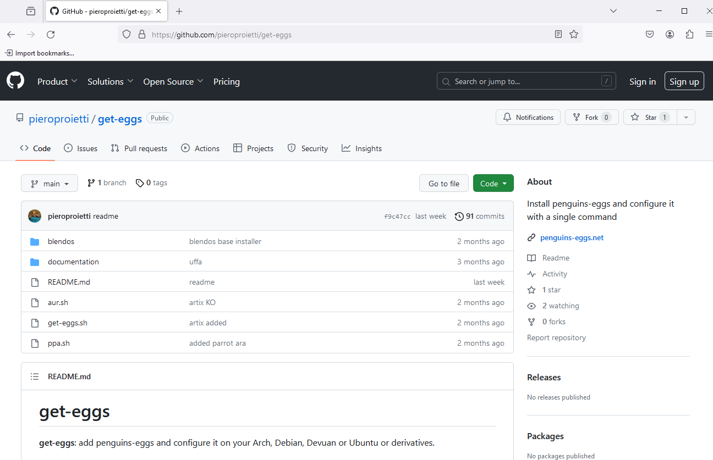

git clone https://github.com/pieroproietti/get-eggs

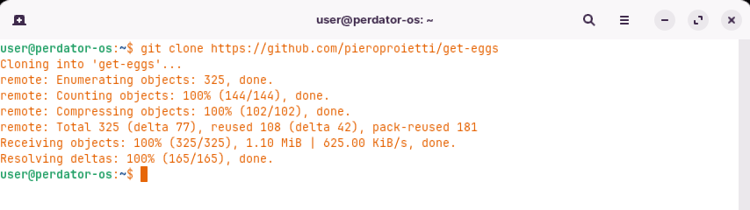

Change into the get**-**eggs directory:

$ cd get-eggs

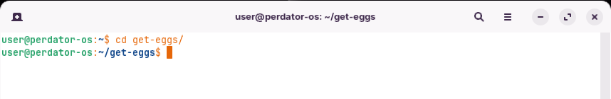

Run the get**-**eggs script with root privileges:

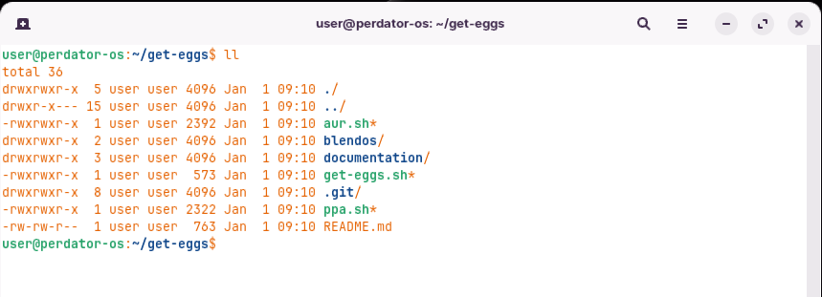

sudo ./get-eggs

By executing this script with root privileges, it will add the necessary repositories to your system**.** On Arch Linux, it will add the AUR repository **(**formerly known as **“**addaura**”).** On Debian**-**based systems, including Ubuntu, it will add a PPA **(**Personal Package Archive**)** for **“**penguins**-**eggs**”.**

Please note that running scripts with root privileges should be done with caution**.** Make sure you trust the source and understand the actions being performed by the script**.**

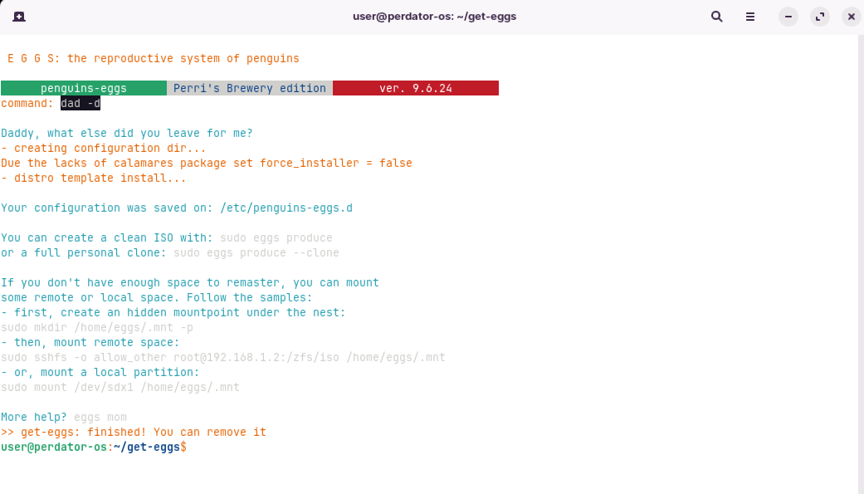

## Method2:

## penguins-eggs-ppa

**Repository (Debian based)**

Using ppa depository on Debian based:

To use the repository, follow these steps:

1. Copy and paste the following two lines into a terminal window:

$curl -fsSL https://pieroproietti.github.io/penguins-eggs-ppa/KEY.gpg | sudo gpg --dearmor -o /etc/apt/trusted.gpg.d/penguins-eggs.gpg

$sudo echo “deb [arch=$(dpkg --print-architecture)] https://pieroproietti.github.io/penguins-eggs-ppa ./” | sudo tee /etc/apt/sources.list.d/penguins-eggs.list > /dev/null

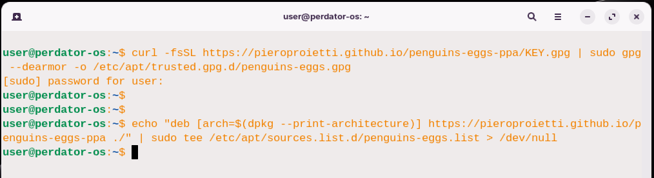

Now, you can use standard apt commands to install and upgrade the eggs package**.** Remember to run sudo apt update to update the package lists before installing or upgrading the eggs package**.**

$sudo apt update

$ sudo apt install eggs

Once the eggs package is successfully installed, you can use the eggs command**-**line tool to add the penguins**-**eggs**-**ppa repository and receive updates via apt**.** To add the repository, execute the following command:

$ sudo eggs tools ppa --add

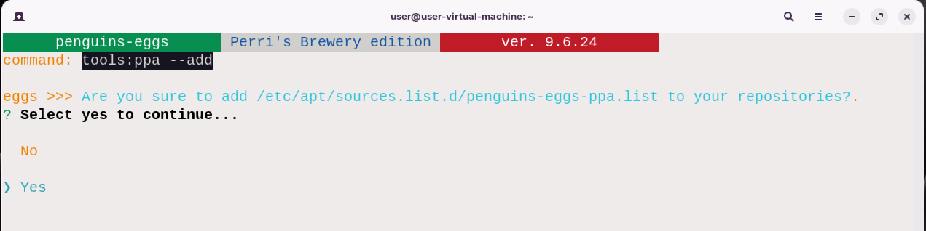

Final:

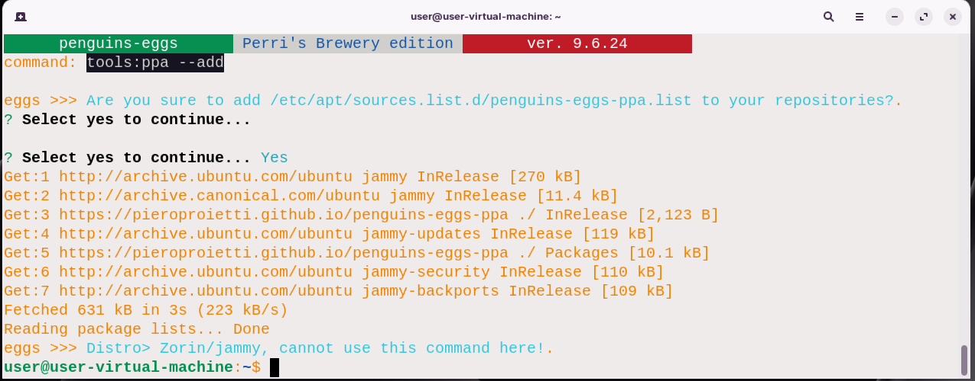

By following these steps, you can install the eggs package, resolve any missing dependencies, and add the penguins**-**eggs**-**ppa repository for future updates**.**

## Method4: eggs package (Debian based)

If you prefer not to include the penguins**-**eggs**-**ppa repository in your system's repositories, you have an alternative method to install the eggs package**.** Follow these steps:

1. Visit the sourceforge site to download the latest version of the eggs package in **.**deb format**.**
2. Once the package is downloaded, open a terminal and navigate to the directory where the **.**deb file is located**.**

https://sourceforge.net/projects/penguins-eggs/files/DEBS/

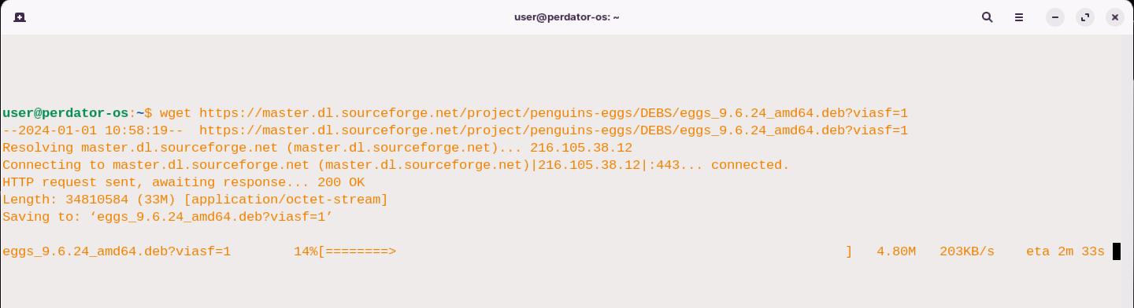

1. Install the eggs package using the dpkg command with sudo**.** For example:

sudo dpkg -i eggs-9.4.x.deb

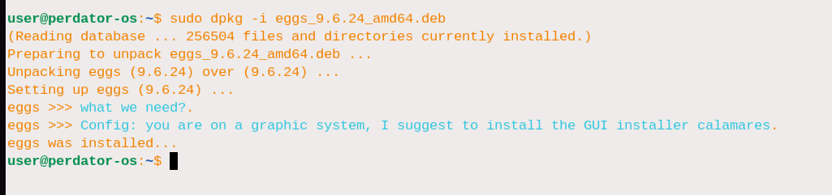

1. Since this is your first installation, there may be missing dependencies preventing the package from being fully installed**.** To resolve this, run the following command:

$ sudo apt install -f

This command will automatically install any missing dependencies required by the eggs package**.**

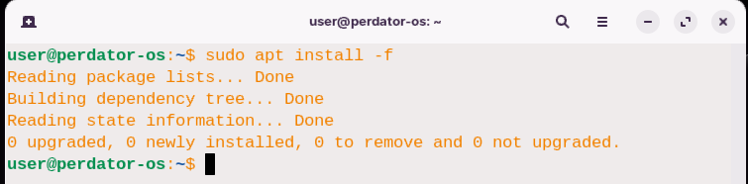

1. If you have the gdebi package manager installed on your system, you can use it to install the eggs package in graphical mode**.** Simply right**-**click on the **.**deb file, select **“**Open with GDebi Package Installer,**”** and follow the on**-**screen instructions**.**

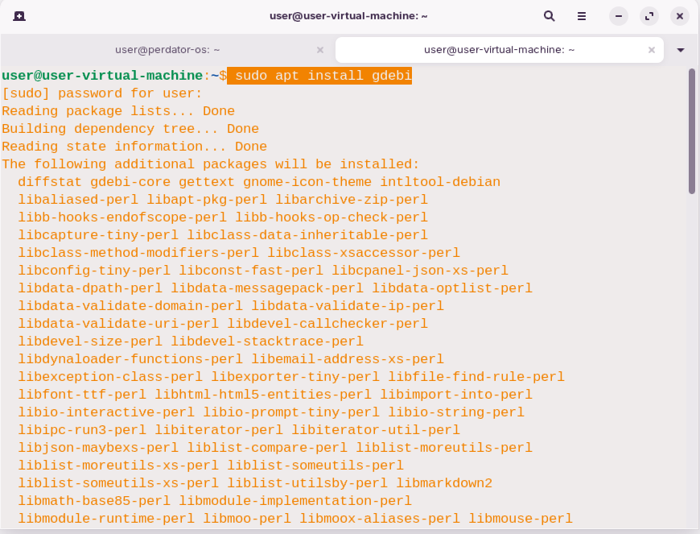

More details:

SourceForge**.**net is a widely recognized platform that has been serving the software development community for many years**.** It has established itself as a reliable source for hosting and distributing open**-**source software projects**.** By hosting projects on SourceForge**.**net, developers can showcase their work, collaborate with other developers, and make their software easily accessible to users**.** When it comes to the installation of eggs, SourceForge**.**net provides a convenient location to download the necessary **.**deb package files**.** These files contain the software package that you need to install on your system**.** By navigating to the designated page for the penguins**-**eggs project on SourceForge**.**net, you can access the list of available **.**deb files**.**

Downloading the appropriate **.**deb file for your system architecture is crucial for a successful installation**.** Whether you are using an AMD64 or i386 system, SourceForge**.**net offers the necessary files to cater to your specific requirements**.** Once you have downloaded the desired **.**deb file, you can proceed with the installation process**.** Using the `dpkg` command with the `**-**i` flag, you can install the eggs package onto your system**.** It is important to note that running the installation command as a superuser **(**using `sudo`**)** ensures that the necessary permissions are granted for the installation process**.**

During the installation, you may encounter dependency issues**.** Dependencies are additional software components that need to be present on your system for the eggs package to function correctly**.** Resolving these dependencies is essential for a smooth installation**.** Fortunately, the `apt` package manager provides a convenient way to automatically resolve and install any missing dependencies**.** By running `sudo apt -f install`, you can prompt the package manager to fix any dependency**-**related issues**.**

After successfully installing the eggs package and resolving any dependencies, it is always a good idea to verify the installation**.** Using the `eggs status` command, you can check the current status of the eggs package on your system**.** This command provides information about the installed version and any relevant updates or notifications**.**

By following these steps and utilizing SourceForge**.**net as a reliable source for the eggs package, you can ensure a seamless installation process and enjoy the benefits of this software on your system**.**

## Method5: installing on Arch Linux

To configure the Chaotic**-**AUR repository and install the penguins**-**eggs package on Arch Linux, follow these steps:

1. Import the Chaotic**-**AUR repository key by running the following command:

pacman-key --recv-key FBA220DFC880C036 --keyserver keyserver.ubuntu.com

Description: The pacman**-**key **--**recv**-**key command is used in Arch Linux**-**based distributions, such as Manjaro, to import and trust a specific GPG key**.** This command is typically used to validate the authenticity and integrity of packages downloaded from specific repositories**.**

In the example you provided, FBA220DFC880C036 is the key ID that you want to import, and keyserver**.**ubuntu**.**com is the keyserver from which you want to retrieve the key**.**

To import the key using pacman**-**key **--**recv**-**key, follow these steps:

Open a terminal or command prompt**.**

Run the following command:

$ sudo pacman-key --recv-key FBA220DFC880C036 --keyserver keyserver.ubuntu.com

This command will retrieve the specified key from the keyserver and import it into your system's keyring**.** After the key is imported, you need to trust it by running the following command:

$ sudo pacman-key --lsign-key FBA220DFC880C036

This command will locally sign the key, indicating that you trust it**.**

By importing and trusting the key, you can ensure the authenticity of packages signed with that key when you install them using pacman or related package managers**.**

1. Sign the imported key by running the following command:

$ sudo pacman-key --lsign-key FBA220DFC880C036

1. Install the Chaotic**-**AUR keyring and mirrorlist packages by running the following command:

$sudo pacman -U 'https://cdn-mirror.chaotic.cx/chaotic-aur/chaotic-keyring.pkg.tar.zst' 'https://cdn-mirror.chaotic.cx/chaotic-aur/chaotic-mirrorlist.pkg.tar.zst'

1. Open the **/**etc**/**pacman**.**conf file in a text editor and add the following lines at the end:

[chaotic-aur]

Include = /etc/pacman.d/chaotic-mirrorlist

1. Save the changes and exit the text editor**.**
2. Update the package lists by running the following command:

$ sudo pacman -Sy

1. Finally, install the penguins**-**eggs package by running the following command:

$ sudo pacman -Sy penguins-eggs

By following these steps, you will successfully configure the Chaotic**-**AUR repository and install the penguins**-**eggs package on your Arch Linux system**.**

on Arch Linux, you have multiple options to install eggs**.** One popular choice is to use the yay AUR helper**.** Here's how you can install eggs using yay:

1. Open a terminal and run the following command to install yay if you don't already have it:

$sudo pacman -Sy yay

1. Once yay is installed, you can use it to install eggs by running the following command:

$ sudo yay -S penguins-eggs

yay will handle the installation process, including fetching the package from the AUR **(**Arch User Repository**)** and resolving any dependencies**.**

Alternatively, if you prefer a more traditional approach, you can manually build and install the penguins**-**eggs package from the AUR using git and pkgbuild commands**.** Here's how:

1. Open a terminal and run the following command to clone the penguins**-**eggs AUR repository:

$ git clone https://aur.archlinux.org/penguins-eggs.git penguins-eggs-aur

1. Change your current directory to the newly cloned repository:

$ cd penguins-eggs-aur

1. Build and install the package using pkgbuild command:

$sudo makepkg -si

This command will build the package and prompt you for confirmation before installing it**.**

## Method6: Installing on Manjaro Linux

On Manjaro, you can easily install the penguins**-**eggs package from the Manjaro community repository using the pamac package manager**.** Here are the steps to install it:

1. Open a terminal and run the following command to update your system packages:

$ sudo pamac upgrade

This command ensures that your system is up to date before installing any new packages**.**

1. Once the system is updated, you can install penguins**-**eggs by running the following command:

$ sudo pamac install penguins-eggs

The pamac command will handle the installation process, including fetching the package from the Manjaro community repository and resolving any dependencies**.** By following these steps, you should be able to successfully install the penguins**-**eggs package on Manjaro using the pamac package manager**.**

## Method7: installing by npm command

While it is technically possible to install penguins**-**eggs directly as an npm package, it is worth noting that the npm packages may still have dependencies that need to be installed separately**.** Additionally, since penguins**-**eggs is developed with Node**.**js, it is more commonly distributed as a package for specific Linux distributions or available in the AUR**.** If you still prefer to install penguins**-**eggs using npm and handle the installation of dependencies separately, you can follow these general steps:

1. Ensure that you have Node**.**js and npm installed on your system**.**

This is the website of npm how to install it:

https://docs.npmjs.com/downloading-and-installing-node-js-and-npm

or use the following steps based on your Linux distro:

# installing node.js

To install Node**.**js and npm on different Linux distributions, here are the steps for Debian**-**based, Arch**-**based, Red Hat**-**based, and Fedora**-**based systems:

## Debian-based (e.g., Ubuntu, Linux Mint):

1. Open a terminal and update the package lists:

sudo apt update

1. Install Node**.**js and npm:

sudo apt install nodejs npm

1. Verify the installation:

node --version

npm --version

## Arch-based (e.g., Arch Linux, Manjaro):

1. Open a terminal and update the package lists:

sudo pacman -Syu

1. Install Node**.**js and npm:

sudo pacman -S nodejs npm

1. Verify the installation:

node --version

npm --version

## Red Hat-based (e.g., CentOS, RHEL):

1. Open a terminal and update the package lists:

sudo yum update

1. Enable the EPEL repository **(**Extra Packages for Enterprise Linux**)**:

sudo yum install epel-release

1. Install Node**.**js and npm:

sudo yum install nodejs npm

1. Verify the installation:

node --version

npm --version

## Fedora-based (e.g., Fedora):

1. Open a terminal and update the package lists:

sudo dnf update

1. Install Node**.**js and npm:

sudo dnf install nodejs npm

1. Verify the installation:

node --version

npm --version

These steps should help you install Node**.**js and npm on the respective Linux distributions**.** After installation, you can start using Node**.**js and npm for your development needs**.**

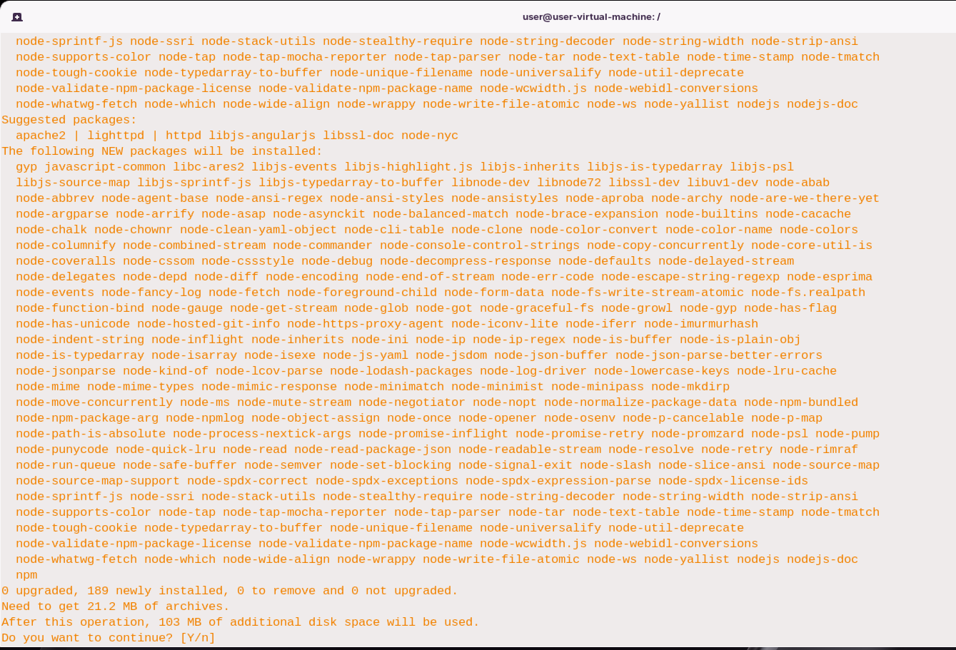

You can check if they are already installed by running the following commands in a terminal:

node -v

npm -v

If they are not installed, you can refer to the Node**.**js and npm documentation for instructions on how to install them**.**

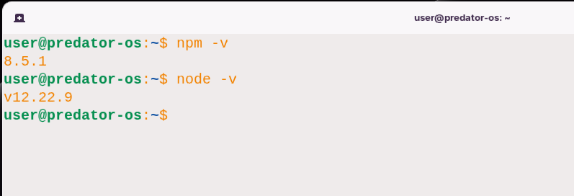

1. Once you have Node**.**js and npm installed, you can install penguins**-**eggs by running the following command in a terminal:

$ sudo npm install -g penguins-eggs

This command will install the penguins**-**eggs package globally on your system**.**

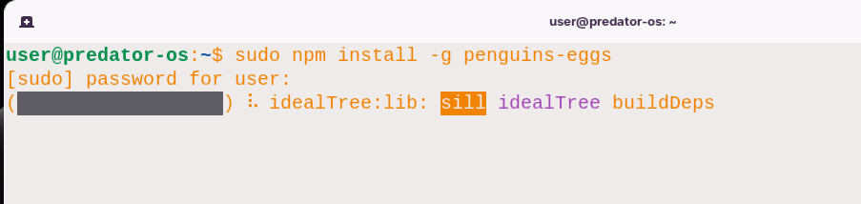

1. After installing penguins**-**eggs, you will need to manually handle the installation of any dependencies that are required by the package**.** You can refer to the documentation or instructions provided with penguins**-**eggs to identify and install the necessary dependencies**.**

Please note that this method may require more manual effort and may not be as straightforward as using the distribution**-**specific package managers like apt, yay, or pamac**.** It is generally recommended to use the package manager specific to your Linux distribution whenever possible, as it will handle the dependencies and installation process more seamlessly**.**

## Method 8: Installing Eggs from npm source

Using penguins**-**eggs from the source code can indeed provide benefits such as easier debugging and the ability to review the code running on your machine**.** It can also offer greater security and the potential for collaboration on the project**.** Here are the steps to install and use penguins**-**eggs from the source code:

1. Install the required dependencies, including Node**.**js and the pnpm package manager**.** On Manjaro, you can run the following command to install them:

sudo pamac install nodejs pnpm devel-base

On Debian**/**Devuan**/**Ubuntu, it is recommended to use the NodeSource repository to install Node**.**js version 16**.**x**.**

1. Once Node**.**js and npm are installed, you can install pnpm globally by running the following command:

sudo npm i pnpm -g

1. Clone the penguins**-**eggs source code repository by running the following command:

git clone https://github.com/pieroproietti/penguins-eggs

1. Change your current directory to the penguins**-**eggs directory:

cd penguins-eggs

1. Install the project dependencies using pnpm by running the following command:

$ sudo pnpm install

Note that pnpm is used instead of the traditional npm command, which allows for faster compilation**.**

Once the installation is complete, you can use penguins**-**eggs directly from the source code**.** For example, to run the produce command with verbose output, you can use the following command:

$ sudo ./eggs produce --verbose

Please note that when using the source code, you need to specify the path to start eggs as **./**eggs, and you should launch it from the ~**/**penguins**-**eggs directory**.** The functionality remains the same as when using precompiled packages, but you have the advantage of being able to interact with the code directly**.**

Keep in mind that using the source code requires some technical knowledge and may involve additional steps compared to using precompiled packages**.**

# Updating the eggs

Once the package is installed, you can use the command eggs tools ppa –add to add the repository penguins**-**eggs**-**ppa and get all the updates to eggs via the command apt**.** To do this simply issue the command:

sudo eggs tools ppa –add

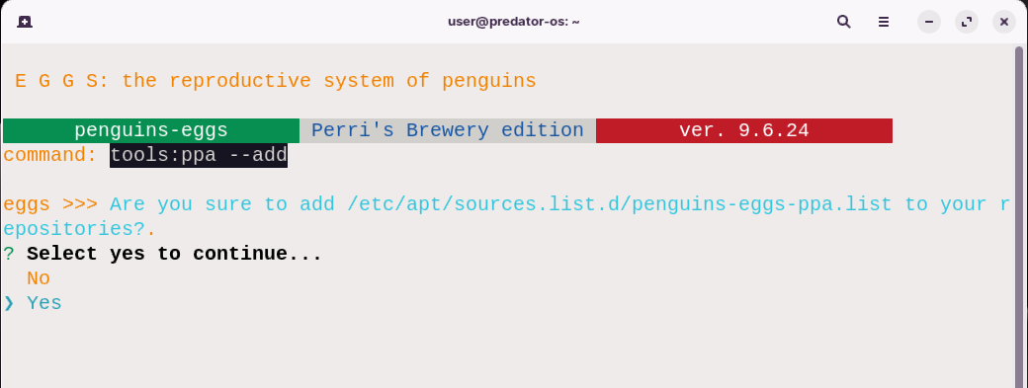



The eggs tools ppa command is used to add or remove PPA **(**Personal Package Archive**)** repositories in the Debian family of operating systems**.** Here is a breakdown of its usage:

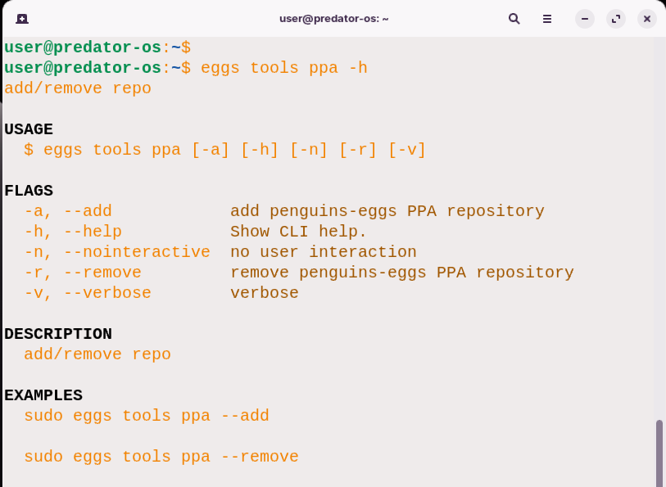

In the EXAMPLES: section, you can find two usage EXAMPLES::

$ sudo eggs tools ppa --add

This command adds the penguins**-**eggs PPA repository to the system**.** PPAs are commonly used in Debian**-**based systems to provide additional software packages that are not available in the official repositories**.**

$ sudo eggs tools ppa --remove

This command removes the penguins**-**eggs PPA repository from the system**.** Removing a PPA repository can be useful if you no longer need the packages provided by that repository or if you want to clean up your system**.** Please note that adding or removing PPA repositories can have implications for your system, such as introducing new software sources or removing access to certain packages**.** Exercise caution and ensure that you are familiar with the PPA and its contents before adding or removing it**.**

Here's a more detailed description of each flag used in the eggs tools ppa command:

* **-**a, **--**add: This flag adds the penguins**-**eggs PPA repository to the system**.** PPAs are additional software repositories commonly used in Debian**-**based systems to provide access to packages not available in the official repositories**.** Adding a PPA allows you to install software from that repository**.**
* **-**h, **--**help: This flag displays the help message for the eggs tools ppa command**.** It provides information about the command's usage, flags, and EXAMPLES:**.**
* **-**n, **--**nointeractive: This flag allows the operation to be performed without any user interaction**.** When this flag is used, the command will not prompt for any confirmation or additional input**.** It can be useful when you want to automate the process of adding or removing a PPA repository**.**
* **-**r, **--**remove: This flag removes the penguins**-**eggs PPA repository from the system**.** Removing a PPA repository can be useful if you no longer need the packages provided by that repository or if you want to clean up your system**.**
* **-**v, **--**verbose: This flag enables verbose output, providing more detailed information during the execution of the eggs tools ppa command**.** It can be helpful for understanding the progress and actions taken during the operation**.**

The eggs tools ppa command is used to add or remove PPA repositories in the Debian family of operating systems**.** Adding a PPA allows you to access additional software packages, while removing a PPA removes access to those packages**.**

Here are a couple of EXAMPLES::

$ sudo eggs tools ppa --add

This command adds the penguins**-**eggs PPA repository to the system, allowing you to install software packages from that repository**.**

$ sudo eggs tools ppa --remove

This command removes the penguins**-**eggs PPA repository from the system, preventing further installations or updates from that repository**.** Please note that adding or removing PPA repositories can have implications for your system, such as introducing new software sources or removing access to certain packages**.** Exercise caution and ensure that you are familiar with the PPA and its contents before adding or removing it**.**

**More details in source code:**

https://github.com/pieroproietti/penguins-eggs/blob/master/src/commands/tools/ppa.ts

# eggs version

The eggs version command is used to display information about the version of the **“**eggs**”** command**-**line interface **(**CLI**)** tool**.** Here is a breakdown of its usage:

**USAGE**

$ eggs version [--json] [--verbose]

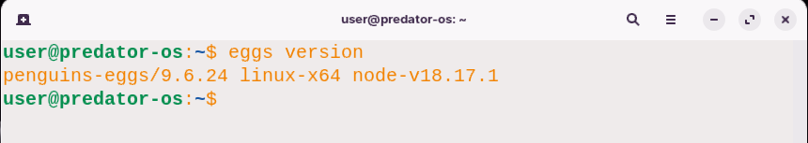

The command has the following flags:

**FLAGS**

--verbose Shows additional information about the CLI.

--json Formats the output as JSON.

By running the eggs version command without any flags, you will get the version of the **“**eggs**”** CLI tool**.** It will display the version number of the tool**.**

Note:

If you want more detailed information, you can use the --verbose flag. This will show additional information about the CLI, including the architecture, Node.js version, operating system, and versions of any plugins being used.

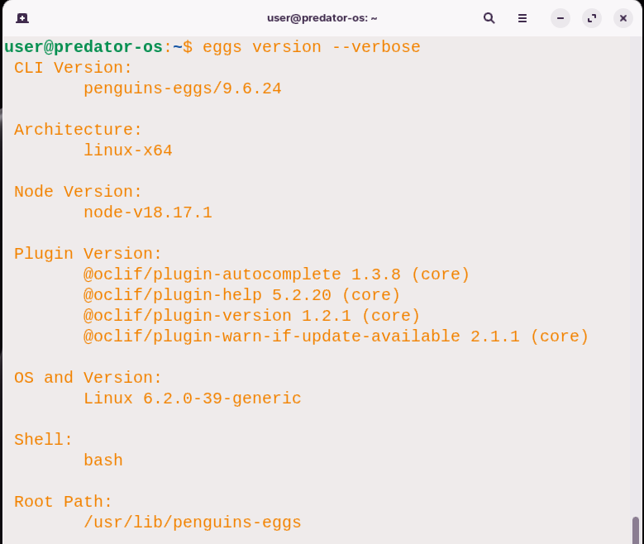

If you prefer the output to be in JSON format, you can use the **--**json flag**.** This will format the output as JSON, which can be useful if you want to programmatically parse the version information**.** Remember to include the eggs command before the version subcommand when running the command**.**

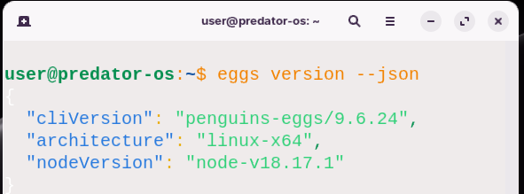



# Chapter 6

# Eggs Installer

The Eggs tool provides two different installers for installing your distributionafter creating the ISO file image:

## 1.Calamares Installer (GUI):

1. Calamares is a graphical installer framework that provides a user**-**friendly interface for installing your distribution**.**
2. It offers a visual systematic installation process, making it easier for users who prefer a graphical interface**.**
3. To use the Calamares installer, you can run the eggs calamares command**.** This command allows you to configure, install, or configure Calamares**.**

## 2.Krill Installer (TUI):

1. Krill is a command**-**line interface **(**CLI**)** system installer provided by Eggs**.**
2. It offers a text**-**based installation process, allowing you to install your distribution without a graphical interface**.**
3. The Krill installer is designed for users who prefer a command**-**line installation experience**.**
4. To use the Krill installer, you can run the eggs install command**.** This command installs Krill, transforming the **“**egg**”** into a **“**penguin**”** and enabling the CLI system installer functionality**.**

**You can choose the installer that suits your preference and installation requirements.**

## Method 1. Calamares installer (GUI)

# What is calamares

Calamares is an open**-**source installation framework designed to simplify the installation process of Linux distributions**.** It provides a user**-**friendly, modular, and customizable graphical installer for Linux operating systems**.** Calamares aims to be distribution**-**agnostic, meaning it can be used by various Linux distributions with different desktop environments**.** The main goal of Calamares is to provide an easy**-**to**-**use installation experience for both novice and experienced users**.** It offers a simple and intuitive interface that guides users through the installation process, allowing them to configure various aspects of the system, such as disk partitioning, user accounts, localization settings, and more**.**

Calamares is written in C**++** and uses the Qt framework for its graphical user interface**.** It is designed to be highly customizable and extensible, allowing Linux distributions to tailor the installer to their specific needs**.** Distribution developers can customize the appearance, behavior, and functionality of Calamares by creating or modifying modules, which are individual components that handle specific installation tasks**.** By using Calamares, Linux distributions can provide a consistent and user**-**friendly installation experience, making it easier for users to install and try out their operating systems**.** It abstracts away many of the complexities of the installation process, making it accessible to a wider range of users and contributing to a more welcoming Linux ecosystem**.**

## Calamares modules

  These are the commonly used modules in a typical Calamares installation:

1. Welcome: This module provides an introduction and overview of the installation process**.** It may include information about the distribution and its features**.**
2. Location: This module allows users to select their geographic location, which is used to set the system's time zone**.**
3. Keyboard: This module enables users to choose their preferred keyboard layout or input method**.**
4. Partitions: The partitions module allows users to configure disk partitions for the installation**.** It provides options for automatic partitioning or manual partitioning, including the ability to create, resize, or format partitions**.**
5. Users: This module allows users to set up user accounts and configure user**-**related settings, such as usernames, passwords, and user privileges**.**
6. Summary: The summary module provides a summary of the chosen installation settings and allows users to review and confirm their choices before proceeding with the installation**.**
7. Install: This module handles the actual installation process, copying the necessary files to the designated partitions and configuring the system accordingly**.**
8. Finish: The finish module marks the completion of the installation process and may prompt users to reboot their system**.**

**Additionally**, **there are optional modules available in Calamares**, **which are used for specific use cases or distributions:**

1. License: This module presents the end**-**user license agreement **(**EULA**)** and requires users to accept the terms before proceeding with the installation**.**
2. Netinstall: The netinstall module enables network**-**based installation, allowing users to download and install packages directly from the internet during the installation process**.**
3. Notesqml: This module provides a text**-**based note or information to the user during the installation process**.**
4. Packagechooser: The packagechooser module allows users to select additional software packages or components to be installed alongside the base system**.**
5. Plasmalnf: This module is specific to KDE Plasma**-**based distributions and provides additional configuration options for the Plasma desktop environment**.**
6. Tracking: The tracking module allows distributions to collect anonymous usage data or statistics regarding the installation process, helping developers gather insights and improve the installer**.**
7. Webview: This module integrates a web browser or web**-**based interface within the installer, allowing users to access online resources or perform specific tasks during the installation**.**

These optional modules offer flexibility and customization options for specific installation scenarios or distribution requirements**.**

# Calamares installation

How to install Calamares?

## Step 1:  installing Calamares using the distribution's repository

Here are the instructions to install Calamares on Debian, Ubuntu, Arch Linux, Manjaro, and Fedora:

1**.** **Debian**:

**-** Open a terminal**.**

**-** Update the package lists:

sudo apt update

**-** Install Calamares:

sudo apt install calamares

2**.** **Ubuntu**:

**-** Open a terminal**.**

**-** Update the package lists:

sudo apt update

**-** Install Calamares:

sudo apt install calamares

3**.** **Arch Linux**:

**-** Open a terminal**.**

Install Calamares from the Arch User Repository **(**AUR**)** using an AUR helper like yay or paru:

 $ sudo yay -S calamares-git

or

 $ sudo paru -S calamares-git

4**.** **Manjaro**:

**-** Open a terminal**.**

**-** Install Calamares from the official repositories:

sudo pacman -S calamares

5**.** **Fedora**:

**-** Open a terminal**.**

**-** Install Calamares from the official repositories:

sudo dnf install calamares

**Or**

Add the RPM Fusion repository, which provides Calamares:

sudo dnf install -y https://mirrors.rpmfusion.org/free/fedora/rpmfusion-free-release-$(rpm -E %fedora).noarch.rpm

sudo dnf install -y https://mirrors.rpmfusion.org/nonfree/fedora/rpmfusion-nonfree-release-$(rpm -E %fedora).noarch.rpm

Update the package lists:

sudo dnf update

Install Calamares:

sudo dnf install calamares

After installing Calamares, you can launch it from the application menu or by running the `calamares` command in the terminal**.** Keep in mind that Calamares is primarily designed to be used during the installation process of a Linux distribution, so you might not find it as a standalone application for everyday use**.**

Check the default installer:

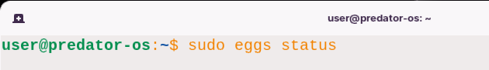

Then, you can see which installer is installed**.**

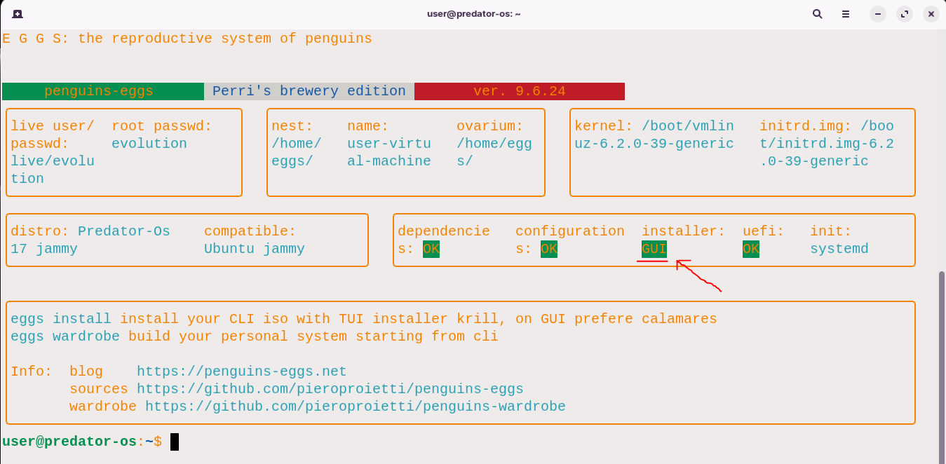

## Step 2: installing calamares with eggs

**Debian based**

$ sudo apt install calamares

$ sudo eggs calamares --install

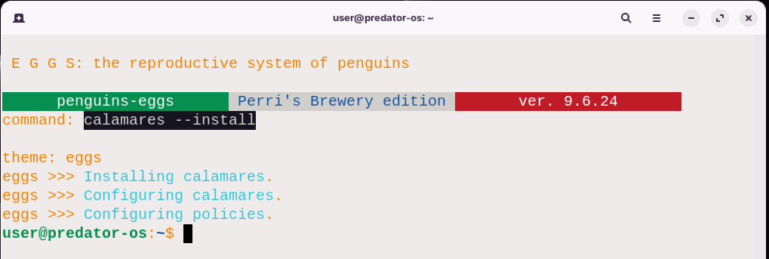

**Arch Linux using Chaotic-AUR**

1. Open a terminal**.**
2. Install the Chaotic**-**AUR key and mirrorlist:

pacman-key --recv-key 3056513887B78AEB --keyserver keyserver.ubuntu.com

pacman-key --lsign-key 3056513887B78AEB

pacman -U 'https://cdn-mirror.chaotic.cx/chaotic-aur/chaotic-keyring.pkg.tar.zst'

pacman -U 'https://cdn-mirror.chaotic.cx/chaotic-aur/chaotic-mirrorlist.pkg.tar.zst'

Open the **/**etc**/**pacman**.**conf file using a text editor:

$ sudo nano /etc/pacman.conf

Append the following lines to the end of the file:

[chaotic-aur]

Include = /etc/pacman.d/chaotic-mirrorlist

1. Save and exit the text editor**.**
2. Update the package lists:

$ sudo pacman -Syu

Install Calamares using pacman or sudo eggs:

$ sudo pacman -S calamares

then

$ sudo eggs calamares --install

Wait for the installation process to complete**.** The package manager will download and install Calamares along with any necessary dependencies**.**

**With yay**

To install Calamares using yay on Arch Linux, you can follow these steps:

1. Open a terminal**.**
2. Clone the penguins**-**eggs**-**pkgbuilds repository from GitHub:

git clone https://github.com/pieroproietti/penguins-eggs-pkgbuilds

Change into the ckbcomp directory:

cd penguins-eggs-pkgbuilds/aur/ckbcomp

Build and install the ckbcomp package using makepkg:

makepkg -si

Once ckbcomp is installed, you can install Calamares using yay:

yay calamares

1. yay will search for the Calamares package in the AUR **(**Arch User Repository**)**, present you with the available options, and prompt you to choose the package to install**.** Select the appropriate Calamares package when prompted**.**
2. Review the installation details and dependencies, and confirm the installation**.**
3. yay will handle the download, build, and installation process for Calamares, along with any necessary dependencies**.**

**On Manjaro** Linux, you can install Calamares directly from eggs using the following command:

sudo eggs calamares --install

This command will use the eggs package manager to install Calamares on your system**.** Make sure you have eggs installed before running this command**.** If eggs tool is not installed, you can install it using the package manager provided by Manjaro**.** After executing the command, eggs will handle the download, installation, and any necessary dependencies for Calamares**.** Once the installation is complete, you can launch Calamares from the application menu or by running the calamares command in the terminal**.**

# Calamares settings

After installing Calamares, the configuration files can be found in the following path:

/etc/calamares

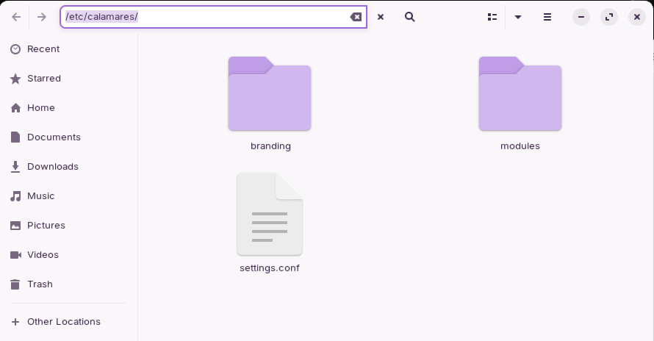

In this directory, you will find various configuration files that allow you to customize and fine**-**tune the behavior of Calamares during the installation process**.** These files include:

## settings.conf

1. settings.conf: This file serves as the main configuration file for Calamares**.** It contains global settings and options that determine the behavior of the installer**.** You can modify various parameters such as the theme, language, keyboard layout, partitioning scheme, and more**.**

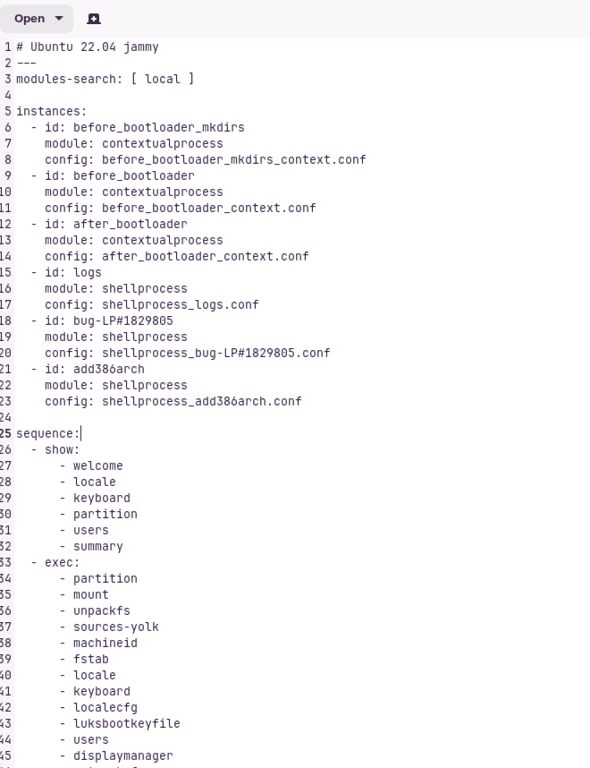

The provided sequence of steps and exec in the settings**.**conf file appears to be a configuration for an installation or deployment process**.** Here's a breakdown of the sequence and their corresponding actions:

1**.** Show Welcome, Locale, Keyboard, Partition, Users, Summary: These are steps to display various screens or prompts to the user during the installation process, including welcome messages, language**/**locale selection, keyboard configuration, partitioning options, user account setup, and a summary of the installation choices**.**

2**.** Exec: This section contains a series of actions to be executed during the installation process**.** Each action represents a specific task or operation:

* Partition: Handles partitioning of the disk**.**
* Mount: Mounts the necessary file systems**.**
* Unpackfs: Unpacks the file system**.**
* Sources**-**yolk: Configures software sources**.**
* Machineid: Sets the machine ID**.**
* Fstab: Configures the file system table**.**
* Locale: Sets the system locale**.**
* Keyboard: Configures the keyboard layout**.**
* Localecfg: Configures locale**-**related settings**.**
* Luksbootkeyfile: Handles LUKS boot key file setup**.**
* Users: Sets up user accounts**.**
* Displaymanager: Configures the display manager**.**
* Networkcfg: Configures network settings**.**
* Hwclock: Handles hardware clock configuration**.**

## Branding

**2.branding**: This directory defines the branding information for Calamares**.** It allows you to specify the name, logo, and other visual elements that will be displayed during the installation process**.** By customizing this file, you can create a consistent branding experience for your distribution**.**

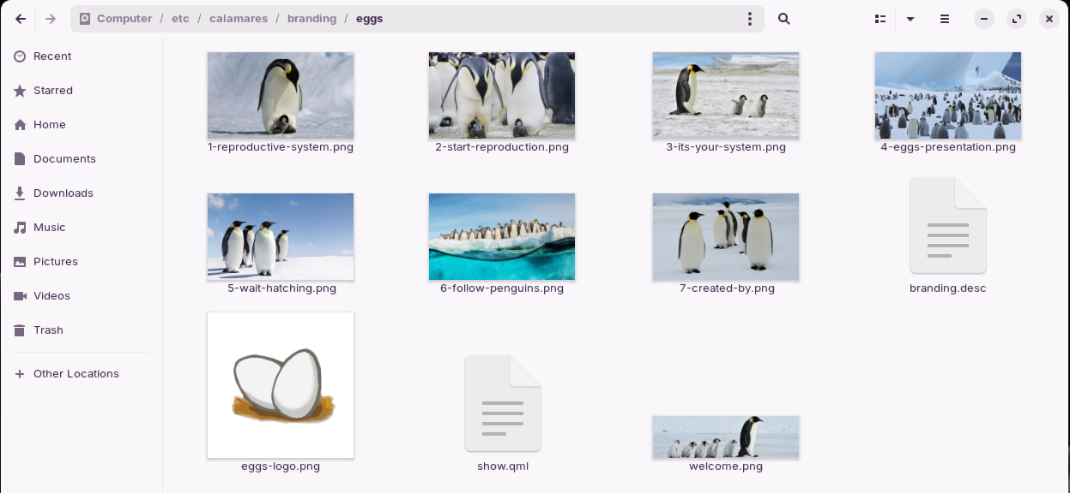

The branding directory in Calamares allows you to define the branding information for your distribution during the installation process**.** By customizing this file, you can create a consistent and personalized branding experience**.** Here is what you can specify in the branding**.**desc file:

* Name: You can set the name of your distribution or customize the name that will be displayed during the installation**.** This helps users identify your distribution throughout the installation process**.**
* Logo: You can specify the logo or icon that represents your distribution**.** This image will be displayed in various places during the installation, such as the installer's welcome screen or progress bar**.**
* Visual Elements: Apart from the name and logo, you can also define other visual elements to create a cohesive branding experience**.** This may include specifying colors, fonts, or any other design elements that align with your distribution's brand identity**.**

By customizing the branding**.**desc file, you can ensure that the installer reflects the unique identity of your distribution**.** It helps create a consistent and recognizable experience for users during the installation process**.**

Default eggs branding.desc:

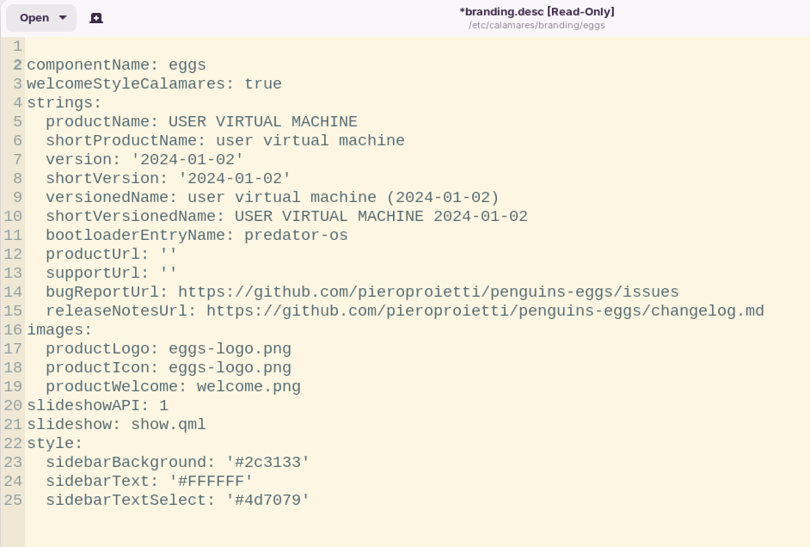

Show.qml file

The **/**etc**/**calamares**/**branding**/**show**.**qml file refers to a specific QML **(**Qt Meta**-**Object Language**)** file used in the Calamares installer framework**.** This file is typically located in the **/**etc**/**calamares**/**branding**/** directory**.** The purpose of the show**.**qml file within the branding directory is to define the graphical user interface **(**GUI**)** for displaying screens or pages during the installation process, specifically for a particular branding or customization of the Calamares installer**.**

By modifying the show**.**qml file, you can customize the appearance, layout, and behavior of the installer's user interface to match a specific branding or theme**.** This allows Linux distributions and system integrators to tailor the installation experience to their desired look and feel**.** Please note that the specific contents and structure of the show**.**qml file can vary depending on the branding or customization being applied**.** The file may contain QML code that defines the layout, styling, and interactive elements of the installer screens, such as labels, buttons, input fields, and progress indicators**.**

To view the contents of the **/**etc**/**calamares**/**branding**/**show**.**qml file on your system, you can use a text editor or command**-**line tools like cat or less**.** For example, you can run the following command in a terminal:

$ cat /etc/calamares/branding/eggs/show.qml

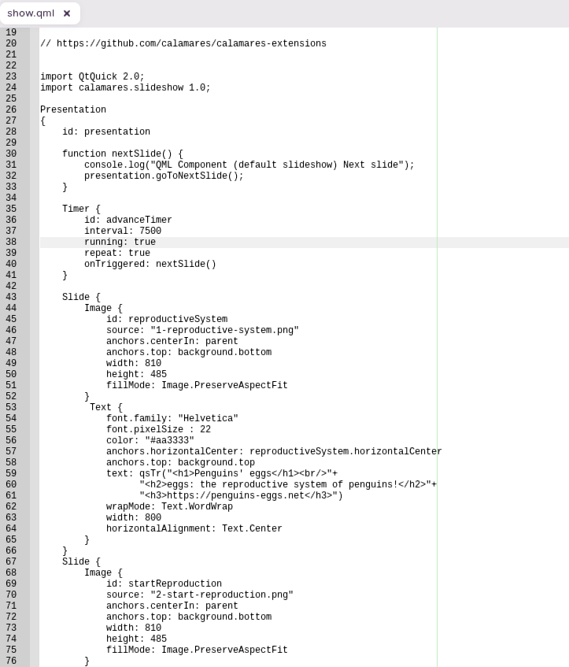

## modules

3**.modules**: This directory lists the modules that Calamares should load during the installation**.** Each module represents a specific step or functionality in the installation process**.**

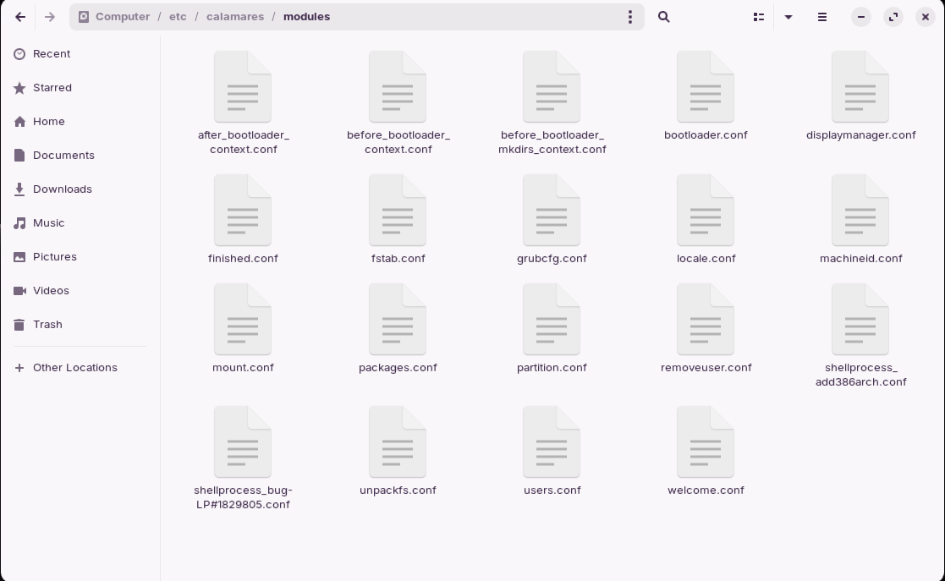

By enabling or disabling modules, you can control which features are available to the user during installation**.** EXAMPLES: of modules include partitioning, user account creation, bootloader installation, and more**.**

**Partitioning**: The partitioning module handles the disk partitioning process, allowing users to create, resize, or delete partitions as needed**.**

* User Account Creation: This module enables users to create user accounts during the installation process, specifying usernames, passwords, and other account details**.**
* Bootloader Installation: The bootloader module handles the installation and configuration of the bootloader, allowing users to choose the boot device and configure boot options**.**
* Localization: This module allows users to select the system's language, keyboard layout, timezone, and other regional settings**.**
* Package Selection: The package selection module enables users to choose the software packages they want to install, allowing for customization and fine**-**tuning of the system's software selection**.**
* Summary and Installation: This module presents a summary of the selected options and performs the actual installation process**.**

These are just a few EXAMPLES: of the modules that can be included in the modules**.**conf file**.** By modifying this file, you can enable or disable specific modules based on your requirements, thus controlling which features are available to the user during the installation**.**

## Method2: The Krill installer (TUI)

The Krill installer **(**TUI**)** in the Eggs tool allows for a command**-**line installation experience**.** Here's a breakdown of the usage, flags, and descriptions provided:

**Usage:**

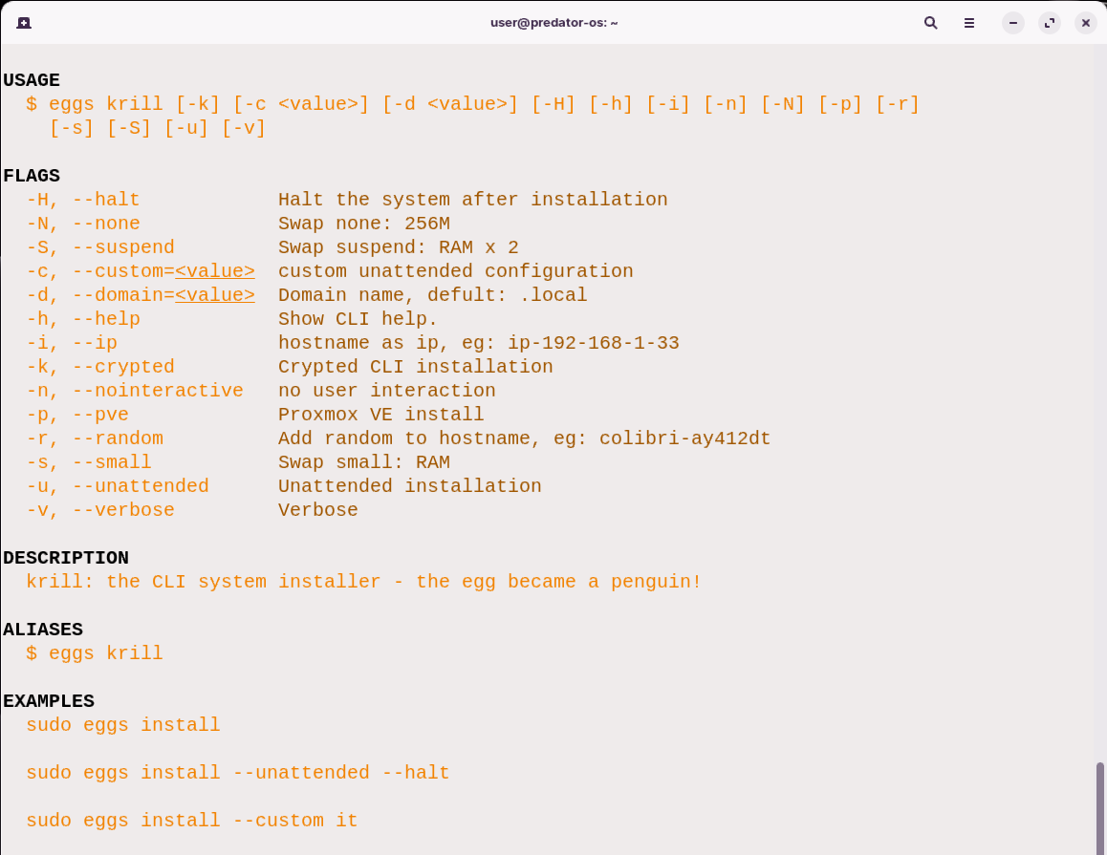

The **“**eggs install**”** or **“**eggs krill**”** command seems to be a CLI system installer**.** It provides various flags to customize the installation process, such as specifying a custom unattended configuration, domain name, IP address, swap settings, Proxmox VE installation, and more**.** The command can be run with administrative privileges using sudo**.** The description mentions that it is a CLI system installer where the **“**egg became a penguin,**”** possibly indicating a transition or transformation of some sort**.**

The EXAMPLES: demonstrate different ways to use the command, such as running a standard installation, running an unattended installation, and running a custom installation with the configuration specified as **“**it**”.**

## Config krill manually:

Got the following path:

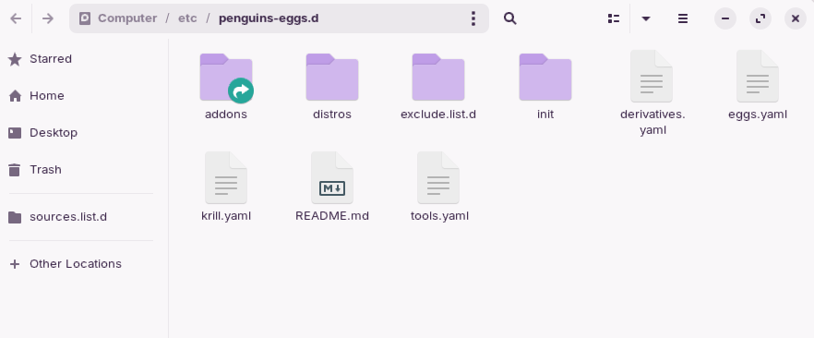

Then you can see the krill config file:

/etc/ penguins-eggs/conf/krill.yaml

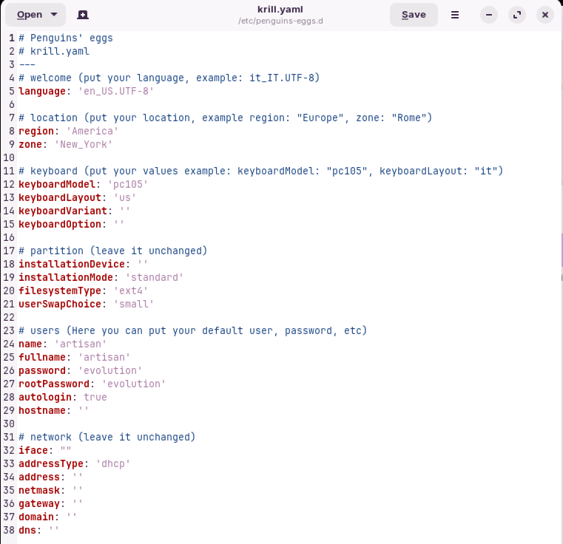

## The content of krill.yaml

The YAML configuration file named **“**krill**.**yaml**”** for configuring the installation settings of the **“**eggs install**”** or **“**eggs krill**”** CLI system installer**.** Let's go through the different sections of the configuration:

welcome

**language**: Specifies the language for the installation**.** In this case, it is set to 'en_US**.**UTF**-**8' for English language with UTF**-**8 encoding**.**

location

**region**: Specifies the region**/**location**.** In this case, it is set to 'America'**.**

**zone**: Specifies the zone within the region**.** In this case, it is set to 'New_York'**.**

keyboard

**keyboardModel**: Specifies the keyboard model**.** In this case, it is set to 'pc105'**.**

**keyboardLayout**: Specifies the keyboard layout**.** In this case, it is set to 'us'**.**

**keyboardVariant**: Specifies the keyboard variant**.** It is left empty **(**''**)** in this configuration**.**

**keyboardOption**: Specifies any additional keyboard options**.** It is left empty **(**''**)** in this configuration**.**

partition

**installationDevice**: Specifies the installation device**.** It is left empty **(**''**)** in this configuration**.**

**installationMode**: Specifies the installation mode**.** It is set to 'standard'**.**

**filesystemType**: Specifies the filesystem type**.** In this case, it is set to 'ext4'**.**

**userSwapChoice**: Specifies the user's swap choice**.** It is set to 'small'**.**

users

**name**: Specifies the default username**.** In this case, it is set to 'artisan'**.**

**fullname**: Specifies the full name of the default user**.** In this case, it is set to 'artisan'**.**

**password**: Specifies the password for the default user**.** In this case, it is set to 'evolution'**.**

**rootPassword**: Specifies the root password**.** In this case, it is set to 'evolution'**.**

**autologin**: Specifies whether autologin should be enabled for the default user**.** In this case, it is set to 'true'**.**

**hostname**: Specifies the hostname**.** It is left empty **(**''**)** in this configuration**.**

network

**iface**: Specifies the network interface**.** It is left empty **(**''**)** in this configuration**.**

**addressType**: Specifies the type of address configuration **(**e**.**g**.**, dhcp or static**).** In this case, it is set to 'dhcp'**.**

**address**: Specifies the IP address**.** It is left empty **(**''**)** in this configuration**.**

**netmask**: Specifies the network mask**.** It is left empty **(**''**)** in this configuration**.**

**gateway**: Specifies the gateway address**.** It is left empty **(**''**)** in this configuration**.**

**domain**: Specifies the domain name**.** It is left empty **(**''**)** in this configuration**.**

**dns**: Specifies the DNS server address**.** It is left empty **(**''**)** in this configuration**.**

**See more details and source code:**

https://github.com/pieroproietti/penguins-eggs/tree/master/src/krill/modules



# Chapter 7

# Eggs Configuration

## Part1: configuration automatically

You can configure eggs tool automatically and also manually**.** To configure the Eggs tool automatically, you can follow the steps outlined below:

$sudo eggs autocomplete

Autocomplete command is indeed a handy tool for quickly accessing available commands and their supported flags in the eggs package manager**.** To utilize autocomplete in the eggs package manager, you can start by typing eggs and then press the TAB key**.** This action will display a list of the available commands that you can choose from**.** Here's an example of the available commands:

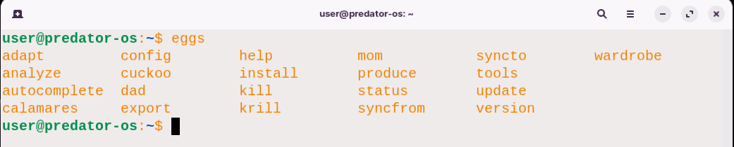

Once you have selected a command, you can type it out and then press TAB to see the flags supported by that specific command**.** For instance, if you enter eggs produce **--** and then press TAB, you will be presented with the available flags for the produce command, like this:

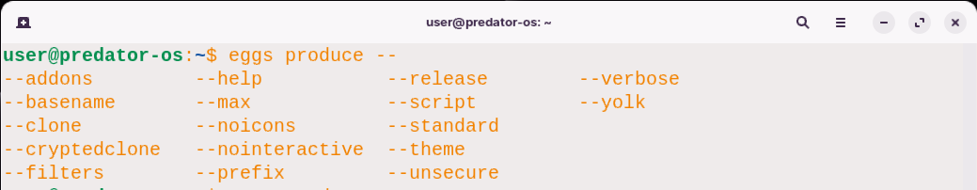

If you wish to access the help screen for a particular command, you can utilize the **--**help flag**.** For instance, to obtain detailed information about the usage and options available for the produce command, you can enter the following:

eggs produce --help

Executing this command will provide you with comprehensive information about the produce command, including its usage and available options**.**

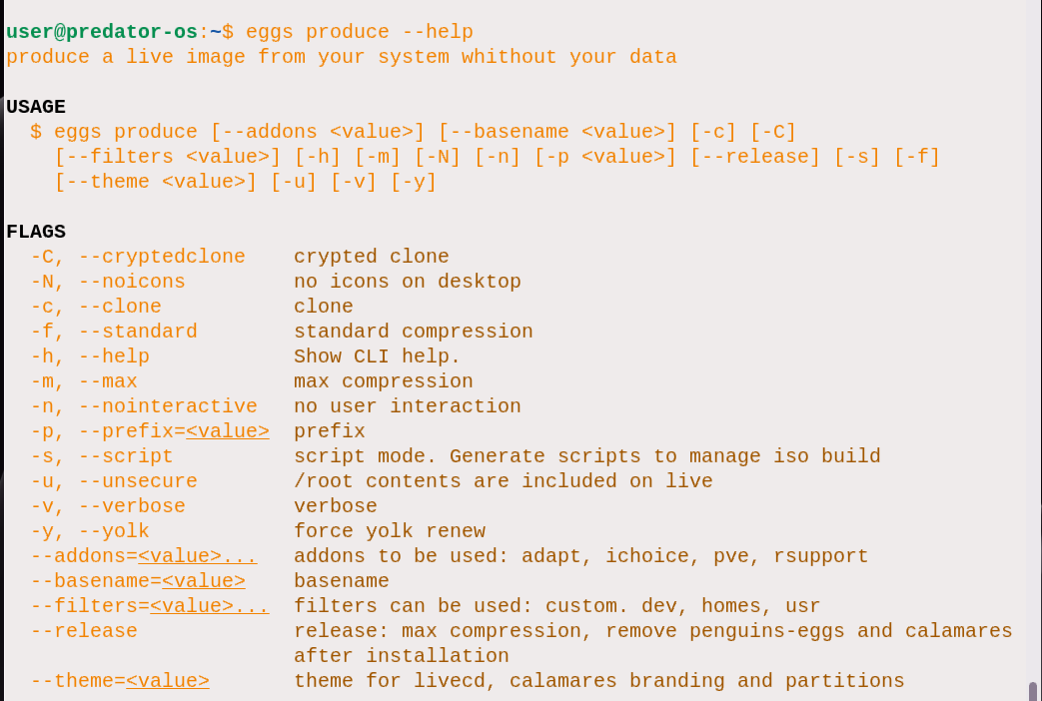

The eggs autocomplete [SHELL] command in the eggs package manager is used to display autocomplete installation instructions for a specific shell type**.** Here is the usage and options for the eggs autocomplete [SHELL] command:

**USAGE:**

$ sudo eggs autocomplete [SHELL] [-r]

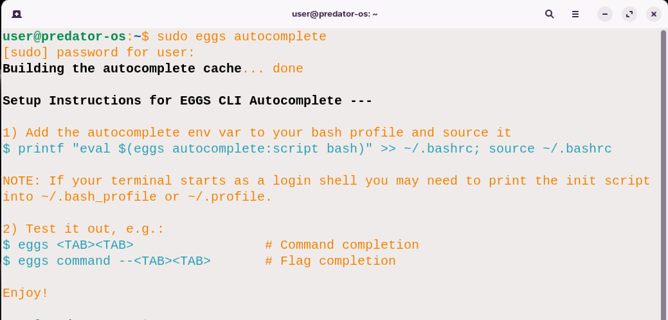

**ARGUMENTS:**

* SHELL: Specifies the shell type for which you want to display autocomplete installation instructions**.**

**FLAGS:**

* **-**r, **--**refresh**-**cache: Refreshes the cache and ignores displaying instructions**.**

**DESCRIPTION**: This command is used to display autocomplete installation instructions for the specified shell type**.**

**EXAMPLES:**:

To display autocomplete installation instructions for all available shell types:

$ sudo eggs autocomplete

To display autocomplete installation instructions for the bash shell:

$ sudo eggs autocomplete bash

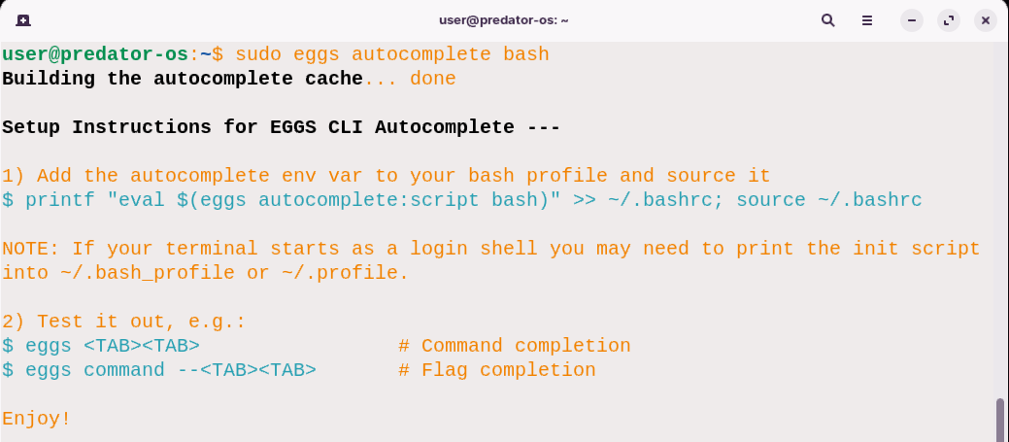

To display autocomplete installation instructions for the zsh shell:

$ sudo eggs autocomplete zsh

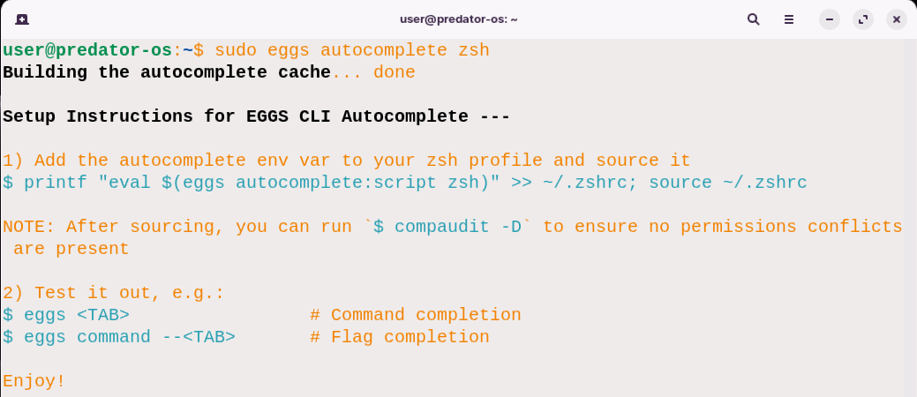

To refresh the cache and ignore displaying instructions:

$ sudo eggs autocomplete --refresh-cache

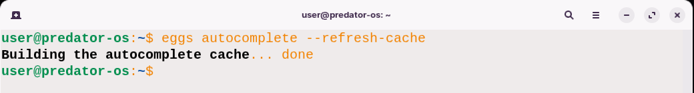

## Eggs adaptive resolutions

The eggs adapt command allows you to conveniently resize the video output to fit the size of a virtual machine window**.** This feature is particularly useful when working with virtual machines that have graphical interfaces other than cinnamon, gnome3, and KDE, as it provides a way to adjust the screen resolution accordingly**.** This functionality is not directly associated with ISO production but proves extremely handy when dealing with virtual machine environments**.**

**Usage:**

$ eggs adapt [-h] [-v]

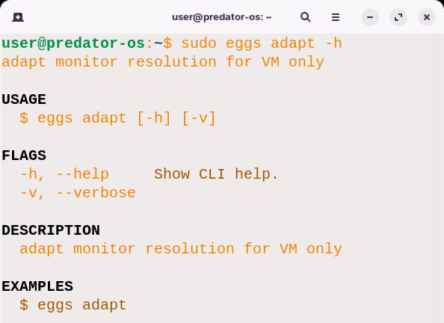

**Flags:**

* **-**h, **--**help: Displays the help documentation for the CLI**.**
* **-**v, **--**verbose: Enables verbose mode for more detailed output**.**

**Description:**

The eggs adapt command is specifically designed to adapt the monitor resolution for virtual machines**.** By invoking this command, the underlying mechanism **(**utilizing xrandr**)** adjusts the screen resolution to match the current settings of the virtual machine**.** This ensures that the video output is properly scaled and fits the dimensions of the virtual machine window**.** This feature is particularly useful when working with virtual machines that have different graphical interfaces, allowing for a seamless and optimized viewing experience**.**

**EXAMPLES::**

$ sudo eggs adapt

In this example, the eggs adapt command is executed without any additional flags or arguments**.** This triggers the process of adapting the monitor resolution for the virtual machine, ensuring that the video output is properly scaled and fits the size of the virtual machine window**.**

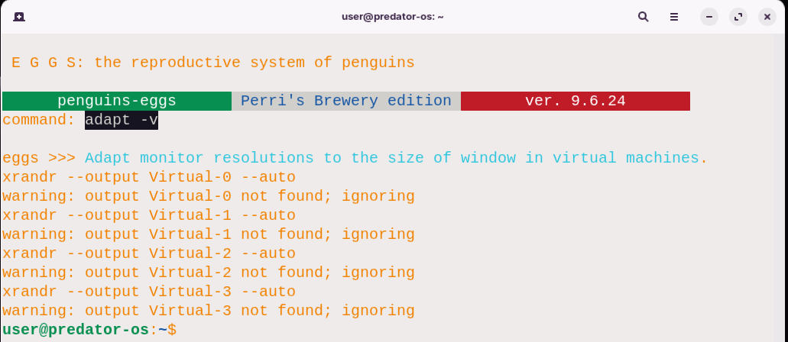

$ sudo xrandr --output Virtual-0 --auto'

The command `'xrandr **--**output Virtual**-**0 **--**auto'` is a command**-**line instruction that utilizes the `xrandr` tool to adjust the display output settings for a specific output named **“**Virtual**-**0**”.** Here's a breakdown of the command:

**-** `**xrandr**`: This is the command**-**line tool used for configuring the screen settings in X Window System**.**

**-** **`--output Virtual-0**`: This option specifies the output display that we want to modify, in this case, **“**Virtual**-**0**”.** It refers to a virtual display output within the virtual machine**.**

**-** **`--auto**`: This option tells `xrandr` to automatically detect and set the optimal resolution and refresh rate for the specified output**.**

By executing this command, `xrandr` will adjust the display settings for the **“**Virtual**-**0**”** output in the virtual machine, automatically determining the best resolution and refresh rate based on the capabilities of the virtual display**.**

The purpose of using this command in the provided code snippet is likely to ensure that the display output named **“**Virtual**-**0**”** in the virtual machine is set to the appropriate resolution and refresh rate, adapting it to the size of the window where the virtual machine is running**.**

## eggs analyze

Eggs will analyze your system, to get users and servers data**.**

The eggs analyze command is used to perform system analysis and gather data related to users and servers**.** Here's a description of the command and its options:

**Usage:**

$ sudo eggs analyze [-h] [-v]

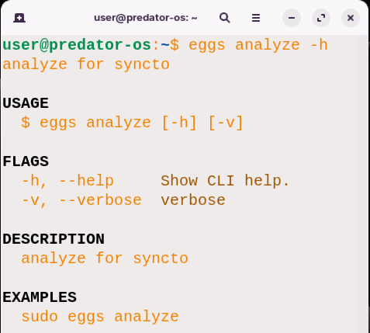

**Flags:**

* **-**h, **--**help: Displays the help documentation for the CLI**.**
* **-**v, **--**verbose: Enables verbose mode, providing more detailed output during the analysis process**.**

**Description**: The eggs analyze command is designed to conduct a comprehensive analysis of the system, specifically targeting user and server**-**related data**.** By executing this command, the program will gather relevant information and insights about the system's users and servers**.**

**EXAMPLES::**

$ sudo eggs analyze

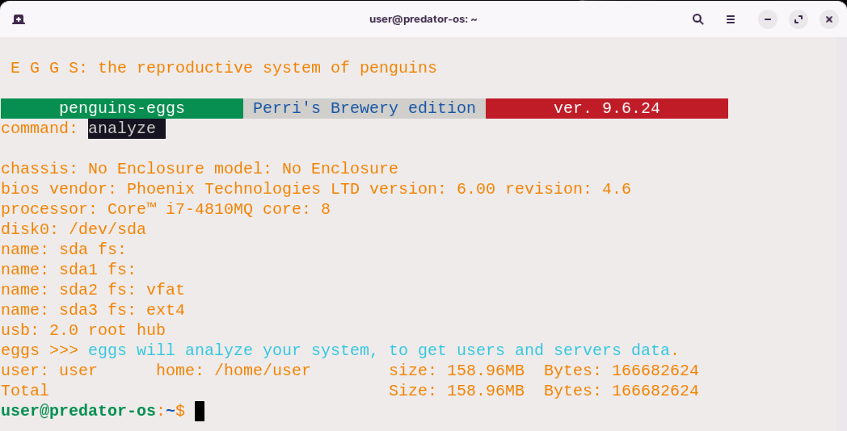

In this example, the sudo command is used to execute the eggs analyze command with administrative privileges**.** This allows the system analysis to access and collect data that may require elevated permissions**.**

Please note that the provided information is a combination of the original text and additional descriptions to enhance understanding**.**

## Eggs Config

DESCRIPTION: The eggs config command sets up and installs the necessary Debian packages needed to run the program**.** It ensures that all dependencies and prerequisites are properly configured**.**

**USAGE**:

$ eggs config [-c] [-h] [-n] [-v]

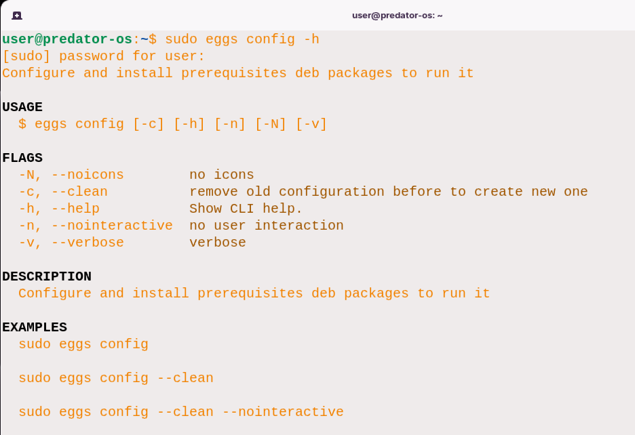

**FLAGS:**

* **-**c, **--**clean: Removes the previous configuration before creating a new one**.**
* **-**h, **--**help: Displays the command**-**line interface **(**CLI**)** help**.**
* **-**n, **--**nointeractive: Performs the configuration without requiring user interaction**.**
* **-**N, **--**noicons: Disables the display of icons**.**

**EXAMPLES::**

To configure and install the required Debian packages for the program with administrative privileges:

$ sudo eggs config

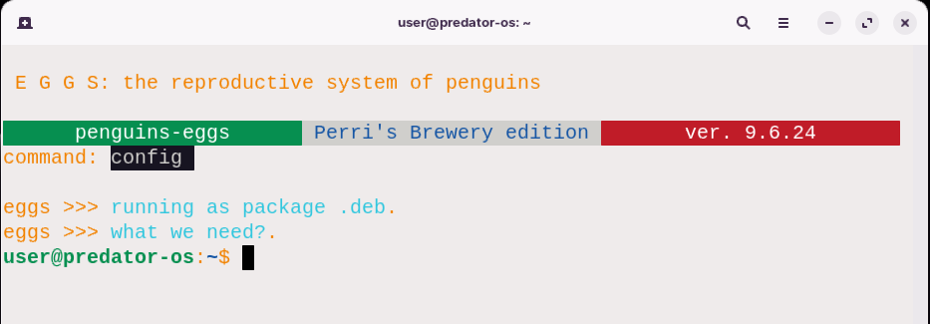

To remove the previous configuration before creating a new one, ensuring a fresh installation of the necessary packages:

sudo eggs config --clean

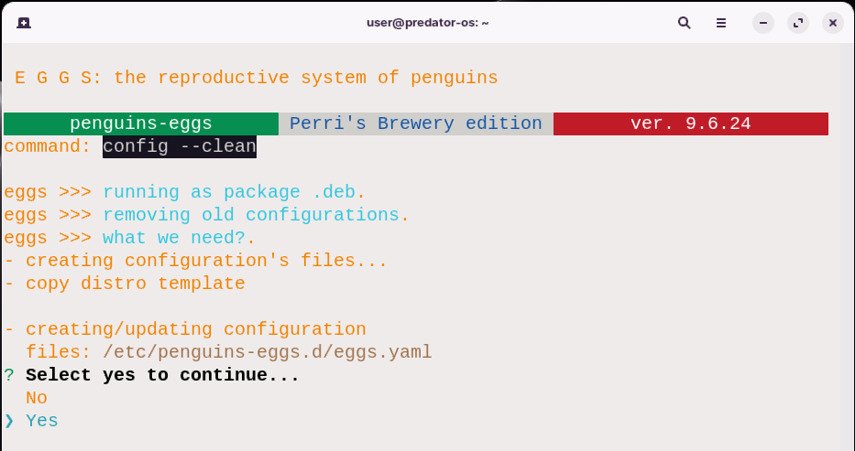

After choosing yes:

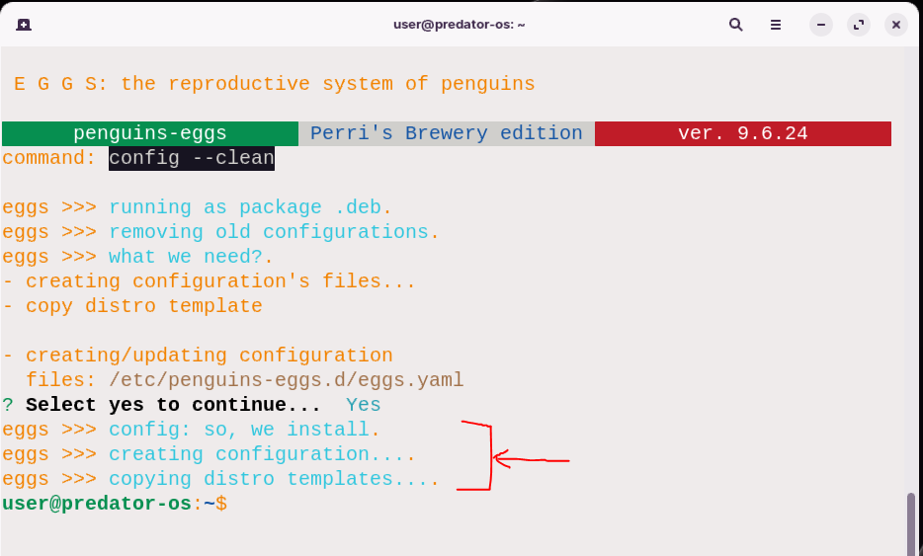

**You can use –v option to see more details:**

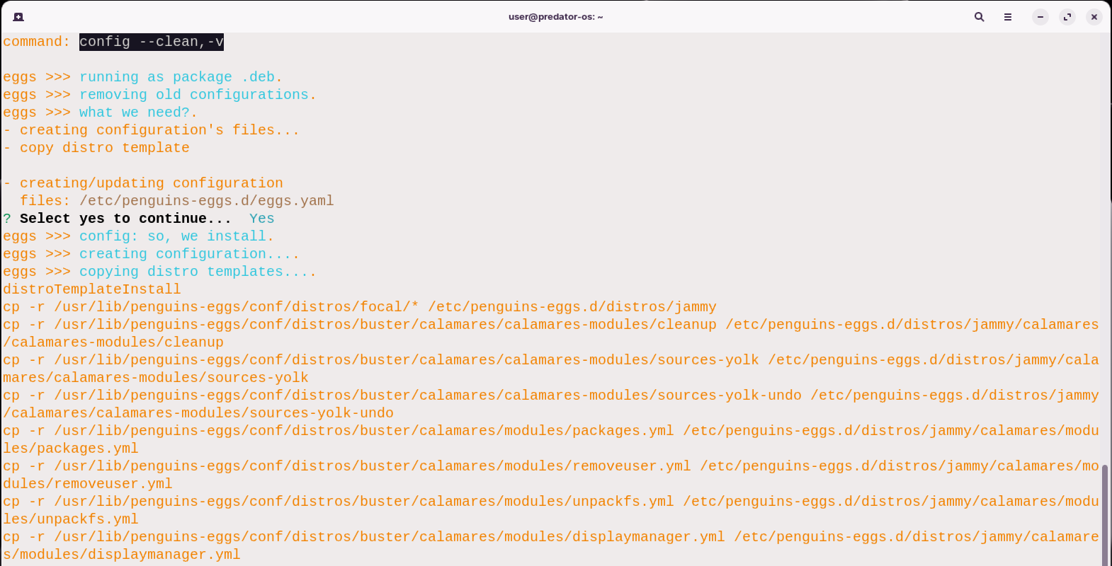

To remove the previous configuration and perform the setup process without requiring any user interaction:

sudo eggs config --clean --nointeractive

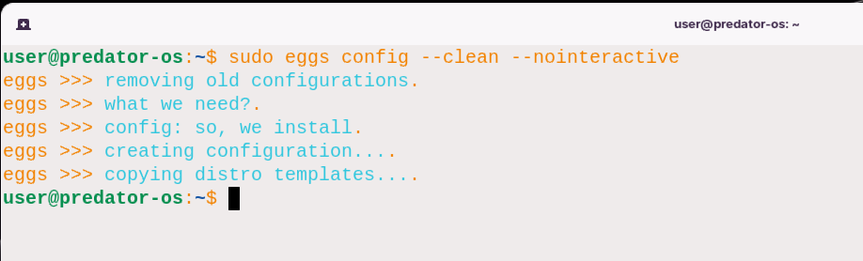

## eggs dad

The **“**eggs dad**”** command is a CLI **(**Command Line Interface**)** command that provides a TUI **(**Text User Interface**)** configuration helper**.** It allows you to interactively configure certain settings or options using a command line interface**.** Here is a breakdown of the different components of the command:

**Command:**

sudo eggs dad

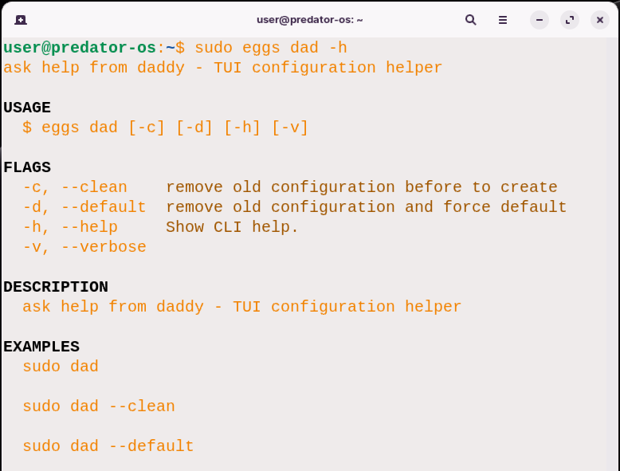

**Flags:**

* **-**c, **--**clean: This flag indicates that the old configuration should be removed before creating a new one**.**

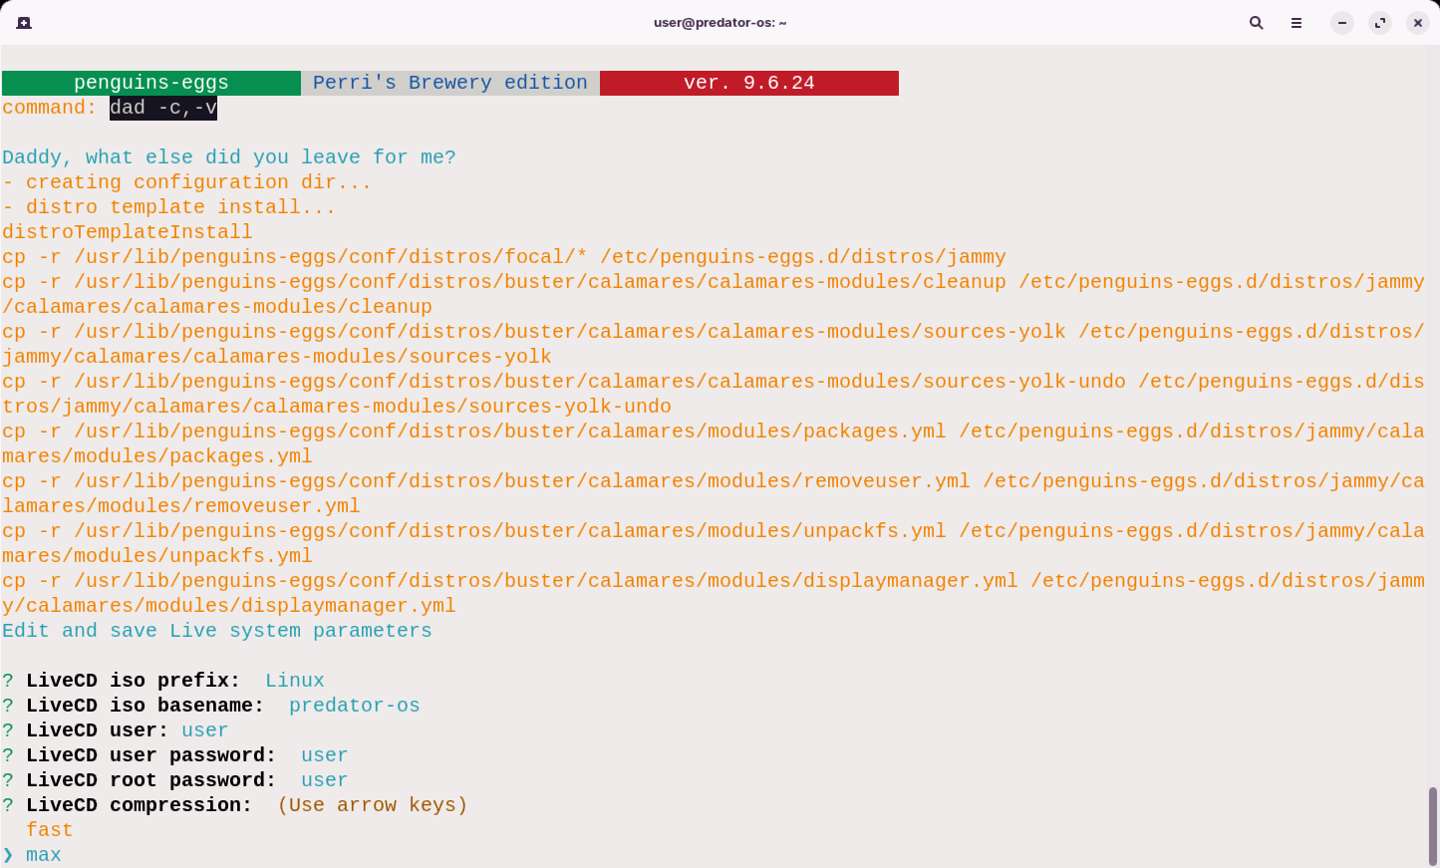

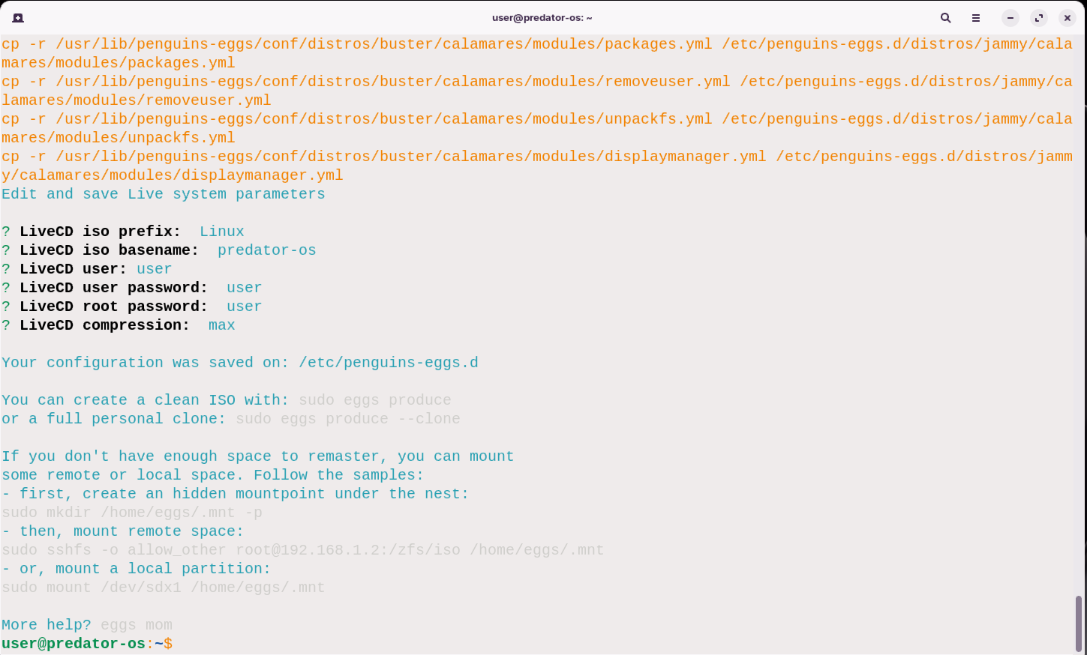

* **-**d, **--**default: This flag indicates that the old configuration should be removed and the default configuration should be applied**.**
* **-**h, **--**help: This flag displays the help information for the command**.**
* **-**v, **--**verbose: This flag enables verbose output, providing more detailed information during the configuration process**.**

Description: **”**ask help from daddy **-** TUI configuration helper**”**

This description suggests that the **“**eggs dad**”** command is a tool that assists in configuring settings or options, with the help of a TUI **(**Text User Interface**)** that guides the user through the configuration process**.**

**EXAMPLES:**:

sudo dad

This example runs the **“**dad**”** command with default settings**.**

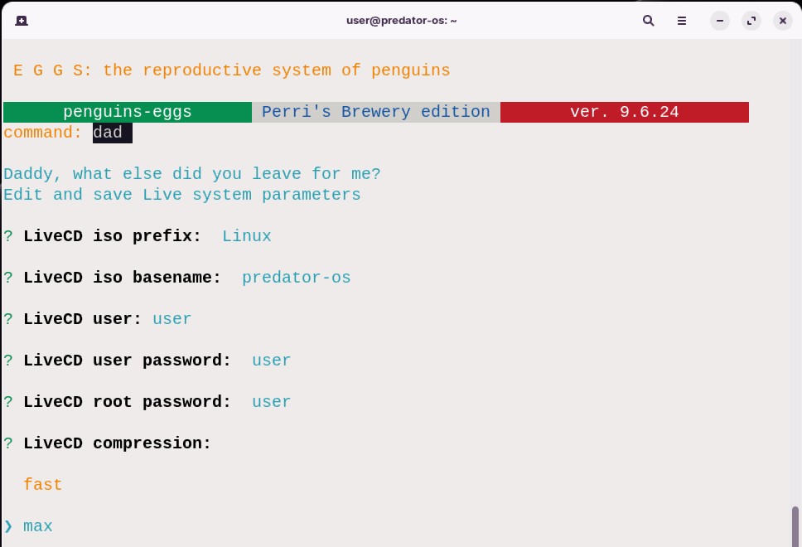

sudo dad –clean

This example runs the **“**dad**”** command and removes the old configuration before creating a new one**.**

sudo dad –default

This example runs the **“**dad**”** command and removes the old configuration, then applies the default configuration**.**

# Eggs Configuration

## Part2: configuration manually

During the installation of the eggs program, three different configuration files are automatically generated**.** These files can be found in the following directory**.** The eggs configuration file path is:

/etc/penguins-eggs.d

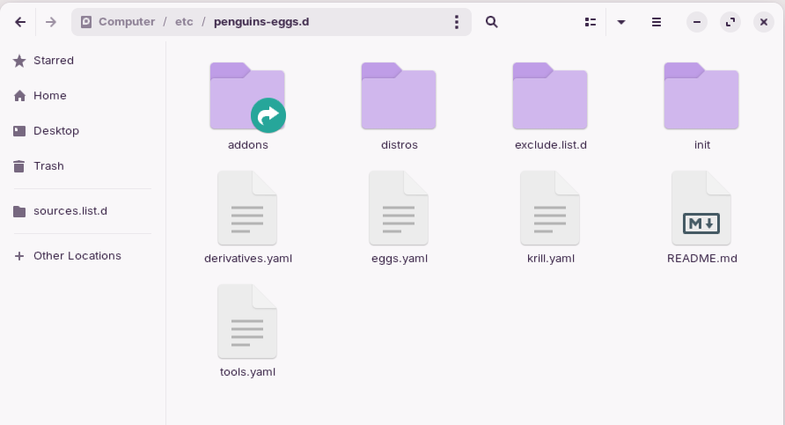

After installing eggs, the main configuration file can be found at the above**-**mentioned path**.** This file allows manual configuration of the eggs program**.**

The contents of the configuration **eggs.yaml** file are as follows:

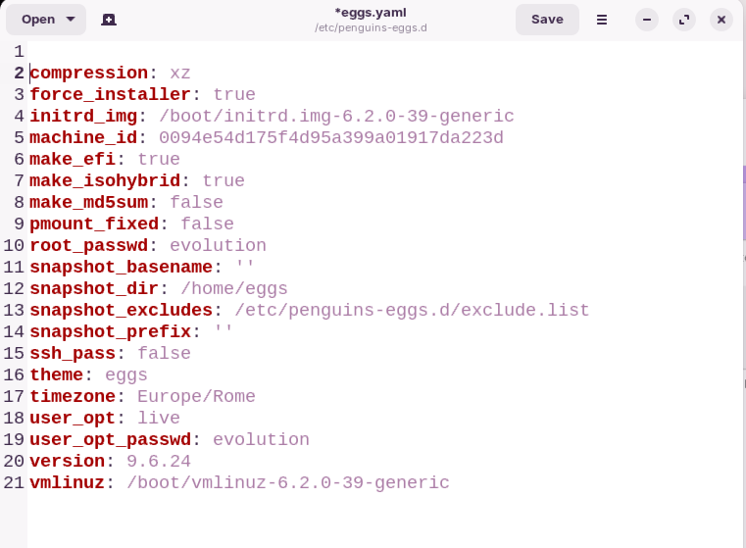

Now, let's provide some explanations for the lines in the configuration file:

By modifying these configuration options within the file, you can manually configure the eggs program according to your specific requirements**.** The provided text has been rewritten, and additional explanations have been included for each line to enhance understanding**.** Information from the web has been used to provide accurate descriptions of the purpose and functionalities of the configuration file**.** This configuration file will change with this command: we introduced this command before**.**

$sudo eggs config

## Krill config file

The krill config file described before**.** This is the entry of it:

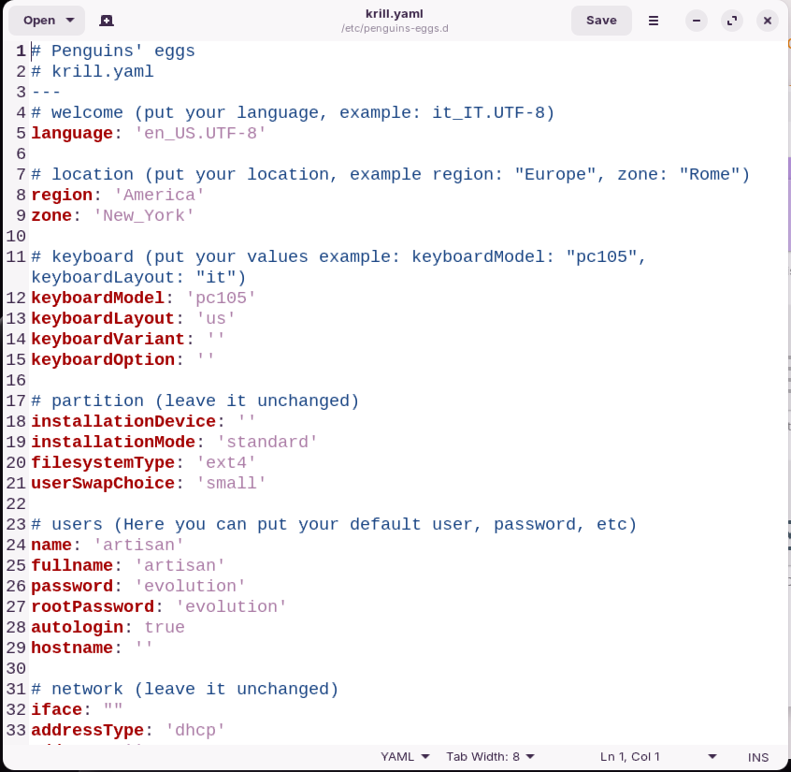

## Tools.yaml

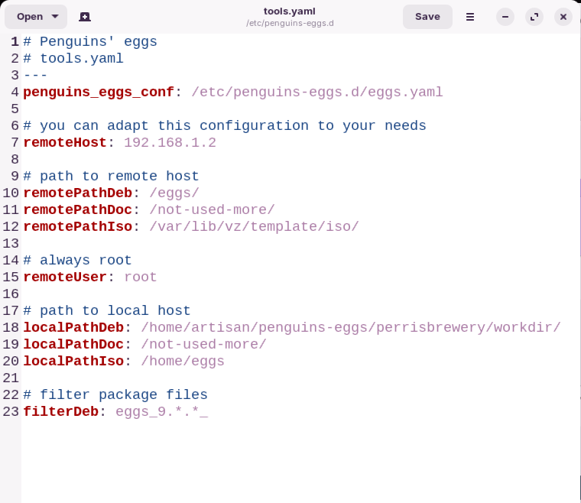

YAML is a human**-**readable data serialization format often used for configuration files**.** Based on the provided YAML content, it appears to be a configuration file for the Calamares installer, specifically for setting up the installation environment with certain parameters**.** Let's go through the different sections:

* language: Specifies the language to be used during the installation process**.** In this case, it's set to 'en_US**.**UTF**-**8', indicating American English**.**
* region and zone: Define the geographical region and time zone for the installation**.** Here, it's set to 'America' and 'New_York', respectively**.**
* keyboardModel, keyboardLayout, keyboardVariant, and keyboardOption: Specify keyboard**-**related settings**.** It seems to be set for a PC with a US keyboard layout**.**
* installationDevice, installationMode, and filesystemType: These settings are related to the installation process and file system type**.** They are left unchanged in the provided configuration**.**
* name, fullname, password, rootPassword, autologin, and hostname: These settings define the default user account, password, and system hostname**.** In this case, the default user is named 'artisan' with the password 'evolution', and autologin is enabled**.**
* iface, addressType, address, netmask, gateway, domain, and dns: These settings are related to network configuration**.** They are left unchanged in the provided configuration**.**

## Exclude.list files

We wrote about it in the previous chapter**.**

/etc/penguins-eggs.d/exclude.list.d/

Or

/etc/penguins-eggs.d/exclude.list

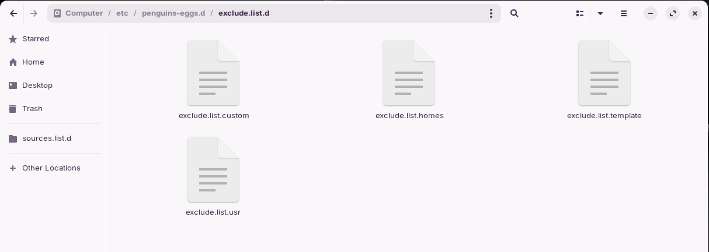

/etc/penguins-eggs.d/addons/

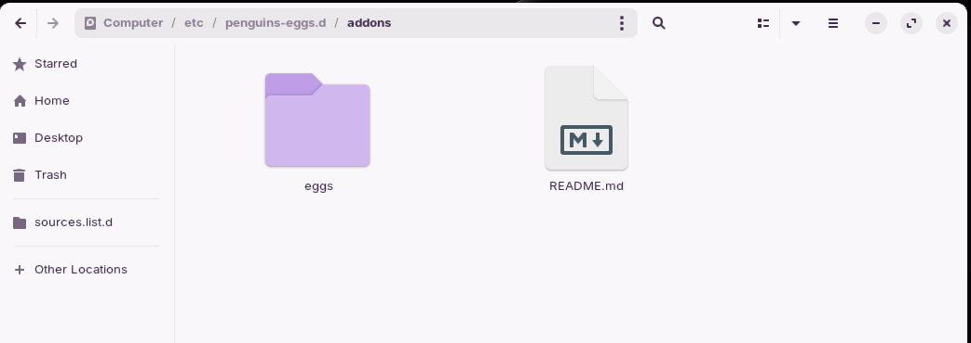

/etc/penguins-eggs.d/addons/eggs/

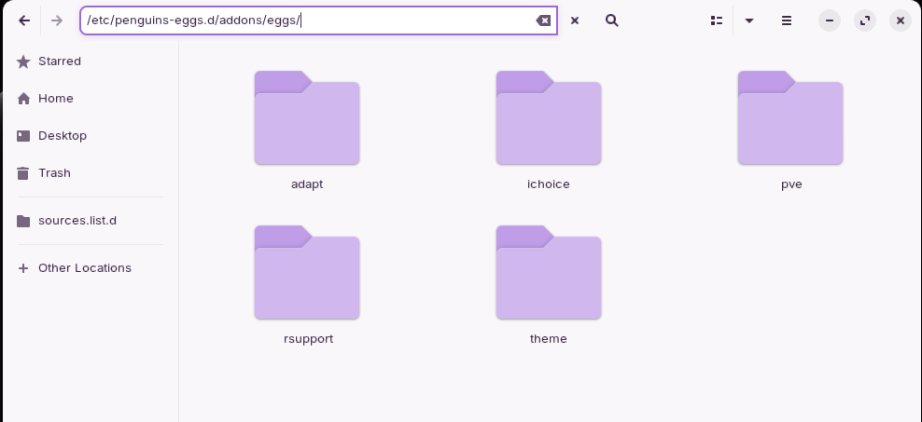

Adopt

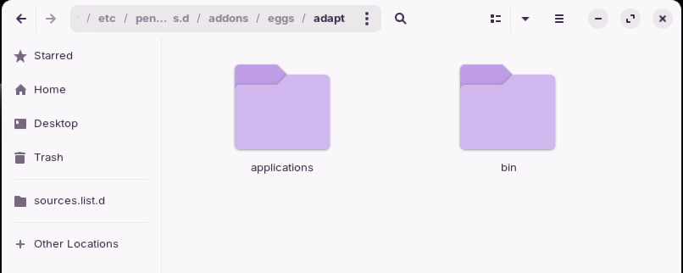

/etc/penguins-eggs.d/addons/eggs/theme/livecd/

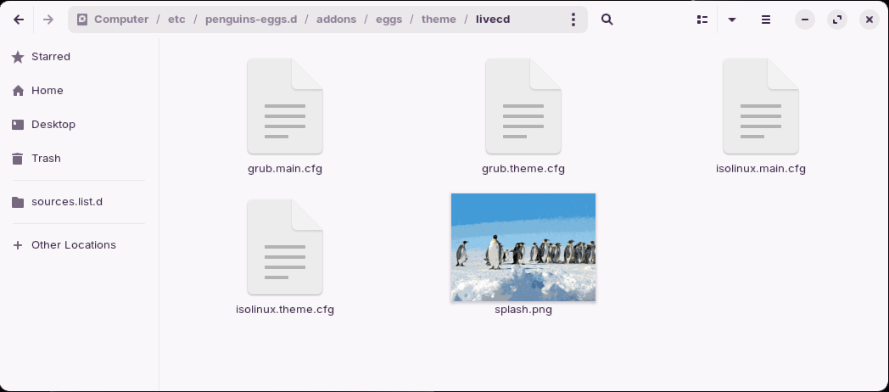

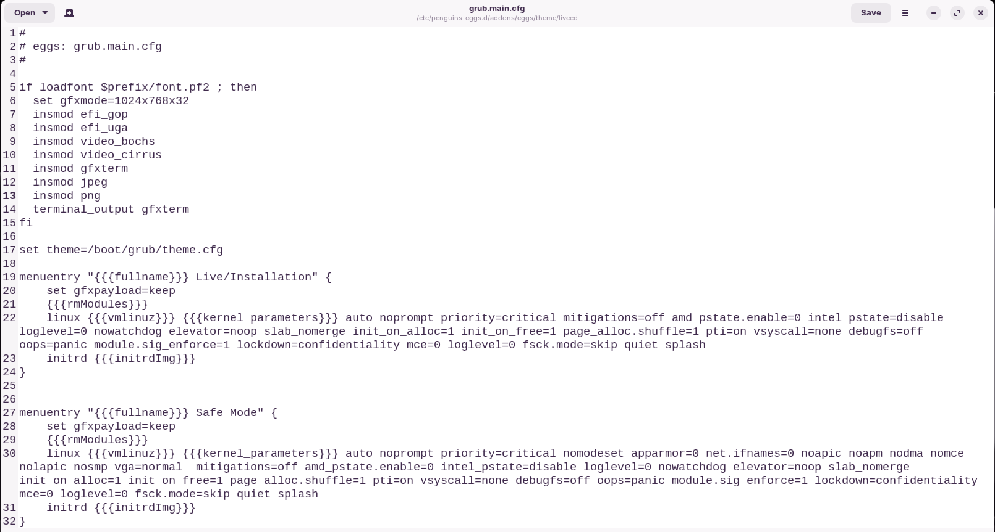

Grub.main.cfg

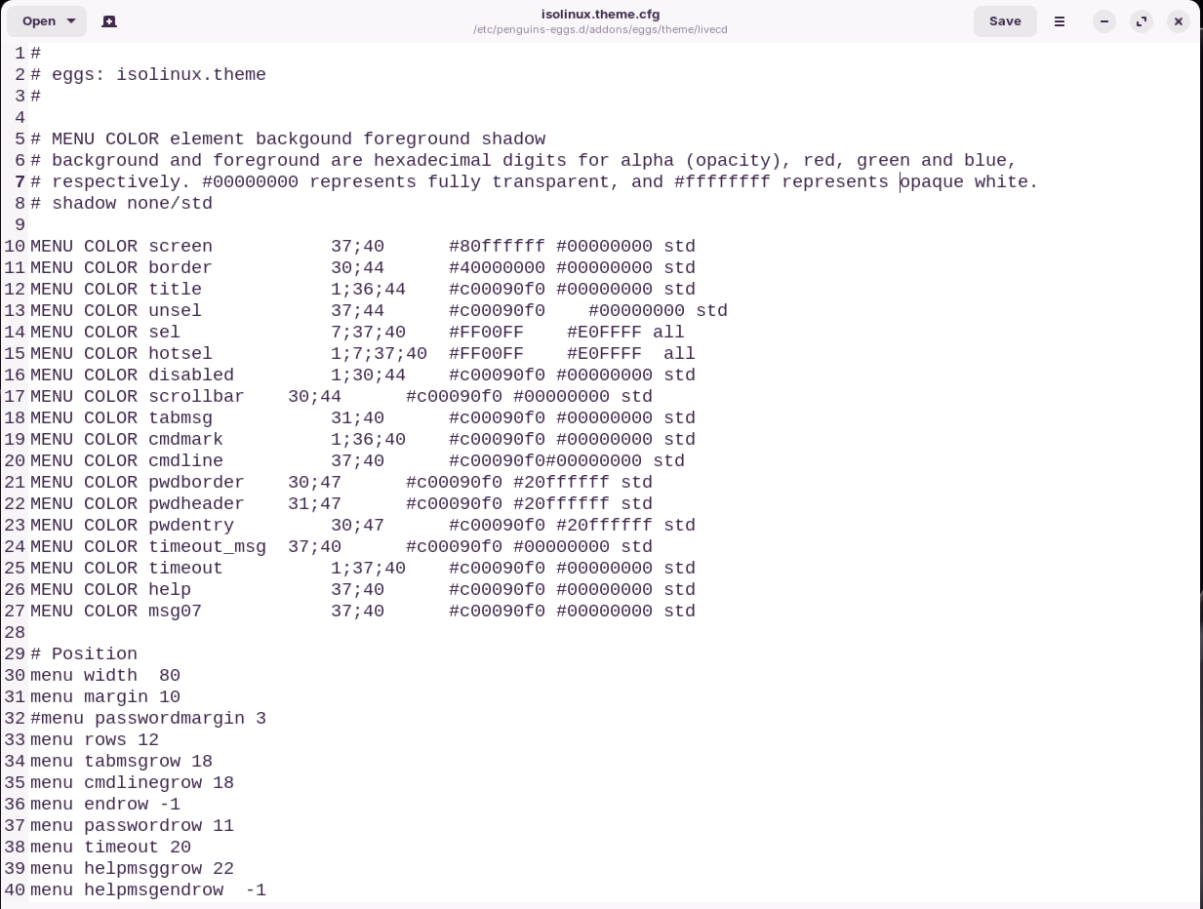

# Part3: Configuration status

## eggs status

The eggs status command provides information about the status of the **“**eggs**”** system**.** Here is some information about the command:

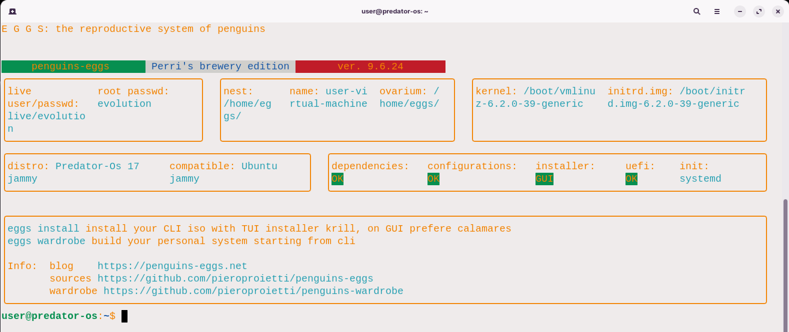

**USAGE**

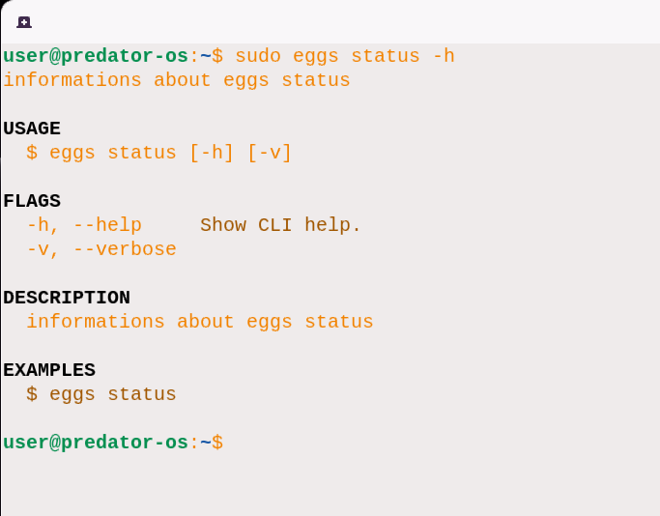

**FLAGS**

* **-**h, **--**help: Displays help information about the command**.**
* **-**v, **--**verbose: Provides more detailed and verbose output**.**

**DESCRIPTION** The eggs status command is used to retrieve information about the status of the **“**eggs**”** system**.** It can provide details about the current state of the system, including information about running processes, system health, resource usage, and more**.**

**EXAMPLES:** Here are some EXAMPLES: of how to use the eggs status command:

$ sudo eggs status

This command will display the status information of the **“**eggs**”** system**.** Please note that the specific output and available information may vary depending on the implementation of the **“**eggs**”** system and the version of the CLI tool you are using**.**

# Eggs Change log notes

## penguins-eggs-9.6.x

Since version 9.6.x Penguins' eggs is released - as Debian package - for: amd64, i386 and arm64 architectures, supporting the majority of PCs, old ones and single board systems like Raspberry Pi. Read more on the article [Triple somersault!](https://penguins-eggs.net/blog/triple-somersault)

https://penguins-eggs.net/blog/triple-somersault

## penguins-eggs-10.0.13

* dad: bugfix on flag --file;
* exclude.list.d: usr.list is now completely - intentionally - empty;
* produce: removed flag --sidecar, not necessary.

## penguins-eggs-10.0.11-2

The /usr/bin/penguins-links-add.sh script called by /etc/xdg/autostart/penguins-links-add.desktop now waits for the Desktop folder to be present before copying the links to the desktop, with the result that all links are shown correctly.

## penguins-eggs-10.0.11-1

* produce --excludes, now accept static, homes and home,
* sudo eggs --excludes static you can use a static exclude.list;
* sudo eggs --excludes homes you want to clean all users' homes;
* sudo eggs --excludes home don't save my home dir.

## penguins-eggs-10.0.10-1

* dad: added a new flag --file to have own configuration defaults.

Configuration defaults are passed with own YAML file, eg: custom.yaml

# custom.yaml

---

root_passwd: secret

snapshot_basename: columbus

snapshot_prefix: '' # none

user_opt_passwd: secret

user_opt: user

Usage:

sudo eggs dad --file ./custom.yaml

## penguins-eggs-10.0.9-1

krill: fixed a noising problem, when use resolvectl krill was not able to create to link /etc/resolv.conf to /run/systemd/resolve/resolv.conf, now I fixed this. I'm using krill sudo eggs install more than calamares due it's much fast and can be used with flags like --unattended, --nointeractive, etc.

## penguins-eggs-10.0.8-2

just a new pratical way to add/remove local repository yolk, during installation.

Yolk was created mostly to let installation without internet connection during the system installation. Before, I decided to remove all repos during installation with calamares/krill and use just /etc/apt/sources.list.d/yolk.list, now I changed this strategy: I just add /etc/apt/sources.list.d/yolk.list during installation process without remove the others repos. The result is a light slow initializations - when we are not on the net - but the possibility to add every packages during installation when we are connected.

## penguins-eggs-10.0.8-1

* removed the code that allowed genisoimage to be used instead of xorriso to generate the ISO;
* restored the operation of eggs produce --script for both: Debian and Ubuntu derivatives (for the moment it has been tested only on Debian bookworm and Linuxmint 21.3 Virginia;
* using eggs produce --script actually generated a link in /home/eggs to the ISO in .mnt;
* Warning: I checked eggs produce --script on ArchLinux too, but actually don't work.

## penguins-eggs-10.0.7-1

For the joy of all respin producer who don't like to have my eggs on the desktop, I changed a flag in sudo eggs produce.

I already add flag --noicons, equivalent to not create icons at all on the desktop: not eggs, not calamares, and so on, I think too much. So I update it to: sudo eggs produce --noicon in singular form, and remove just my eggs symbol and my blog link. For someone this can be important.

For others, don't take cure, always is better to have eggs on the fridge!

## penguins-eggs-10.0.6-3

Generate debian packages for all Debian/Devuan/Ubuntu distros plus a specific for Ubuntu bionic, from the same codebase. Thanks to mods in [perrisbrewery](https://github.com/pieroproietti/perrisbrewery).

Of course Arch and Manjaro are generated aside, thanks his [PKGBUILD](https://github.com/pieroproietti/eggs-pkgbuilds).

### Note about bionic version

To have bionic, and armonize with all the others version, I did:

* package.json: "engines": { "node": ">=16.0.0" },

Now we have two template for control file:

* perrisbrewery/template/dependencies.yaml;
* perrisbrewery/template/dependencies-bionic.yaml I removed line: live-config-systemd | live-config-sysinitv, added live -- live-boot, and put `nodejs (>= 16);
* live-boot package: on bionic - for same reason - when the system is installed, directory /lib/live/boot is erased. The system work, eggs work and can produce, but the resulting ISO will not boot! To solve this problem, before generate the ISO, give: sudo apt install live-boot --reinstall. This will restore /lib/live/boot and it's full contents.

## penguins-eggs-10.0.6-1

I received from Glenn Chugg same informations about fixes on README and on eggs skel command.

* README: added link to the important issue [#368](https://github.com/pieroproietti/penguins-eggs/issues/368) regarding nodejs 18, fixes on the text;
* skel: cinnamon desktop. not more copy./conf/cinnamon in /etc/skel.

## penguins-eggs-10.0.5-2

* produce: default compression is now zstd 1M Xcompression-level 3, fast the same and better in decompression;
* produce: added flag --pendrive, using zstd 1M Xcompression-level 15 optimized to use with pendrives.

## penguins-eggs-10.0.4

* calamares: calamares now receive branding's configuration parameters homeUrl, supportUrl and bugReportUrl from /etc/os-release;
* node-proxy-dhcpd: I am trying to restore the operation of eggs cuckoo. I have not succeeded yet, you can refer to the related [issue](https://github.com/pieroproietti/penguins-eggs/issues/367).

## penguins-eggs-10.0.3

* krill installaler: sudo eggs install now have a new option to chroot on the installed system before reboot. This let you di add/remove last time packages, before your system is rebooted;
* again in krill: krill now respect the calamares module: packages.conf or it's own, packages are added/removed after it's configuration. This born becouse of Devuan daedalus amd64 version, I noted it go in kernel panic after installation, if penguins-eggs and it's dependecies are not removed. The problem arise - probably - from the package live-config-sysvinit. I solved using the option --release in command produce, to configurate calamares/krill to remove penguins-eggs, calamares and it's dependencies before to finish the installation process;
* Other little fixes on wardrobe.

## penguins-eggs-10.0.2

A whole series of tweaks to make the Debian package more standard, a pity not to have been able to generate a single package -any for all architectures.

## penguins-eggs-10.0.0

There would be many ways to change the version number and emphasize an important fact in the code. I don't pretend to be right, but having spent a full morning reintroducing new headers on the sources and, a few days switching from commonjs modules to a more modern node16 to support both CommonJS and ECMAScript modules, I decided this way. Don't hold it against me... :-)

In this version all dependencies have finally been updated. from [oclif](https://oclif.io/), [ink](https://github.com/vadimdemedes/ink), etc.

Another new feature, for those who want to try their hand at penguins-eggs development: you can create your penguins-eggs deb packages with these simple commands, of course after installing nodejs and pnpm.

To make your life easier and save yourself from installation of nodejs and pnpm, you can use any recent version of my live [colibri ISO](https://sourceforge.net/projects/penguins-eggs/files/ISOS/debian/bookworm/amd64/).

* git clone https://github.com/pieroproietti/penguins-eggs
* cd penguins-eggs
* pnpm i
* pnpm deb

In short, what I am about to tell you is that it is a good time to get on board!

## penguins-eggs-9.8.3

I consider the cleanup and adjustments resulting from the switch to oclif4 and Debian package name change to be over. I put the new version in the PPA and you can install it with the command: sudo apt install penguins-eggs.

## penguins-eggs-9.8.2

Removed a lot of unusefull code, when eggs started I thought to use npm packages to distribuite it, so inside there was the code to install necessary packages. From long time now, we produce deb packages and arch packages so there was no need ot that code. I tested it working on i386 Debian Bookworm, amd64 Debian Bookworm, Arch.

## penguins-eggs-9.8.1

Released for i386, arm64 and amd64. Checked on i386 Debian Bookworm, amd64 Debian Bookworm, Arch.

## penguins-eggs-9.8.0

It had been a long time since I was forced to use an outdated version of [oclif](https://oclif.io/) because I had modified it to be able to use [pnpm](https://pnpm.io/it/) instead of [npm](https://github.com/pieroproietti/penguins-eggs/blob/master). Recently, I think in March, with version 4 of oclif it is possible to use oclif with pnpm and I could then try to upgrade the package. The next step was to put the pieces back together. I do in fact use - in addition to oclif - another mine Debian package building tool called [perrisbrewery](https://github.com/pieroproietti/perrisbrewery) and, of course, I had to update/modify that as well.

Basically this version is different, although on the surface it does not seem too distant to the previous one.

For that reason I decided to highlight the change by changing in addition to the release also the name of the package itself, no longer eggs but penguins-eggs. Commands and logic remain the same.



# Chapter 8

# Producing ISO image file

Producing a live image from a system without including any personal data**.** If you **are** referring to creating a live image of an operating system **(**such as a live Linux distribution**)**, this generally does not include personal data unless specifically configured to do so**.** Live images typically run from a read**-**only medium like a CD, DVD, or USB drive and don**’**t modify the host system unless explicitly instructed to do so**.** However, ensuring that personal data is not captured or transmitted is a matter of configuring the live image and the software it runs to avoid such behavior**.** If you have specific concerns about privacy and data security, it **is** important to carefully review the settings and documentation of the live image you**’**re using**.**

**“**Producing a live image from your system without your data**”** typically refers to creating a bootable image of an operating system that can be run directly from a USB drive, DVD, or other media without making any changes to the existing system or accessing the user's personal data**.** In this context, a live image is a snapshot or representation of an operating system that includes all the necessary files and configurations to run the system on a different computer**.** It allows users to experience and test an operating system without installing it on their own machines**.**

When creating a live image, the goal is to capture the entire operating system setup, including the necessary system files, applications, and configurations, while excluding any personal data or user**-**specific information**.** This ensures that the live image can be used safely and doesn't expose any sensitive or private information**.** The process of producing a live image typically involves using specialized software or tools that can create an image file from an existing system, compressing it, and making it bootable on different hardware**.** This allows users to boot into the live image on another computer and experience the operating system without affecting the host system or leaving any traces of personal data**.** Live images are commonly used for various purposes, such as testing new operating systems, providing a portable environment for troubleshooting or system recovery, or distributing pre**-**configured systems for educational or demonstration purposes**.**

# Step 1: cleaning the system

## Cleaning with eggs

The **eggs tools clean** command is used to clean various system logs and apt**-**related files**.** Here is the breakdown of its usage:

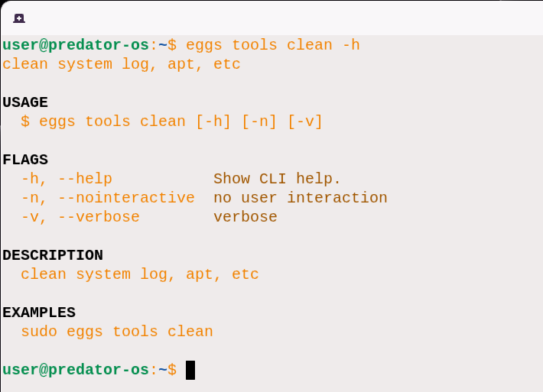

In the EXAMPLES: section, you can find one usage example:

## sudo eggs tools clean -v

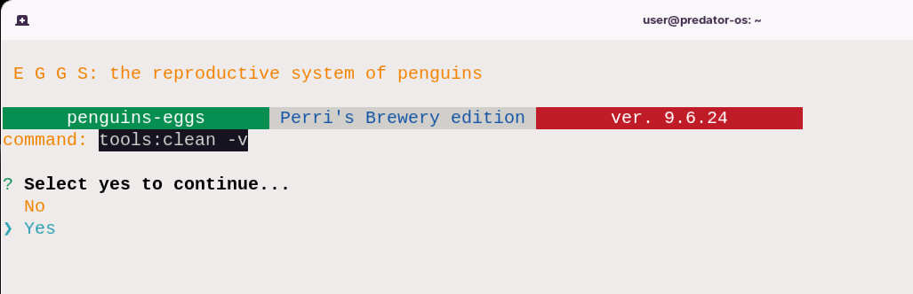

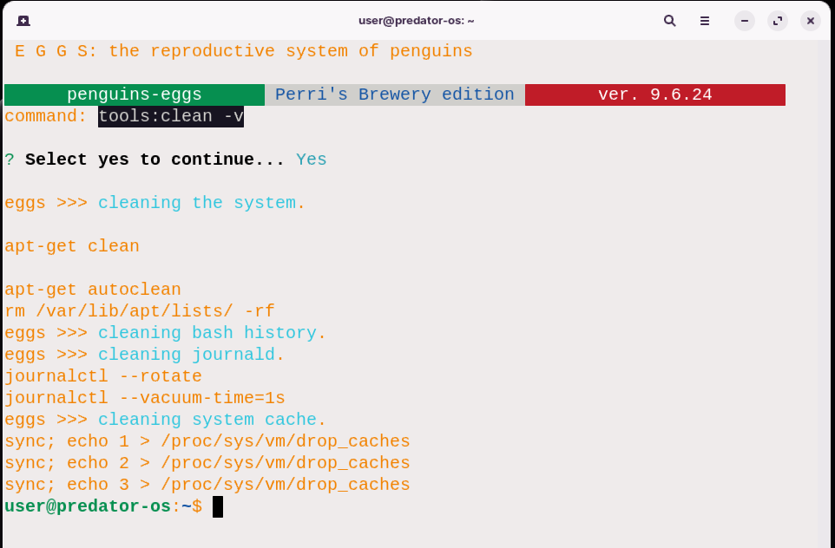

This command performs the cleanup process, which includes cleaning system logs, apt**-**related files, and other relevant items**.** It is recommended to run this command with administrative privileges **(**using sudo**)** to ensure proper access and permissions**.** Please note that the cleanup process may permanently delete some files or modify system configurations**.** Exercise caution when using this command, and ensure that you have a backup of any important data**.**

Here is a more detailed description of each flag used in the eggs tools clean command:

* **-**h, **--**help: This flag displays the help message for the eggs tools clean command**.** It provides information about the command's usage, flags, and EXAMPLES:**.**
* **-**n, **--**nointeractive: This flag allows the cleanup process to be performed without any user interaction**.** When this flag is used, the command will not prompt for any confirmation or additional input**.** It can be useful when you want to automate the cleanup process**.**
* **-**v, **--**verbose: This flag enables verbose output, providing more detailed information during the execution of the eggs tools clean command**.** It can be helpful for understanding the progress and actions taken during the cleanup process**.**

## Cleaning with bleachbit

BleachBit is a popular open**-**source system cleaning and privacy tool for Linux operating systems**.** It helps you free up disk space, protect your privacy, and improve system performance by removing unnecessary files and data**.**

Here are some key features of BleachBit:

1. Disk Cleanup: BleachBit can scan and clean up various system and application files, such as temporary files, cache files, log files, and other unnecessary data that can accumulate over time**.**
2. Privacy Protection: BleachBit can help protect your privacy by securely deleting sensitive files, such as browser history, cookies, and temporary internet files**.** It can also clear the usage history of many applications, including web browsers, instant messengers, and more**.**
3. Freeing Disk Space: By removing unnecessary files, BleachBit can free up valuable disk space on your Linux system**.** This can help improve system performance and make more room for important files and applications**.**
4. Customizable Cleaning: BleachBit allows you to customize the cleaning process by selecting specific categories or types of files to clean**.** You can also exclude certain files or folders from being cleaned if desired**.**
5. Shredding Files: In addition to regular file deletion, BleachBit offers secure file shredding options**.** This ensures that deleted files cannot be recovered using data recovery tools**.**
6. Command**-**Line Interface: BleachBit provides a command**-**line interface for advanced users who prefer to automate or script cleaning operations**.**

Run bleachbit with:

$ sudo bleachbit

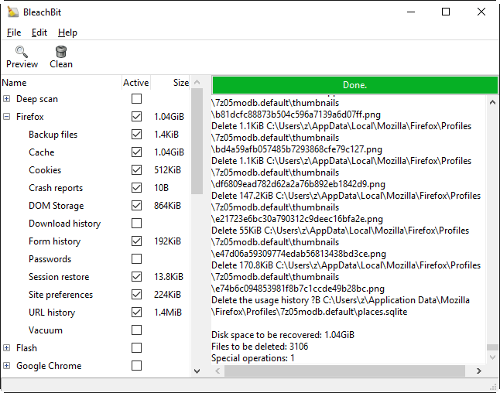

To obtain the latest version of BleachBit, you can download the appropriate package for your Linux distribution from the official BleachBit website**.** Here are the steps to select the correct package:

1. Visit the BleachBit website at [https:**//**www**.**bleachbit**.**org**/**](https://www.bleachbit.org/)**.**
2. Navigate to the **“**Download**”** section of the website**.**
3. Look for the available package options, which are typically provided in **.**deb format for Debian**-**based distributions and **.**rpm format for RPM**-**based distributions**.**
4. Identify your Linux distribution and select the corresponding package**.** For example, if you are using Ubuntu or a Debian**-**based distribution, select the **.**deb package**.** If you are using Fedora or a Red Hat**-**based distribution, select the **.**rpm package**.**
5. Click on the download link for the selected package to begin downloading it to your system**.**
6. Once the package is downloaded, you can install it using the appropriate package manager for your distribution**.** For example, on Debian**-**based systems, you can use the dpkg command to install the **.**deb package, and on RPM**-**based systems, you can use the rpm or dnf command to install the **.**rpm package**.**

BleachBit is indeed a feature**-**rich software designed to help you clean your computer, free up space, and maintain your privacy**.** Here's a breakdown of its key features and uses:

Privacy and File Deletion:

* BleachBit offers secure file deletion, ensuring that deleted files cannot be recovered**.** It is designed to delete files so completely that even data recovery tools cannot retrieve them**.**
* You can easily select the files you want to delete by checking the appropriate boxes and preview the changes before permanently deleting them**.**

Cross-Platform Compatibility:

* BleachBit is available for both Linux and Windows operating systems, allowing users of different platforms to benefit from its features**.**

Open Source and Free:

* BleachBit is free of charge and does not have any hidden costs or money trails**.** It is an open**-**source software, which means it can be shared, learned, and modified by users**.**

No Adware or Malware:

* BleachBit is free from adware, spyware, malware, backdoors, browser toolbars, or any **“**value**-**added software**”** that may compromise your system's security**.**

Multi-Language Support:

* It is translated into 65 languages, making it accessible to users worldwide**.**

Shredding and Overwriting:

* BleachBit includes features to shred files, hiding their contents and preventing data recovery**.**
* It can also overwrite free disk space, ensuring that previously deleted files cannot be restored**.**

Portable and Command-Line Support:

* The Windows version of BleachBit can be run without installation, making it portable and convenient**.**
* It also provides a command**-**line interface, allowing advanced users to automate cleaning operations through scripting**.**

Customization and Updates:

* BleachBit allows users to write their own cleaners using CleanerML, an XML**-**based markup language**.**
* It automatically imports and updates winapp2**.**ini cleaner files, providing access to over 2500 additional cleaners for Windows users**.**
* BleachBit frequently releases software updates with new features and improvements**.**

Cleaners:

* BleachBit includes a range of cleaners for popular applications like Google Chrome, Edge, Firefox, VLC, Acrobat Reader, and system logs and temporary files**.**
* It also provides advanced cleaners for specific tasks, such as clearing memory and swap on Linux, deleting broken shortcuts, cleaning APT for Debian**-**based distributions, and more**.**

Overall, BleachBit offers a comprehensive set of features to help you free up disk space, maintain your privacy, improve system performance, and prepare disk images for compression**.** Its customizable nature, frequent updates, and extensive range of cleaners make it a versatile tool for both Linux and Windows users**.**

## Bleachbit help

To see the help of cli commands of bleachbit instead of GUI ,Type :

sudo bleachbit -h

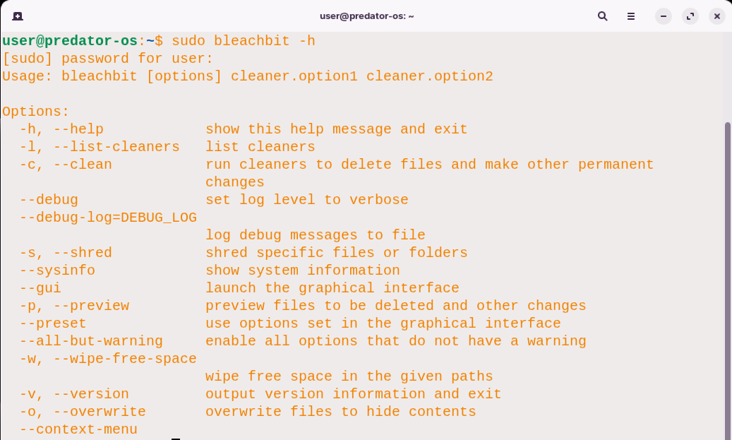

Launch BleachBit: Once BleachBit is installed, you can launch it in either command line or graphical mode**.**

1.Command Line Mode: Open a terminal and run the bleachbit command followed by any desired options or arguments**.** For example, to clean the system, you can use the following command:

First: type the following command to list and then clean**.**

Sudo bleachbit –l

For example:

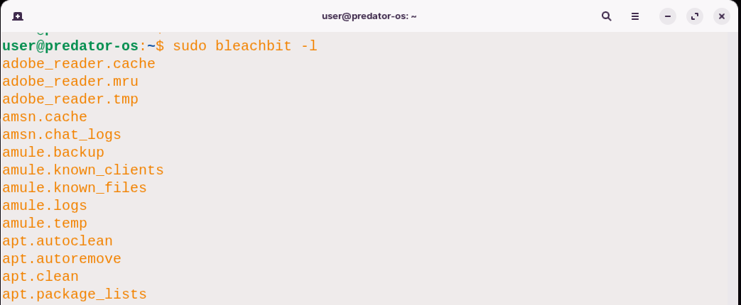

bleachbit –clean apt.clean

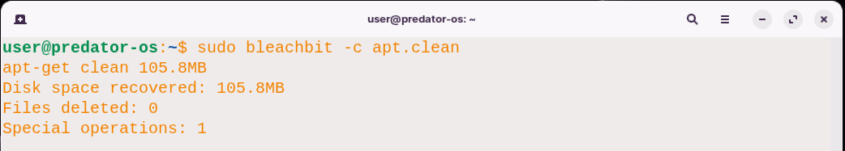

2.Graphical Mode: If you prefer a graphical interface, simply search for **“**BleachBit**”** in your application launcher or menu**.** Click on the BleachBit icon to launch the graphical interface, where you can select the cleaning options and perform the cleanup**.**

$ sudo bleachbit

Or

$ sudo bleachbit --gui

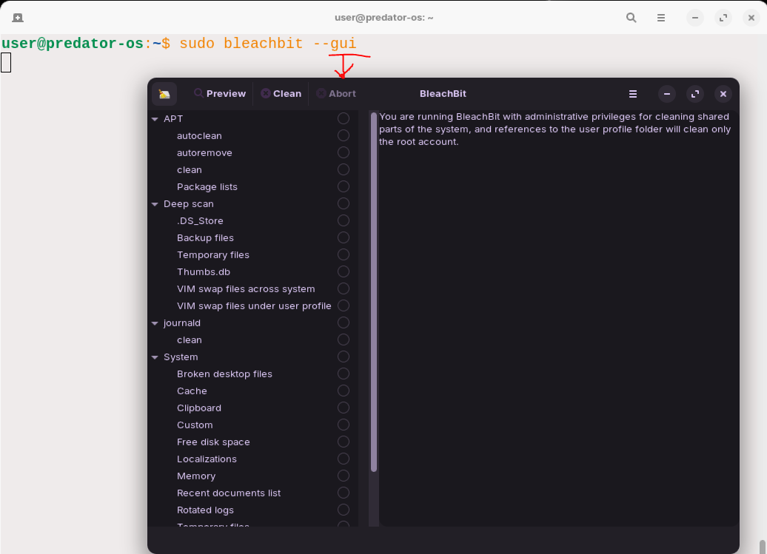

1. Select Cleaning Options: In the BleachBit interface, you'll find a list of cleaning options for various categories such as system, web browsers, applications, and more**.** Check the boxes next to the items you want to clean**.**
2. Start Cleaning: Once you have selected the desired cleaning options, click on the **“**Delete**”** or **“**Clean**”** button to start the cleaning process**.** BleachBit will perform the selected cleanup actions, deleting unnecessary files and freeing up disk space**.**

# Step2: show the status

eggs status

The eggs status command provides information about the status of eggs before creating an iso file**.** Here is the usage and EXAMPLES: for this command:

**USAGE**

$ eggs status [-h] [-v]

**FLAGS**

-h, --help Show CLI help.

-v, --verbose Enable verbose output.

**DESCRIPTION**

Get information about the status of eggs**.**

**EXAMPLES:**

$ eggs status

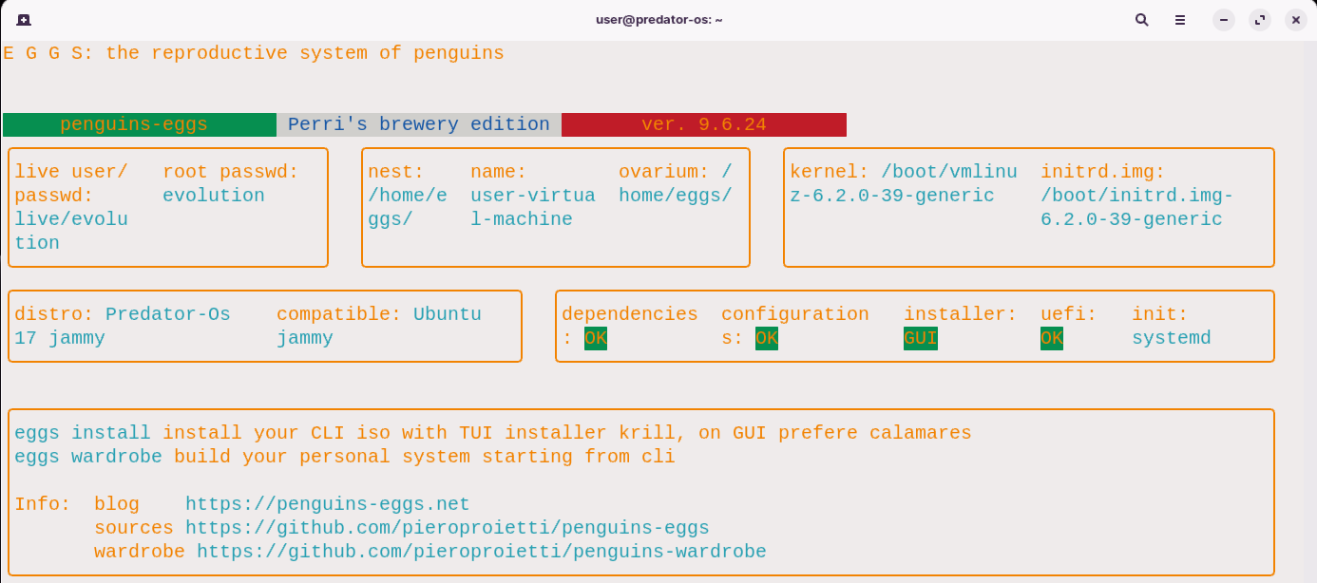

In the EXAMPLES: section, you can use the eggs status command as shown to retrieve information about the eggs' status**.** This command does not require any additional options or arguments**.** Feel free to ask if you have any specific questions or need further assistance with the eggs status command!

# Step3: preparing the skel folder

## eggs tools skel

The eggs tools skel command is used to update the skeleton directory **(/**etc**/**skel**)** on a Linux system with the configuration files from a user's home directory**.** The **/**etc**/**skel directory is a special directory on Linux systems that serves as a template for new user accounts**.** When a new user account is created, the contents of the **/**etc**/**skel directory are copied into the user's home directory**.** This allows the new user to have a pre**-**configured set of files and directories**.**

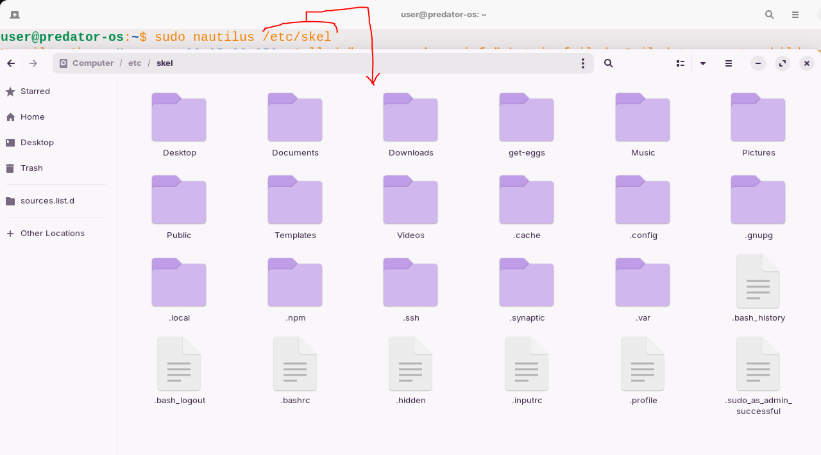

Here are some key points about the **/**etc**/**skel directory:

1. Purpose: The primary purpose of the **/**etc**/**skel directory is to provide default configuration files and directories for new user accounts**.** It ensures that every new user starts with a basic set of files and directories that are commonly needed or desirable**.**
2. Contents: The **/**etc**/**skel directory typically contains a set of default files and directories that are copied into the user's home directory during account creation**.** This can include configuration files for various applications, default shell profiles **(**such as **.**bashrc or **.**zshrc**)**, example documents, and directories for organizing files**.**
3. System**-**wide Changes: Modifying the contents of the **/**etc**/**skel directory can have system**-**wide implications**.** Any changes made to this directory will be reflected in the home directories of all new user accounts created on the system**.**
4. Customization: System administrators can customize the **/**etc**/**skel directory to suit their needs**.** By adding or modifying files and directories in this directory, they can establish a consistent environment for new users**.** This can include pre**-**configured settings, default document templates, or specific directory structures**.**
5. User Modifications: It's important to note that the contents of the **/**etc**/**skel directory only serve as initial defaults for new user accounts**.** Once a user account is created, the user has full control over their own home directory and can modify or remove the files and directories provided by **/**etc**/**skel**.**
6. Security Considerations: When customizing the **/**etc**/**skel directory, it's essential to ensure that sensitive information or potentially harmful files are not included**.** The directory should only contain files and directories that are safe and appropriate for all new users**.**

In summary, the **/**etc**/**skel directory acts as a template for new user accounts on Linux systems**.** It provides default files and directories that are copied into the user's home directory during account creation**.** By customizing the contents of **/**etc**/**skel, system administrators can establish a consistent environment for new users**.**

Here is a breakdown of its usage:

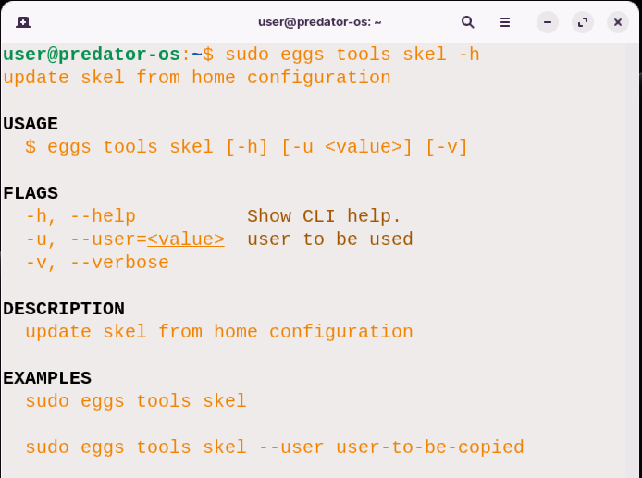

The command has the following EXAMPLES::

sudo eggs tools skel

and this will be the result:

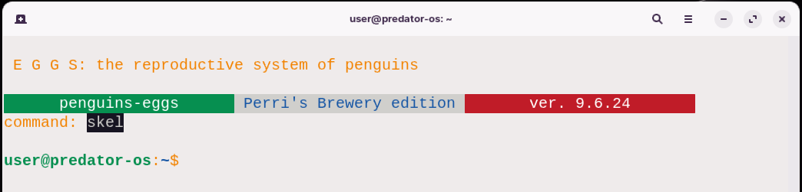

Final:

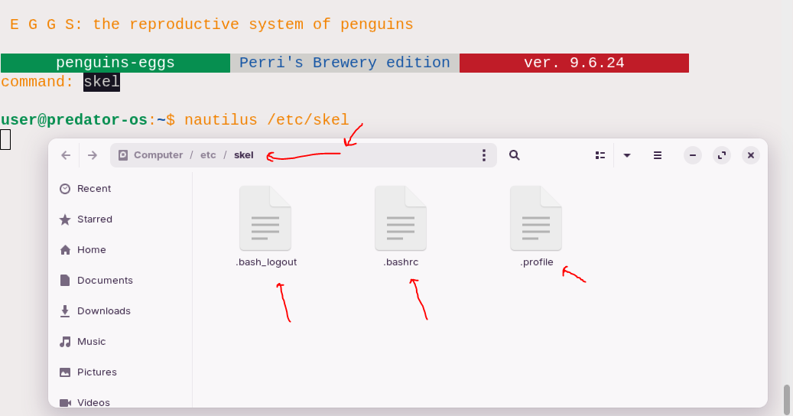

you can manually add additional files to the **/**etc**/**skel directory by using the cp command**.** The **/**etc**/**skel directory serves as a template directory for creating new user home directories**.** When a new user is created, the contents of the **/**etc**/**skel directory are copied to the user's home directory**.**

To add files manually, you can use the following command:

sudo cp -r /home/$(whoami)/. /etc/skel/

Replace **/**path**/**to**/**source**/**file with the actual path to the file you want to add**.** This command will copy the specified file to the **/**etc**/**skel directory**.**

By adding files to the **/**etc**/**skel directory, any new user created on the system will automatically have those files in their home directory**.** This can be useful for setting up default configurations or providing specific files for all new users**.**

This command updates the skeleton directory with the configuration files from the current user's home directory**.**

$ sudo eggs tools skel --user user-to-be-copied

for example:

$ sudo eggs tools skel --user david

This command updates the skeleton directory with the configuration files from the specified user's home directory **(**user**-**to**-**be**-**copied**).** The skeleton directory **(/**etc**/**skel**)** is used as a template when creating new user accounts on Linux systems**.** By updating it with the configuration files from a user's home directory, any new user accounts created on the system will have the same initial configuration as the specified user**.** Please note that the **/**etc**/**skel directory is typically used as a template for creating new user accounts**.** The contents of this directory are automatically copied to a new user's home directory when the account is created**.** Be cautious when modifying or replacing the contents of **/**etc**/**skel to avoid unintended consequences**.**

# Step 4: prepare ISO for offline installation

The eggs tools yolk command is used to configure the **“**eggs**”** tool to install software packages without requiring an internet connection**.**

Here is a breakdown of its usage:

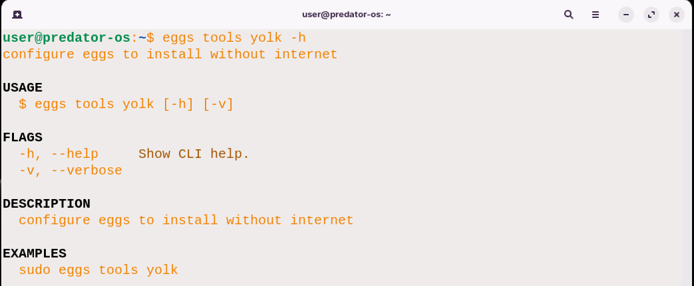

The command has the following example:

sudo eggs tools yolk

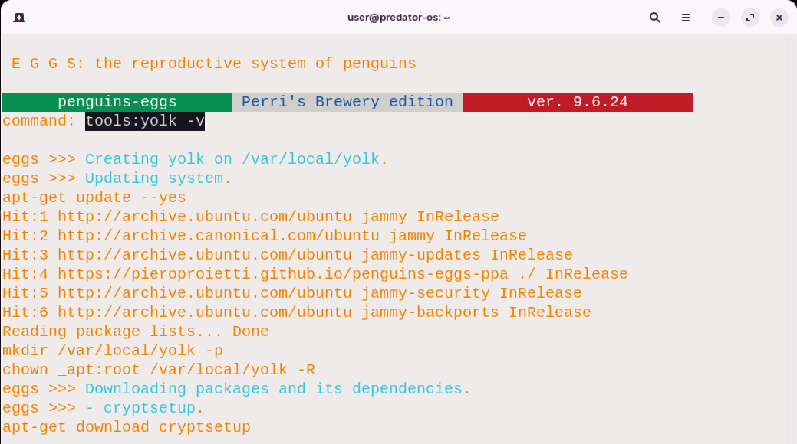

The path of downloaded packages is here:

**/**var**/**local**/**yolk

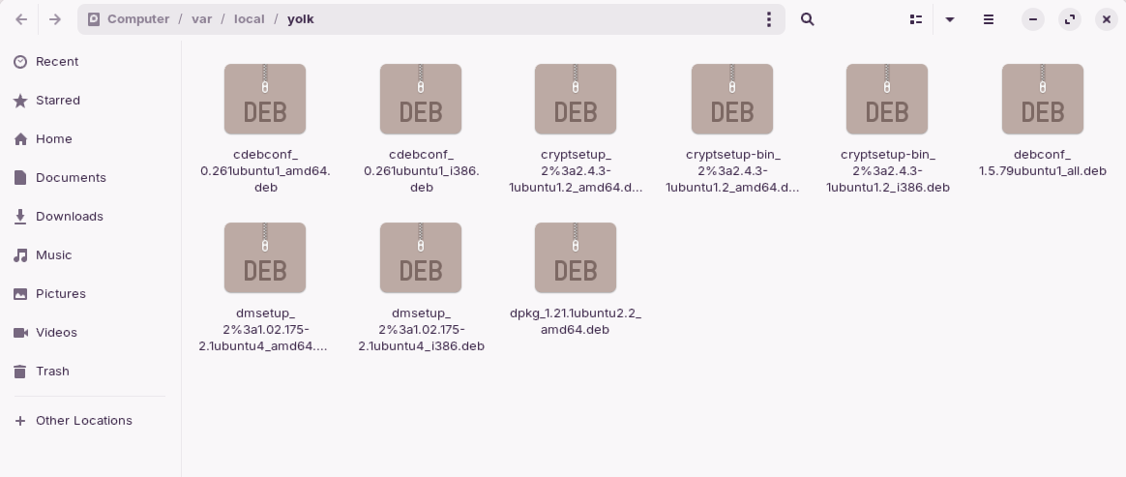

This command configures the **“**eggs**”** tool to install software packages without relying on an internet connection**.** By executing this command with administrative privileges **(**sudo**)**, the necessary configurations are applied to enable offline installations**.** The exact details of how the **“**eggs**”** tool handles offline installations may depend on its implementation and configuration**.** It could involve pre**-**downloading packages, setting up a local package repository, or utilizing other mechanisms to enable installation without internet access**.**

­­

# Step 5: eggs produce

## eggs produce command

The eggs produce command is used to create a live image of your system without including your personal data**.** It allows you to generate a snapshot of your system that can be used for various purposes such as creating a bootable USB or testing your system in a virtual environment**.** Here are the options and flags available for the eggs produce command:

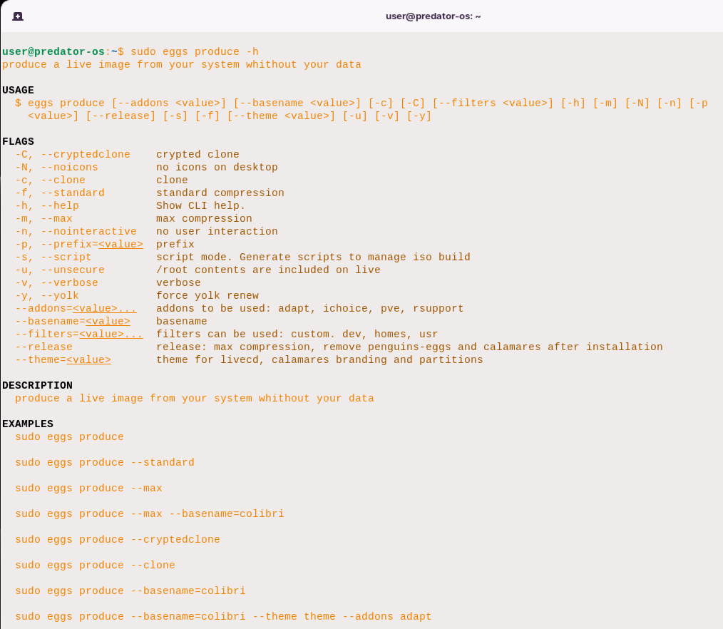

Options:

* **--**addons **<**value**>**: Specifies the additional addons to be used during the image creation process**.** You can provide multiple addons separated by commas, such as **--**addons adapt,ichoice,pve,rsupport**.**
* **--**basename **<**value**>**: Sets the base name for the generated image file**.**
* **-**c, **--**clone: Creates a clone of the system**.**
* **-**C, **--**cryptedclone: Creates a crypted clone of the system**.**
* **-**f, **--**standard: Uses standard compression during the image creation**.**
* **-**h, **--**help: Displays the help information for the command**.**
* **-**m, **--**max: Uses maximum compression during the image creation**.**
* **-**n, **--**nointeractive: Runs the command in non**-**interactive mode, without any user interaction**.**
* **-**p **<**value**>**, **--**prefix**=<**value**>**: Specifies a prefix to be used for the generated image file**.**
* **-**s, **--**script: Generates scripts to manage ISO build in script mode**.**
* **-**u, **--**unsecure: Includes the contents of **/**home**/**\* and the full contents of **/**root in the live image**.**
* **-**v, **--**verbose: Enables verbose output during the image creation process**.**
* **-**y, **--**yolk: Forces the renewal of the yolk**.**

Flags:

* **--**release: Applies maximum compression, removes penguins**-**eggs and calamares after installation**.**
* **--**theme **<**value**>**: Specifies the theme to be used for the live CD, calamares branding, and partitions**.**
* **--**filters**=<**value**>...**: Specifies the filters to be used during the image creation**.** Multiple filters can be provided separated by commas, such as **--**filters custom,dev,homes**.**
* **-**N, **--**noicons: Disables the inclusion of icons in the live image**.**

The command allows for various combinations of options and flags, depending on your specific requirements**.** The provided EXAMPLES: demonstrate different usage scenarios for the eggs produce command**.**

More details on options:

The **--**addons **<**value**>**

The **--**addons **<**value**>** option allows you to specify additional addons to be used during the image creation process**.** You can provide multiple addons by separating them with commas**.** For example, if you want to include the adapt, ichoice, pve, and rsupport addons, you would use the **--**addons option like this:

--addons adapt,ichoice,pve,rsupport

This will ensure that these addons are included when generating the live image of your system**.** Feel free to customize the list of addons according to your specific needs**.**

The **--**basename **<**value**>** option allows you to set the base name for the generated ISO image file**.** When creating the live image, you can provide a custom name that will be used as the base for the resulting file**.** Here's an example:

--basename=colibri

By using this option, the generated image file will have **“**colibri**”** as its base name**.** The actual file name may include additional information, such as the image format or extension, but the base name you provide will be used as the starting point for the file name**.** You can replace **“**colibri**”** with any desired name for the image file**.**

* **-**c, **--**clone: This option allows you to create a clone of the system**.** When used during the image creation process, it will generate an exact copy of the system, including all files, settings, and configurations**.**

The **-**C, **--**cryptedclone option is similar to the **-**c option, but with an added layer of security**.** When you use this option during the image creation process, it not only creates a clone of the system but also encrypts the resulting image**.**

By encrypting the image, it ensures that the data within the clone is secure and protected from unauthorized access**.** This can be particularly useful when dealing with sensitive information or when you want to ensure the privacy and confidentiality of the cloned system**.**

* **-**f, **--**standard: This option specifies the use of standard compression during the image creation**.** It means that the resulting image file will be compressed using a standard compression algorithm, balancing the trade**-**off between compression speed and the resulting size of the image**.**

So, by using the **-**f, **--**standard option, you can create an image with a compressed file size while maintaining a reasonable compression speed**.**

* **-**h, **--**help: When used, this option displays the help information for the command**.** It provides details about the available options, their usage, and any additional information that might be useful for understanding and using the command**.**

**-**m, **--**max: This option instructs the system to use maximum compression during the image creation**.** It applies a more aggressive compression algorithm, which may take more time but can result in a smaller image file size**.**

* **-**n, **--**nointeractive: When this option is used, the command runs in non**-**interactive mode, meaning it does not require any user interaction**.** It allows the command to be executed automatically without any prompts or input required from the user**.**
* **-**p, **--**prefix**=<**value**>**: This option allows you to specify a prefix value for the command**.** The exact functionality and purpose of this prefix value may depend on the specific command you are referring to**.** It could be used as a prefix for file names, directories, or other elements involved in the command's execution**.**
* **-**s, **--**script: When used, this option enables script mode for the command**.** In script mode, the command generates scripts that can be used to manage the ISO build**.** These scripts can be helpful for automating certain tasks or customizing the ISO build process according to specific requirements**.**
* **-**u, **--**unsecure: Including this option instructs the command to include the contents of **/**home**/**\* and the full contents of **/**root on the live system**.** This option may be useful in certain scenarios where you need to include additional files or configurations from these directories in the resulting live system**.**
* **-**v, **--**verbose: When this option is used, the command runs in verbose mode**.** This means that it provides more detailed and extensive output during its execution**.** Verbose mode is particularly helpful for obtaining additional information and understanding the inner workings of the command**.**

  When you include the **-**y, **--**yolk option with the command, it forces the renewal of the yolk**.** The specific meaning and functionality of the yolk can vary depending on the context of the command you are referring to**.** In general, forcing a yolk renewal typically implies that a specific component or configuration associated with the yolk will be updated or refreshed**.** The exact nature of the yolk and the changes made during renewal depend on the command and its specific implementation**.** The yolk could represent a variety of things depending on the context**.** It could refer to a software package, a configuration file, a library, or any other relevant component that plays a role in the execution or behavior of the command**.**

1. **--**addons**=<**value**>...**: This option allows you to specify addons to be used**.** The available addon options are adapt, ichoice, pve, and rsupport**.** You can include multiple addons by providing them as a comma**-**separated list**.**

The **--**addons**=<**value**>...** option allows you to specify addons to be used with the command**.** The available addon options are adapt, ichoice, pve, and rsupport**.** To include multiple addons, you can provide them as a comma**-**separated list**.** For example, if you want to include both adapt and pve addons, you would use the option like this:

--addons=adapt,pve

This will instruct the command to include the specified addons during its execution**.** The addons you specify can provide additional functionality, features, or configurations to enhance the command's behavior according to your needs**.** Make sure to consult the command's documentation or help text for more details on how to use the **--**addons option and the specific effects of each addon**.**

The **--**basename**=<**value**>** option allows you to set the basename for the resulting output or file generated by the command**.** The basename typically refers to the base name or identifier of the file**.** To set a custom value for the basename, you would replace **<**value**>** with the desired name or identifier you want to assign to the output**.** For example:

--basename=myoutput

In this example, the basename is set to **“**myoutput**”.** The command, when executed, will use this custom basename to generate the output file or files associated with the operation**.** Setting a specific basename can be useful for organizing and identifying the resulting files, especially when dealing with multiple outputs or when you want to give them a descriptive name relevant to the task or purpose**.** Remember to refer to the command's documentation or help text for more information on how the basename is used and any specific requirements or limitations associated with setting a custom value**.**

The **--**filters**=<**value**>...** option allows you to specify filters to be used with the command**.** The available filter options are custom, dev, and homes**.** Similar to the **--**addons option, you can include multiple filters by separating them with commas**.** For example, if you want to include both the custom and dev filters, you would use the option like this:

--filters=custom,dev

By specifying filters, you can selectively apply certain criteria or conditions to the command's execution**.** These filters can help narrow down the scope of the operation or customize the behavior according to specific requirements**.**

When you include the **--**release option with the command, it signifies that you want to apply specific actions during the release process**.** These actions typically involve tasks such as maximizing compression, removing penguins**-**eggs, and removing calamares after the installation**.** Here's a breakdown of the actions commonly associated with the **--**release option:

1. Maximizing compression: This action aims to optimize the compression of files or data, potentially resulting in smaller file sizes or more efficient storage utilization**.** By including the **--**release option, you instruct the command to prioritize compression during the release process**.**
2. Removing penguins**-**eggs: This action involves removing or excluding the penguins**-**eggs component from the release**.** The specific purpose or functionality of penguins**-**eggs depends on the context of the command**.** By using the **--**release option, you indicate that you want to exclude this component from the final release**.**
3. Removing calamares after installation: Calamares is a popular open**-**source installation framework**.** When you include the **--**release option, it signifies that you want to remove the Calamares component after the installation process is complete**.** This action can be useful if you no longer require the installation framework once the system is set up**.**

The exact implications and effects of using the **--**release option may vary depending on the specific command and its implementation**.** It's important to consult the command's documentation or help text for further details on the actions performed during the release process and any additional considerations associated with this option**.**

**--**theme**=<**value**>**: This option allows you to set the theme for the livecd, calamares branding, and partitions**.** You can provide a custom value to define the desired theme**.** The **--**theme**=<**value**>** option enables you to set the theme for various components such as the livecd, calamares branding, and partitions**.** You can provide a custom value to define the desired theme**.** To set a custom theme, replace **<**value**>** with the name or identifier of the theme you wish to use**.** For instance:

--theme=mytheme

In this example, the theme is set to **“**mytheme**”.** By specifying a theme, you can customize the appearance, styling, and visual elements of the livecd, calamares branding, and partitions according to your preferences or requirements**.** The specific effects of the theme option may vary depending on the command and its implementation**.** It's recommended to consult the command's documentation or help text to understand the available themes, any specific requirements for using custom themes, and how they are applied to the respective components**.** Remember that the theme option provides an opportunity to personalize the visual aspects of the command's output, making it more aligned with your desired aesthetic or branding**.** Here are some EXAMPLES: demonstrating the usage of the sudo eggs produce command with different options:

sudo eggs produce

This command will execute the **“**produce**”** action without any additional options**.**

sudo eggs produce --standard

This command will execute the **“**produce**”** action with the standard option**.**

sudo eggs produce --max

This command will execute the **“**produce**”** action with the max option**.**

sudo eggs produce --max --basename=colibri

This command will execute the **“**produce**”** action with the max option and set the basename to **“**colibri**”.**

sudo eggs produce --cryptedclone

This command will execute the **“**produce**”** action with the cryptedclone option**.**

sudo eggs produce --clone

This command will execute the **“**produce**”** action with the clone option**.**

sudo eggs produce --basename=colibri

This command will execute the **“**produce**”** action and set the basename to **“**colibri**”.**

sudo eggs produce --basename=colibri --theme /path/to/theme --addons adapt

This command will execute the **“**produce**”** action, set the basename to **“**colibri**”**, use a custom theme located at **“/**path**/**to**/**theme**”**, and include the **“**adapt**”** addon**.** Please note that these EXAMPLES: assume the existence of a valid sudo eggs produce command and may require additional parameters or options depending on the specific context**.** Make sure to consult the command's documentation or help text for accurate usage instructions**.** Here are a few more EXAMPLES: showcasing different usage scenarios for the sudo eggs produce command:

sudo eggs produce --addons adapt,debug

This command will execute the **“**produce**”** action with the **“**adapt**”** and **“**debug**”** addons included**.**

sudo eggs produce –release

This command will execute the **“**produce**”** action and apply specific actions during the release process, such as maximizing compression, removing penguins**-**eggs, and removing calamares after installation**.**

sudo eggs produce --filters custom,dev

This command will execute the **“**produce**”** action and apply the **“**custom**”** and **“**dev**”** filters**.**

sudo eggs produce --theme=mytheme

This command will execute the **“**produce**”** action and set the theme to **“**mytheme**”** for the livecd, calamares branding, and partitions**.**

sudo eggs produce --basename=colibri --theme /path/to/theme

This command will execute the **“**produce**”** action, set the base name to **“**colibri**”**, and use a custom theme located at **“/**path**/**to**/**theme**”.**

sudo eggs produce --max --filters custom --theme=default

This command will execute the **“**produce**”** action with the max option, apply the **“**custom**”** filter, and set the theme to the default theme**.**

sudo eggs produce --clone --basename=backup

This command will execute the **“**produce**”** action with the clone option and set the basename to **“**backup**”.** Remember to adjust the options and values according to your specific requirements and the available features of the sudo eggs produce command**.** Additionally, consult the command's documentation or help text for a comprehensive understanding of the available options and their effects**.**

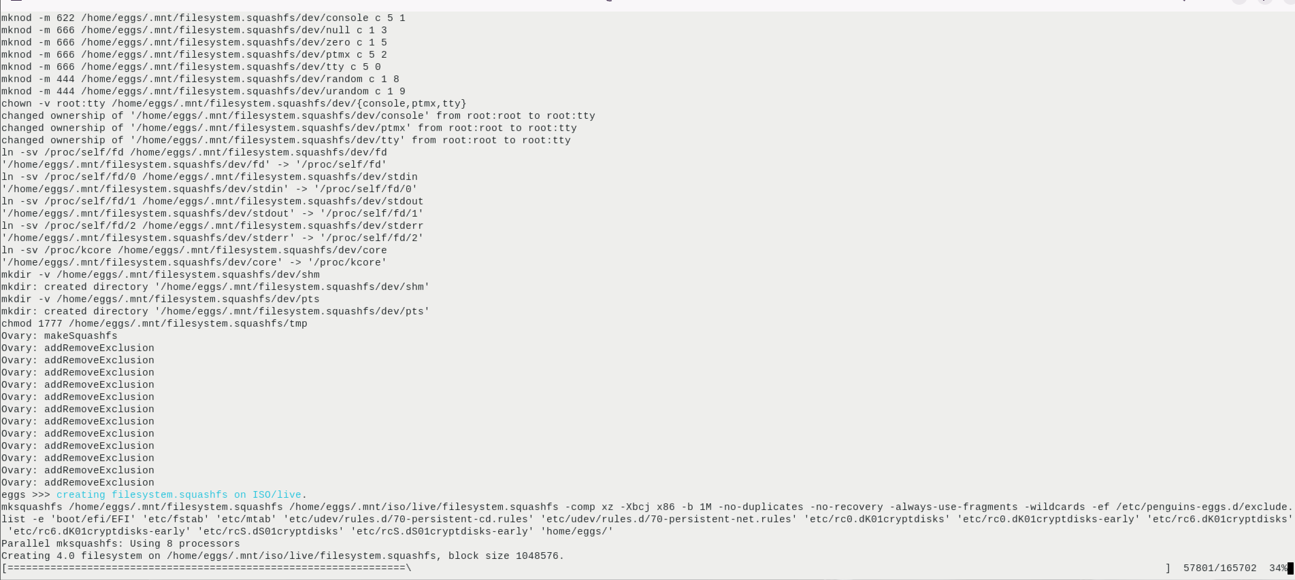

After creating the ISO file:

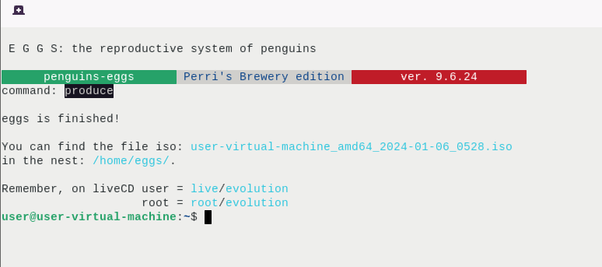

The path of ISO file:

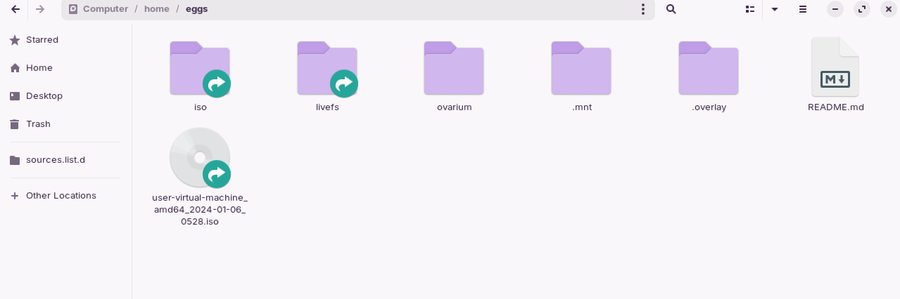

The default location of the ISO file when mounting it in a Linux system**.** In some cases, the ISO file may be mounted in the **.**mnt directory, which is a hidden directory**.** To access hidden directories in a file manager, you can typically press Ctrl **+** h to toggle the visibility of hidden files and directories**.**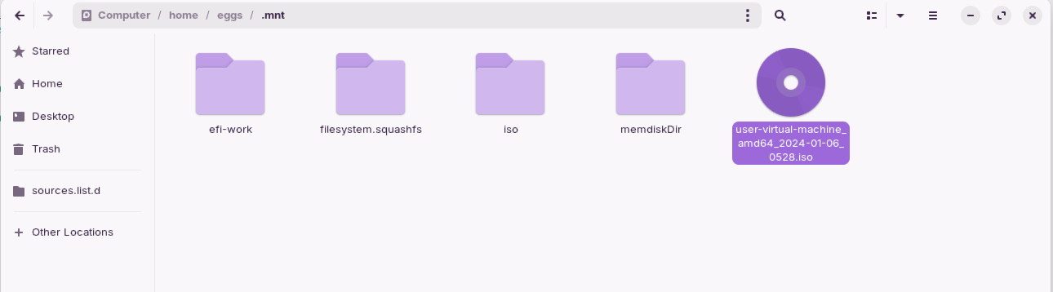

Default grub boot menu:

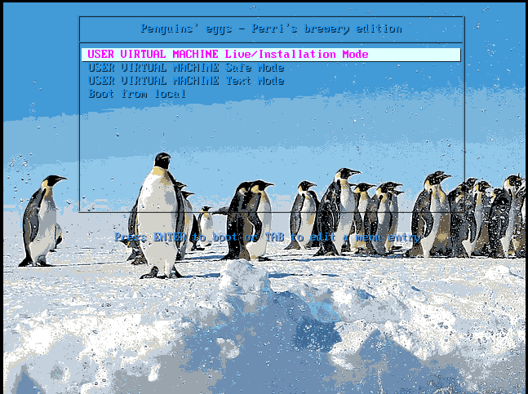



# Chapter 9

# After Producing

## eggs syncto command

The eggs syncto command allows you to save users and user data in a LUKS volume inside the ISO**.** Here is the breakdown of its usage:

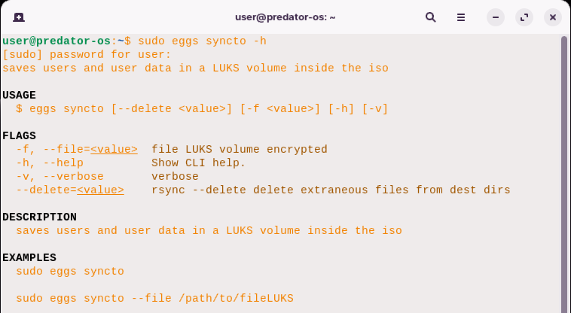

In the EXAMPLES: section, you can find two usage EXAMPLES::

sudo eggs syncto

This command saves users and user data in a LUKS volume inside the ISO**.** The necessary configurations and parameters should be set before running this command**.**

sudo eggs syncto --file /path/to/fileLUKS

This command saves users and user data in the specified LUKS volume file located at **/**path**/**to**/**fileLUKS**.** It creates and encrypts the LUKS volume inside the ISO, preserving the necessary data**.**

Here's a more detailed description of each flag used in the eggs syncto command:

* **-**f, **--**file**=<**value**>**: This flag is used to specify the LUKS volume file that you want to create and encrypt**.** You should provide the path to the LUKS volume file as the **<**value**>.** This file will contain the saved users and user data**.**
* **-**h, **--**help: This flag displays the help message for the eggs syncto command**.** It provides information about the command's usage, flags, and EXAMPLES:**.**
* **-**v, **--**verbose: This flag enables verbose output, providing more detailed information during the execution of the eggs syncto command**.** It can be helpful for troubleshooting or understanding the synchronization process**.**
* **--**delete**=<**value**>**: This flag enables the rsync command with the **--**delete option**.** It allows the deletion of extraneous files from the destination directories during the synchronization process**.** You can provide **<**value**>** to further configure the delete behavior **(**e**.**g**.**, **--**delete**=**after**).**

The eggs syncto command saves users and user data in a LUKS volume inside the ISO**.** Here are some usage EXAMPLES::

sudo eggs syncto

This command saves users and user data in a LUKS volume inside the ISO**.** The default configurations and parameters are assumed to be set correctly**.**

sudo eggs syncto --file /path/to/fileLUKS

This command saves users and user data in the specified LUKS volume file located at **/**path**/**to**/**fileLUKS**.** It creates the LUKS volume and encrypts it inside the ISO, preserving the necessary data**.**

## eggs syncfrom command

The eggs syncfrom command is used to restore users and user data from LUKS volumes**.** Here is the usage and EXAMPLES: for this command:

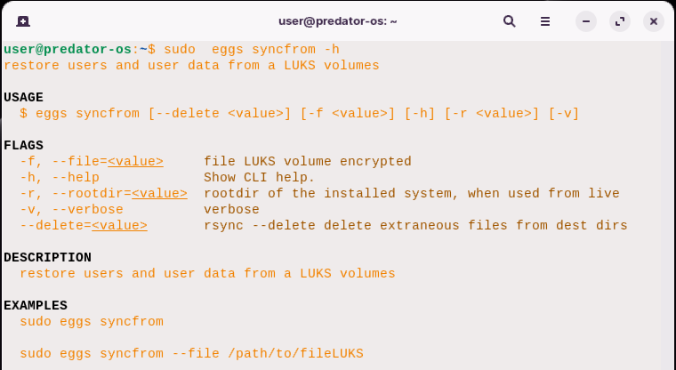

In the EXAMPLES: section, you can use the eggs syncfrom command with various options:

sudo eggs syncfrom

This command will restore users and user data from a LUKS volume**.** It assumes the necessary parameters are provided either through default configurations or prior setup**.**

sudo eggs syncfrom --file /path/to/fileLUKS

This command will restore users and user data from the specified LUKS volume file located at **/**path**/**to**/**fileLUKS**.** The command will decrypt the LUKS volume and sync the data accordingly**.** Please note that the exact behavior and requirements of the eggs syncfrom command may depend on the specific context and implementation**.** Make sure to consult the command's documentation or help text for accurate usage instructions and additional details**.** If you have any further questions or need assistance with the eggs syncfrom command**.** Here's a more detailed description of each flag used in the eggs syncfrom command:

* **-**f, **--**file**=<**value**>**: This flag is used to specify the LUKS volume file that you want to decrypt and sync**.** You should provide the path to the LUKS volume file as the **<**value**>.**
* **-**h, **--**help: This flag displays the help message for the eggs syncfrom command**.** It provides information about the command's usage, flags, and EXAMPLES:**.**
* **-**r, **--**rootdir**=<**value**>**: This flag is used when running the command from a live environment**.** It allows you to specify the root directory of the installed system**.** You should provide the path to the root directory as the **<**value**>.**
* **-**v, **--**verbose: This flag enables verbose output, providing more detailed information during the execution of the eggs syncfrom command**.** It can be helpful for troubleshooting or understanding the synchronization process**.**
* **--**delete**=<**value**>**: This flag enables the rsync command with the **--**delete option**.** It allows the deletion of extraneous files from the destination directories during the synchronization process**.** You can provide **<**value**>** to further configure the delete behavior **(**e**.**g**.**, **--**delete**=**after**).**

The eggs syncfrom command restores users and user data from a LUKS volume**.** Here are some usage EXAMPLES::

sudo eggs syncfrom

This command restores users and user data using the default configurations and assumes that the necessary parameters are already set**.**

sudo eggs syncfrom --file /path/to/fileLUKS

This command restores users and user data from the specified LUKS volume file located at **/**path**/**to**/**fileLUKS**.** It decrypts the LUKS volume and performs the synchronization process accordingly**.**

# Testing the ISO

To test an ISO created with the **“**eggs**”** tool, you can follow these general steps:

1. Prepare a Testing Environment: Set up a virtual machine or a physical system where you can test the ISO**.** This can be done using virtualization software like VirtualBox or by booting the ISO on a separate machine**.**

Setting up a testing environment for your ISO can be done using a virtual machine or a physical system**.** Here's how you can do it:

2**.**Virtual Machine Testing:

* Install a virtualization software like VirtualBox, VMware, or KVM on your computer**.**
* Create a new virtual machine using the virtualization software**.**
* During the virtual machine creation process, configure the system specifications such as CPU, memory, and storage based on your requirements**.**
* When prompted to select an ISO or boot media, choose the ISO file created with the **“**eggs**”** tool**.**
* Complete the virtual machine creation process and start the virtual machine**.**
* The virtual machine will boot from the ISO, allowing you to test the operating system or software contained within the ISO**.**

3**.** Physical System Testing:

* Prepare a separate computer or device where you can boot the ISO**.**
* Create a bootable USB drive or burn the ISO to a DVD**.**
* Insert the bootable USB or DVD into the target system**.**
* Restart the system and access the boot menu or BIOS settings**.**
* Choose the bootable USB or DVD as the primary boot device**.**
* Save the settings and restart the system**.**
* The system will boot from the ISO, allowing you to test the operating system or software contained within the ISO**.**

By using either of these methods, you can create a controlled environment to test your ISO and ensure its functionality and compatibility**.**

4**.** Boot the ISO: Start the virtual machine or the target system and boot from the ISO you created with the **“**eggs**”** tool**.** Ensure that the ISO is accessible during the boot process**.**

5**.** Test Installation: If the purpose of the ISO is to install an operating system, go through the installation process and verify that it completes successfully**.** Pay attention to any errors, warnings, or unexpected behavior during the installation**.**

## Testing the installation

When testing the installation process of an ISO, follow these steps to ensure it completes successfully:

1. Start the system or virtual machine using the ISO as described in the previous steps**.**
2. Follow the on**-**screen instructions to begin the installation process**.**
3. Provide any required information, such as language preferences, keyboard layout, time zone, and user credentials**.**
4. Pay attention to any error messages, warnings, or unexpected behavior during the installation**.** Note down any issues you encounter**.**
5. Proceed through the installation process, selecting the desired installation options**.** This may include disk partitioning, software selection, and additional configurations**.**
6. Monitor the progress of the installation and ensure that it completes without any errors or interruptions**.**
7. Once the installation is finished, the system will prompt you to restart or boot into the newly installed operating system**.**
8. After restarting or booting into the installed system, verify that it functions correctly**.** Check if essential features like networking, display, sound, and other hardware components are working as expected**.**
9. Test basic functionality and run some applications to ensure they work properly**.**
10. Document any issues or bugs you encounter during the installation process and note any steps to reproduce them**.**

By carefully testing the installation process, you can identify and address any issues or errors that may occur, ensuring that the installation completes successfully and the operating system is functional**.**

## Test Functionality

Test Functionality: Once the installation is complete, boot into the installed system and test its functionality**.** Check if essential features like networking, display, sound, and other hardware components are working correctly**.** Run some basic applications to ensure they function as expected**.** After the installation process is complete, you can proceed to test the functionality of the installed system**.** Here are the steps to follow:

1. Restart or boot into the newly installed operating system**.**
2. Check Network Connectivity:
   * Ensure that the networking features are working correctly**.**
   * Connect to the internet and verify if you can access websites or perform network**-**related tasks**.**
   * Test both wired and wireless connections if applicable**.**
3. Display and Graphics:
   * Check if the display resolution is set correctly and matches the capabilities of your monitor**.**
   * Verify that graphics and animations are rendered smoothly without any visual artifacts or glitches**.**
   * Test playing videos or running graphics**-**intensive applications to ensure they function properly**.**
4. Sound and Audio:
   * Play audio files or videos with sound to confirm that the audio output is working as expected**.**
   * Test different audio inputs and outputs **(**e**.**g**.**, speakers, headphones, microphone**)** if available**.**
5. Hardware Compatibility:
   * Test other hardware components such as printers, scanners, external storage devices, or any other peripherals that are relevant to your use case**.**
   * Ensure that the system detects and functions with these hardware devices without any issues**.**
6. Basic Application Testing:
   * Run basic applications such as web browsers, text editors, media players, and office productivity software**.**
   * Verify that these applications launch correctly and perform their intended functions without errors**.**
7. Perform Additional Testing:
   * If there are specific applications or functionalities that are critical for your use case, test them thoroughly to ensure they work as expected**.**
   * Test any customizations or modifications made to the base operating system to confirm that they function correctly**.**
8. Document and Report Issues:
   * If you encounter any issues or unexpected behavior during the functionality testing, document them along with detailed steps to reproduce the problems**.**
   * Report any issues to the developers or maintainers of the ISO so that they can be addrسessed and resolved**.**

## Test Customizations

Test Customizations: If the ISO includes any customizations or modifications, such as pre**-**installed software, configurations, or themes, verify that these changes are present and working as intended**.** When testing customizations or modifications included in an ISO, follow these steps to verify their presence and functionality:

1. Start the system or virtual machine using the ISO as described earlier**.**
2. Once the installation is complete, boot into the installed system**.**
3. Check for Pre**-**Installed Software:
   * Verify if the custom ISO includes any pre**-**installed software or applications**.**
   * Launch these applications and ensure they open without any issues**.**
   * Test their functionality to ensure they work as intended**.**
4. Configuration Customizations:
   * Check if any system configurations have been customized or modified**.**
   * Verify that the desired configurations are present and functioning correctly**.**
   * Test any specific settings or configurations to ensure they are working as intended**.**
5. Theme Customizations:
   * If the ISO includes customized themes or visual elements, check if they are applied correctly**.**
   * Look for changes in the desktop environment, icons, wallpapers, colors, or other visual aspects**.**
   * Verify that the customized themes are visually appealing and consistent throughout the system**.**
6. Custom Scripts or Automations:
   * If the ISO includes custom scripts or automations, test their functionality**.**
   * Ensure that these scripts execute as expected and perform the desired actions**.**
   * Verify that any automated processes or configurations are working correctly**.**
7. Document and Report Issues:
   * If you encounter any issues or unexpected behavior with the customizations, document them along with detailed steps to reproduce the problems**.**
   * Report any issues to the developers or maintainers of the ISO so that they can be addressed and resolved**.**

By thoroughly testing the customizations and modifications included in the ISO, you can ensure that they are present and functioning as intended, providing a tailored experience for the users**.**

## Perform Regression Testing

Perform Regression Testing: If you have previously tested an earlier version of the ISO, it is essential to perform regression testing by comparing the current version with the previous one**.** Ensure that any issues or bugs identified in the earlier version have been resolved in the new ISO**.** Performing regression testing involves comparing the current version of the ISO with a previous version to ensure that any issues or bugs identified in the earlier version have been resolved**.** Here are the steps to perform regression testing:

1. Identify the Previous Version:
   * Determine the specific version of the ISO that was previously tested**.**
   * Retrieve the necessary resources, such as the previous ISO image and any documentation or test cases used during the earlier testing**.**
2. Establish a Baseline:
   * Use the previous version of the ISO as a baseline for comparison**.**
   * Install and boot into the previous version on a system or virtual machine**.**
   * Document any issues, bugs, or unexpected behavior encountered during the previous testing**.**
3. Install and Boot into the Current Version:
   * Install and boot into the current version of the ISO on a separate system or virtual machine**.**
   * Pay close attention to any areas or functionalities that were problematic in the previous version**.**
4. Compare and Verify Fixes:
   * Refer to the documented issues and bugs from the previous testing**.**
   * Verify if the issues identified in the earlier version have been resolved in the current version**.**
   * Retest the problematic areas to confirm that the fixes have been implemented successfully**.**
5. Document and Report Findings:
   * Document any differences, improvements, or regressions observed during the regression testing**.**
   * If any previously identified issues have not been resolved or new issues arise, document them along with detailed steps to reproduce them**.**
   * Report the findings to the developers or maintainers of the ISO, providing them with the necessary information to address any outstanding issues**.**

Regression testing helps ensure that the current version of the ISO is an improvement over the previous version, with resolved issues and enhanced functionality**.**

## Document and Report Issues

Document and Report Issues: If you encounter any problems or bugs during testing, document them along with detailed steps to reproduce the issues**.** Report these problems to the developers or maintainers of the ISO so that they can be addressed and fixed**.** Documenting and reporting issues is crucial for improving the quality of the ISO**.** Here's how you can effectively document and report problems or bugs:

1. Create a Detailed Description:
   * Clearly describe the problem or bug you encountered**.** Include specific details such as error messages, unexpected behavior, or any other relevant information**.**
   * Provide a concise but informative title or summary for the issue**.**
2. Steps to Reproduce:
   * Outline the exact steps or actions required to reproduce the problem**.**
   * Be specific and include any prerequisites or specific configurations needed to recreate the issue**.**
   * If applicable, provide sample data or input that triggers the problem**.**
3. Include System Environment Details:
   * Note down the system environment in which the issue occurred, such as the operating system version, hardware specifications, and any relevant software versions**.**
   * Mention if the problem is specific to certain hardware configurations or software setups**.**
4. Attach Screenshots or Recordings:
   * If possible, capture screenshots or record videos that demonstrate the problem visually**.**
   * Highlight any error messages or unexpected behavior in the visuals**.**
   * Ensure that any sensitive or personal information is redacted from the visuals**.**
5. Prioritize and Categorize:
   * Classify the severity of the issue based on its impact and urgency**.**
   * Categorize the problem under relevant areas, such as installation, functionality, customization, or performance**.**
   * If the issue is a known bug, reference any existing bug reports or tickets related to it**.**
6. Submit the Report:
   * Determine the appropriate channel or platform to report the issue**.** This could be an issue tracker, support forum, or any designated communication platform**.**
   * Follow the guidelines provided by the developers or maintainers for issue reporting**.**
   * Submit the documented issue, ensuring that it is clear, concise, and includes all the necessary information**.**

By documenting and reporting issues effectively, you contribute to the improvement of the ISO and help the developers or maintainers address and fix the problems**.**

# Eggs tools stat

The eggs tools stat command is used to retrieve statistics from SourceForge, a web**-**based hosting service for software development projects**.** Here is a breakdown of its usage:

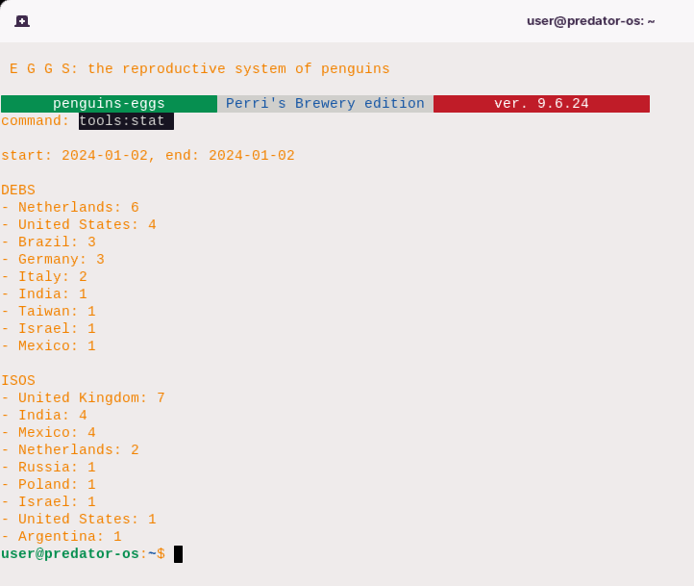

The command has the following EXAMPLES::

$ eggs tools stat

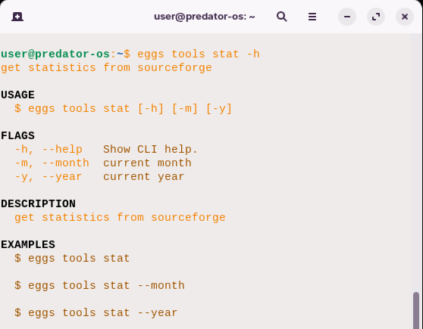

This command retrieves general statistics from SourceForge**.**

$ eggs tools stat –month

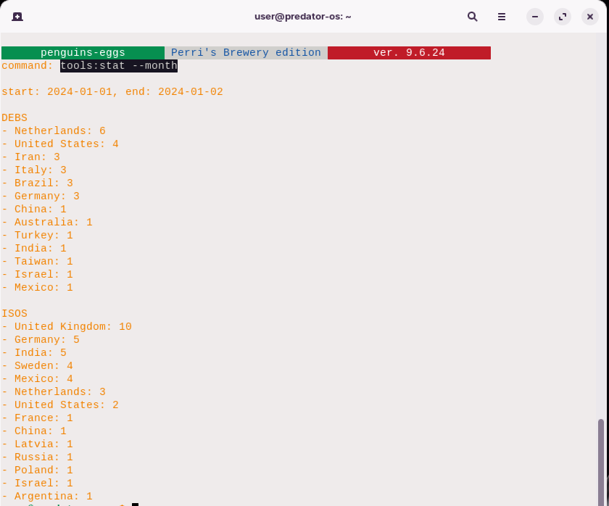

This command retrieves statistics for the current month from SourceForge**.**

$ eggs tools stat –year

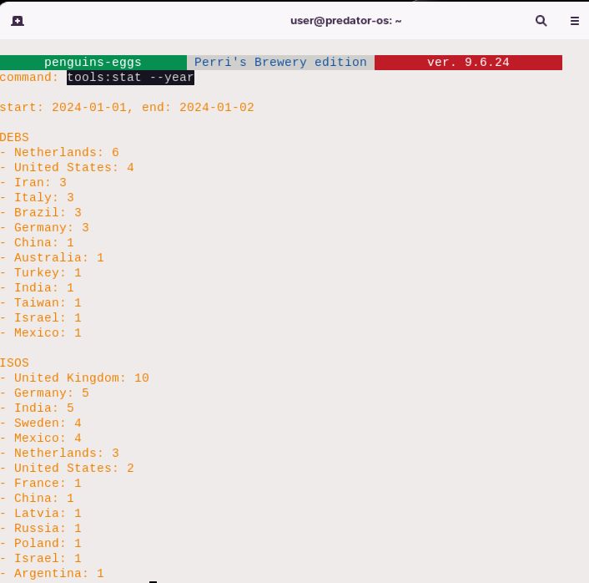

This command retrieves statistics for the current year from SourceForge**.** The specific statistics that are retrieved from Sourceforge may vary depending on the implementation of the command and the available data from the SourceForge API**.**

# Wardrobe users' guide

The Penguins' Wardrobe methodology allows for the tracking and reuse of steps taken during the development of a remastering project**.** It provides a way to create customizations starting from a minimal CLI system that is already installed, referred to as a **“**naked**”** system**.** You have used this methodology to create various generic customizations such as colibri, duck, owl, and eagle**.** Additionally, you have used it to create Linux systems with waydroids named wagtail, warbler, and whipbird, based on Gnome, KDE Plasma, and Weston, respectively**.**

It's worth noting that while the Penguins' Wardrobe methodology is useful for remastering projects, it is not necessary to use it in conjunction with the **“**eggs**”** tool**.** You can still utilize the **“**eggs**”** tool for system customization based on your own methodologies and original customizations**.**

The eggs wardrobe list command is used to list the costumes and accessories available in a wardrobe**.** Here is a breakdown of its usage:

**USAGE**

$ eggs wardrobe list [WARDROBE] [-h] [-v]

**ARGUMENTS**

WARDROBE (optional) Specifies the name of the wardrobe to list.

**FLAGS**

-h, --help Displays the help message for the command.

-v, --verbose Enables verbose output.

**DESCRIPTION**

Lists the costumes and accessories available in a wardrobe**.**

**EXAMPLES:**

$ eggs wardrobe list

Lists the costumes and accessories in the default wardrobe**.**

$ eggs wardrobe list your-wardrobe

Lists the costumes and accessories in a specific wardrobe named **“**your**-**wardrobe**”.** The command has the following EXAMPLES::

$ eggs wardrobe list

This command lists the costumes and accessories in the default wardrobe**.**

$ eggs wardrobe list your-wardrobe

This command lists the costumes and accessories in a specific wardrobe named **“**your**-**wardrobe**”.** The actual implementation code for this command can be found in the src**/**commands**/**wardrobe**/**list**.**ts file**.** Here's a description of the flags in the eggs wardrobe list command:

**FLAGS**

-h, --help Displays the help message for the command.

-v, --verbose Enables verbose output.

* **-**h, **--**help: This flag displays the help message for the eggs wardrobe list command**.** It provides information about the command's usage, arguments, and flags**.**
* **-**v, **--**verbose: This flag enables verbose output when listing the costumes and accessories in a wardrobe**.** Verbose output typically includes more detailed or additional information to provide a more comprehensive view of the output**.**

The command allows for an optional argument:

**ARGUMENTS**

WARDROBE **(**optional**)** Specifies the name of the wardrobe to list**.**

WARDROBE: This argument is optional and allows you to specify the name of the wardrobe you want to list**.** If provided, the command will list the costumes and accessories in the specified wardrobe**.** If not provided, the command will list the costumes and accessories in the default wardrobe**.**

The command's description summarizes its purpose:

**DESCRIPTION**

Lists the costumes and accessories available in a wardrobe**.** The EXAMPLES: provided illustrate the usage of the command:

**EXAMPLES:**

$ eggs wardrobe list

Lists the costumes and accessories in the default wardrobe**.**

$ eggs wardrobe list your-wardrobe

Lists the costumes and accessories in a specific wardrobe named **“**your**-**wardrobe**”.** The eggs wardrobe show command is used to display costumes and accessories in a wardrobe**.** Here is the breakdown of its usage:

**USAGE**

$ eggs wardrobe show [COSTUME] [-h] [-j] [-v] [-w <value>]

**ARGUMENTS**

COSTUME Specifies the costume or accessory to show**.**

**FLAGS**

-h, --help Show CLI help.

-j, --json Output in JSON format.

-v, --verbose Enables verbose output.

-w, --wardrobe=<value> Specifies the wardrobe to show costumes**/**accessories from**.**

**DESCRIPTION**

Shows costumes and accessories in a wardrobe**.**

**EXAMPLES:**

$ eggs wardrobe show colibri

Shows the costume or accessory named **“**colibri**”** in the default wardrobe**.**

$ eggs wardrobe show accessories/firmwares

Shows the costume or accessory named **“**firmwares**”** in the **“**accessories**”** folder of the default wardrobe**.**

$ eggs wardrobe show accessories/

Shows all costumes and accessories in the **“**accessories**”** folder of the default wardrobe**.** Here are some EXAMPLES: of how to use the command:

$ eggs wardrobe show colibri

This command shows the costume or accessory named **“**colibri**”** in the default wardrobe**.**

$ eggs wardrobe show accessories/firmwares

This command shows the costume or accessory named **“**firmwares**”** in the **“**accessories**”** folder of the default wardrobe**.**

$ eggs wardrobe show accessories/

This command shows all costumes and accessories in the **“**accessories**”** folder of the default wardrobe**.** The actual implementation code for this command can be found in the src**/**commands**/**wardrobe**/**show**.**ts file**.**

Here's a more detailed description of the flags in the eggs wardrobe show command:

**FLAGS**

-h, --help Show CLI help.

-j, --json Output in JSON format.

-v, --verbose Enables verbose output.

-w, --wardrobe=<value> Specifies the wardrobe to show costumes/accessories from.

* **-**h, **--**help: This flag displays the command line interface **(**CLI**)** help for the eggs wardrobe show command**.** It provides information on how to use the command and its available options**.**
* **-**j, **--**json: This flag formats the output in JSON format**.** When used, the command will display the costumes or accessories in a structured JSON format, which can be useful for programmatic processing or automation**.**
* **-**v, **--**verbose: This flag enables verbose output**.** When enabled, the command provides more detailed information or additional output, offering a more comprehensive view of the costumes and accessories in the wardrobe**.**
* **-**w, **--**wardrobe**=<**value**>**: This flag allows you to specify the wardrobe from which to show the costumes and accessories**.** You can provide the name of the wardrobe as the value for this flag**.** By default, the command shows the costumes and accessories in the default wardrobe**.**

The command's description summarizes its purpose:

**DESCRIPTION**

Shows costumes and accessories in a wardrobe**.**

The EXAMPLES: provided illustrate the usage of the command:

**EXAMPLES:**

$ eggs wardrobe show colibri

Shows the costume or accessory named **“**colibri**”** in the default wardrobe**.**

$ eggs wardrobe show accessories/firmwares

Shows the costume or accessory named **“**firmwares**”** in the **“**accessories**”** folder of the default wardrobe**.**

$ eggs wardrobe show accessories/

Shows all costumes and accessories in the **“**accessories**”** folder of the default wardrobe**.** The eggs wardrobe get command is used to retrieve a wardrobe from a repository**.** Here is the breakdown of its usage:

**USAGE**

$ eggs wardrobe get [REPO] [-h] [-v]

ARGUMENTS

REPO Specifies the repository to get the wardrobe from**.**

**FLAGS**

-h, --help Show CLI help.

-v, --verbose Enables verbose output.

**DESCRIPTION**

Retrieves a wardrobe from a repository**.**

**EXAMPLES:**

$ eggs wardrobe get

Retrieves the default wardrobe**.**

$ eggs wardrobe get your-wardrobe

Retrieves the wardrobe named **“**your**-**wardrobe**”.**

Here are some EXAMPLES: of how to use the command:

$ eggs wardrobe get

This command retrieves the default wardrobe**.**

$ eggs wardrobe get your-wardrobe

This command retrieves the wardrobe named **“**your**-**wardrobe**”.**

The actual implementation code for this command can be found in the src**/**commands**/**wardrobe**/**get**.**ts file**.** Here's a more detailed description of the flags in the eggs wardrobe get command:

FLAGS

-h, --help Show CLI help.

-v, --verbose Enables verbose output.

* **-**h, **--**help: This flag displays the command line interface **(**CLI**)** help for the eggs wardrobe get command**.** It provides information on how to use the command and its available options**.**
* **-**v, **--**verbose: This flag enables verbose output**.** When enabled, the command provides more detailed information or additional output, offering a more comprehensive view of the retrieval process**.**

The command's description summarizes its purpose:

**DESCRIPTION**

Retrieves a wardrobe from a repository**.**

The EXAMPLES: provided illustrate the usage of the command:

EXAMPLES:

$ eggs wardrobe get

Retrieves the default wardrobe**.**

$ eggs wardrobe get your-wardrobe

Retrieves the wardrobe named **“**your**-**wardrobe**”.** In the first example, running the command without specifying a repository name retrieves the default wardrobe**.** This means that if you don't provide a specific repository, the command will retrieve the wardrobe that is set as the default**.** In the second example, running the command with a specific repository name **(**in this case, **“**your**-**wardrobe**”)** retrieves the wardrobe with that name from the repository**.**

The eggs wardrobe wear command is used to wear a costume or accessories from a wardrobe**.** Here is the breakdown of its usage:

USAGE

$ eggs wardrobe wear [COSTUME] [-h] [-a] [-f] [-s] [-v] [-w <value>]

ARGUMENTS

COSTUME Specifies the costume or accessories to wear**.**

FLAGS

-a, --no_accessories Disables the installation of accessories.

-f, --no_firmwares Disables the installation of firmwares.

-h, --help Show CLI help.

-s, --silent Enables silent mode.

-v, --verbose Enables verbose output.

-w, --wardrobe=<value> Specifies the wardrobe to use.

**DESCRIPTION**

Wears a costume or accessories from a wardrobe**.**

**EXAMPLES:**

$ sudo eggs wardrobe wear duck

Wears the **“**duck**”** costume**.**

$ sudo eggs wardrobe wear accessories/firmwares

Wears the accessories or firmwares from the default wardrobe**.**

$ sudo eggs wardrobe wear wagtail/waydroid

Wears the **“**waydroid**”** costume from the **“**wagtail**”** wardrobe**.**

Here are some EXAMPLES: of how to use the command:

$ sudo eggs wardrobe wear duck

This command wears the **“**duck**”** costume**.**

$ sudo eggs wardrobe wear accessories/firmwares

This command wears the accessories or firmwares from the default wardrobe**.**

$ sudo eggs wardrobe wear wagtail/waydroid

This command wears the **“**waydroid**”** costume from the **“**wagtail**”** wardrobe**.**

You can also use the flags to customize the behavior of the command**.** For example, you can use **-**a to disable the installation of accessories or **-**f to disable the installation of firmwares**.** Please note that the sudo command is used in the EXAMPLES: to indicate that administrative privileges may be required to perform the wardrobe wear operation**.**

Here's a more detailed description of the flags in the eggs wardrobe wear command:

FLAGS

-a, --no_accessories Disables the installation of accessories.

-f, --no_firmwares Disables the installation of firmwares.

-h, --help Show CLI help.

-s, --silent Enables silent mode.

-v, --verbose Enables verbose output.

-w, --wardrobe=<value> Specifies the wardrobe to use.

* **-**a, **--**no_accessories: This flag disables the installation of accessories**.** By using this flag, the command will only wear the costume specified and exclude any associated accessories**.**
* **-**f, **--**no_firmwares: This flag disables the installation of firmwares**.** When enabled, the command will only wear the costume specified and exclude any firmwares that might be associated with it**.**
* **-**h, **--**help: This flag displays the command line interface **(**CLI**)** help for the eggs wardrobe wear command**.** It provides information on how to use the command and its available options**.**
* **-**s, **--**silent: This flag enables silent mode**.** When enabled, the command will run without producing any additional output or prompts unless absolutely necessary**.**
* **-**v, **--**verbose: This flag enables verbose output**.** When enabled, the command provides more detailed information or additional output, offering a more comprehensive view of the wearing process**.**
* **-**w, **--**wardrobe**=<**value**>**: This flag allows you to specify the wardrobe to use**.** By providing a value, you can select a specific wardrobe from which to wear the costume or accessories**.**

The command's description summarizes its purpose:

**DESCRIPTION**

Wears a costume or accessories from a wardrobe**.**

The EXAMPLES: provided illustrate the usage of the command:

**EXAMPLES:**

$ sudo eggs wardrobe wear duck

Wears the **“**duck**”** costume**.**

$ sudo eggs wardrobe wear accessories/firmwares

Wears the accessories or firmwares from the default wardrobe**.**

$ sudo eggs wardrobe wear wagtail/waydroid

Wears the **“**waydroid**”** costume from the **“**wagtail**”** wardrobe**.**

In the first example, running the command with the **“**duck**”** costume specified will wear that specific costume**.**

In the second example, running the command with **“**accessories**/**firmwares**”** specified will wear the accessories or firmwares from the default wardrobe**.**

In the third example, running the command with **“**wagtail**/**waydroid**”** specified will wear the **“**waydroid**”** costume from the **“**wagtail**”** wardrobe**.**



# Appendix 1

# Penguins Eggs Terms

1. Live CD: A Live CD is a bootable CD or DVD that contains a complete Linux operating system**.** It allows users to run and test Linux without installing it on their computer's hard drive**.**
2. Bootable: A bootable device, such as a Live CD, is capable of starting up a computer and loading the operating system**.**
3. ISO: An ISO file is an image of a CD or DVD that contains the entire contents of the disk**.** It is often used to distribute Linux Live CDs, which can be burned onto a physical disc or used to create a bootable USB drive**.**
4. Persistence: Persistence refers to the ability of a Live CD to save changes made during a session**.** With persistence, user settings, installed software, and files can be retained across multiple reboots**.**
5. Filesystem: The filesystem is the method used to organize and store files on a storage device**.** In the context of Live CDs, the filesystem is typically read**-**only to preserve the integrity of the Live CD image**.**
6. Desktop Environment: A desktop environment provides a graphical user interface **(**GUI**)** for Linux**.** Popular desktop environments used in Live CDs include GNOME, KDE, Xfce, LXDE, Cinnamon, MATE, and Unity**.**
7. Session: A session refers to the period of time during which a Live CD is running**.** It starts when the Live CD is booted and ends when the system is shut down or restarted**.**
8. Installer: Some Live CDs include an installer that allows users to install the Linux operating system onto their computer's hard drive**.** This allows for a permanent installation instead of running from the Live CD**.**
9. Driver: A driver is a software component that allows the operating system to communicate with and control hardware devices**.** Live CDs often include a variety of drivers to ensure compatibility with different hardware configurations**.**
10. Terminal: The terminal is a command**-**line interface that allows users to execute commands and interact with the Linux operating system**.** It can be accessed from within a Live CD session to perform advanced tasks or troubleshooting**.**
11. Remastering: Remastering refers to the process of customizing a Live CD by adding or removing software, modifying settings, or including additional files**.** This allows users to create their own customized Live CD images**.**
12. Chroot: Chroot is a command that allows users to change the root directory of a running process**.** In the context of Live CDs, chroot can be used to access and modify the files on the Live CD's filesystem**.**
13. Persistence File: A persistence file is a file created on the storage device that the Live CD is booted from**.** It is used to store changes made during a Live CD session when persistence is enabled**.**
14. Virtualization: Some Live CDs support virtualization, allowing them to be run as a virtual machine within another operating system**.** This is useful for testing or running Linux alongside other operating systems**.**
15. Checksum: A checksum is a value calculated from a file or data to verify its integrity**.** Live CDs often provide checksums that can be used to verify the integrity of the downloaded ISO file before burning it to a disc or creating a bootable USB drive**.**
16. BIOS: BIOS stands for Basic Input**/**Output System**.** It is firmware embedded in the computer's motherboard that initializes hardware during the boot process and provides basic system configuration settings**.**
17. UEFI: UEFI stands for Unified Extensible Firmware Interface**.** It is a modern replacement for BIOS that provides enhanced boot and system configuration capabilities**.** UEFI is used in many newer computers**.**
18. GRUB: GRUB, short for GRand Unified Bootloader, is a boot loader commonly used in Linux**.** It allows users to select the operating system or boot parameters at startup**.**
19. Boot Menu: The boot menu is a menu displayed during the boot process that allows users to choose the device or operating system to boot from**.** It is often accessed by pressing a specific key, such as F12 or ESC**.**
20. Partition: A partition is a logical division of a storage device, such as a hard drive or SSD**.** It allows for the creation of multiple separate areas for storing data or installing different operating systems**.**
21. File Manager: A file manager is a software application that provides a graphical interface for managing files and directories**.** It allows users to navigate, copy, move, rename, and delete files within the Live CD environment**.**
22. Encryption: Encryption is the process of encoding data in such a way that only authorized parties can access and understand it**.** It is used to protect sensitive information during transmission or storage**.**
23. Decryption: Decryption is the process of converting encrypted data back into its original, readable form**.** It requires the appropriate decryption key or password to access the encrypted information**.**
24. X Window System: The X Window System, also known as X11 or simply X, is a windowing system that provides the foundation for graphical user interfaces in Linux and other Unix**-**like operating systems**.** It allows applications to display windows, icons, and graphics**.**
25. Display Manager: A display manager is a graphical login manager that allows users to log in and start a desktop session**.** It presents a login screen and handles the authentication process**.**
26. Xfce: Xfce is a lightweight desktop environment for Linux**.** It aims to be fast, efficient, and visually appealing while using fewer system resources compared to other desktop environments**.**
27. GNOME: GNOME is a popular desktop environment for Linux**.** It emphasizes simplicity, ease of use, and a clean user interface**.** GNOME provides a wide range of applications and customization options**.**
28. KDE: KDE, short for the K Desktop Environment, is another widely used desktop environment for Linux**.** It offers a feature**-**rich and highly customizable user experience, with a focus on productivity and aesthetics**.**
29. LXDE: LXDE, which stands for Lightweight X11 Desktop Environment, is designed to be lightweight and energy**-**efficient**.** It is often used on older or low**-**specification hardware**.**
30. Cinnamon: Cinnamon is a desktop environment forked from GNOME**.** It provides a traditional desktop layout with a taskbar, system tray, and customizable settings**.** Cinnamon is the default desktop environment of Linux Mint**.**
31. MATE: MATE is a desktop environment derived from the GNOME 2 codebase**.** It aims to provide a familiar and intuitive user experience, especially for users transitioning from GNOME 2**.**
32. Unity: Unity was a desktop environment developed by Canonical for the Ubuntu operating system**.** It featured a unique user interface with a sidebar and a global menu**.** However, it has been discontinued in favor of GNOME**.**
33. Package Manager: A package manager is a software tool used to install, update, and manage software packages on a Linux system**.** It handles dependencies, resolves conflicts, and simplifies the installation process**.**
34. APT: APT stands for Advanced Package Tool**.** It is a command**-**line package management system used in Debian**-**based distributions, such as Ubuntu**.** APT allows users to install, upgrade, and remove software packages**.**
35. DPKG: DPKG is a low**-**level package management tool used in Debian**-**based distributions**.** It handles the installation, removal, and management of individual software packages**.**
36. RPM: RPM stands for Red Hat Package Manager**.** It is a package management system used in Red Hat**-**based distributions, such as Fedora and CentOS**.** RPM allows users to install, upgrade, and remove software packages**.**
37. YUM: YUM stands for Yellowdog Updater, Modified**.** It is a command**-**line package management tool used in Red Hat**-**based distributions**.** YUM simplifies the process of installing, updating, and removing software packages**.**
38. DNF: DNF stands for Dandified YUM**.** It is the next**-**generation package manager used in recent versions of Fedora and CentOS**.** DNF provides improved performance and dependency resolution compared to YUM**.**
39. Software Repository: A software repository, often called a repo, is a collection of software packages and metadata hosted on a server**.** It allows users to easily download and install software using a package manager**.**
40. Kernel: The kernel is the core component of the Linux operating system**.** It manages system resources, provides hardware abstraction, and facilitates communication between software and hardware components**.**
41. Kernel Modules: Kernel modules, also known as device drivers, are pieces of code that can be dynamically loaded and unloaded into the kernel**.** They provide support for specific hardware devices or functionality**.**
42. Init System: The init system is the first process started during the boot process and is responsible for initializing the system**.** Popular init systems in Linux include SysV init, Upstart, and systemd**.**
43. SysV init: SysV init is a traditional init system used in many Linux distributions**.** It follows a series of runlevels to control the execution of services and scripts during system startup and shutdown**.**
44. Systemd: Systemd is a modern init system that has become the standard in many Linux distributions**.** It offers faster boot times, parallel service startup, dependency management, and advanced logging capabilities**.**
45. Upstart: Upstart is an event**-**based init system used in some Linux distributions**.** It provides advanced features such as event monitoring and automatic service restarting**.**
46. Runlevel: A runlevel is a specific operating state of a system that determines which services and processes are running**.** Each runlevel has a predefined set of services that are started or stopped**.**
47. Service: A service is a program or process that runs in the background and provides specific functionality or functionality to other programs**.** Services can be managed by the init system and controlled using commands like start, stop, and restart**.**
48. Kernel Panic: A kernel panic is a critical error that occurs in the Linux kernel, causing the system to halt and display an error message**.** It usually indicates a severe software or hardware issue**.**
49. Filesystem: A filesystem is a method used to organize and store files on a storage device**.** It defines how files are named, organized into directories, and accessed by the operating system**.**
50. EXT4: EXT4 is a widely used filesystem in Linux**.** It is the fourth version of the Extended Filesystem **(**EXT**)** and offers improvements in performance, reliability, and storage capacity compared to its predecessors**.**
51. NTFS: NTFS stands for New Technology File System**.** It is the default filesystem used in Windows operating systems**.** NTFS supports features like file and folder permissions, encryption, and journaling**.**
52. FAT32: FAT32 is a filesystem commonly used in removable storage devices, such as USB flash drives and SD cards**.** It has limitations on file size and partition size but offers compatibility with various operating systems**.**
53. Mounting: Mounting is the process of making a filesystem accessible to the operating system by associating it with a specific directory **(**mount point**)** in the directory hierarchy**.** Mounted filesystems can be accessed and manipulated like any other directory**.**
54. Unmounting: Unmounting is the process of detaching a mounted filesystem from its mount point, making it inaccessible to the operating system**.** It ensures that all pending read**/**write operations are completed before disconnection**.**
55. Remastering: Remastering Linux refers to the process of customizing an existing Linux distribution by modifying its packages, configurations, and settings to create a new, personalized version**.**
56. Live CD**/**DVD**/**USB: A live CD**/**DVD**/**USB is a bootable media that contains a complete operating system, allowing users to run and test the Linux distribution without installing it on their computer**.** Live media is often used for remastering Linux**.**
57. ISO: ISO is a file format that represents an exact copy of a CD or DVD, including its file system**.** An ISO file can be used to create a bootable media or to distribute a Linux distribution**.**
58. Chroot: Chroot **(**change root**)** is a Unix command that changes the root directory for a process and its children**.** It allows you to run programs and access files as if they were running on a different Linux system, which is useful for remastering**.**
59. SquashFS: SquashFS is a compressed read**-**only file system used in many Linux distributions**.** It allows more data to be stored in a smaller space, making it efficient for live environments and remastering purposes**.**
60. Overlay File System: An overlay file system is used to combine multiple file systems into a single unified view**.** It allows changes made to a read**-**only base system **(**such as a live CD**)** to be stored separately without modifying the original files**.**
61. Customization: Customization involves modifying various aspects of a Linux distribution during the remastering process, such as desktop environments, themes, wallpapers, default applications, configurations, and installed packages**.**
62. Package Selection: Package selection refers to the process of choosing which software packages should be included or excluded in the remastered Linux distribution**.** It allows users to tailor the distribution to their specific needs**.**
63. Configuration Files: Configuration files contain settings and options that determine the behavior of software applications or the system as a whole**.** During remastering, modifying or replacing configuration files can help customize the Linux distribution**.**
64. Scripts: Scripts are executable files containing a series of commands that automate tasks**.** They can be used during the remastering process to perform various operations, such as installing packages, configuring settings, or modifying files**.**
65. Initramfs: Initramfs **(**initial RAM file system**)** is a temporary file system used during the Linux boot process**.** It contains essential files and scripts needed to mount the root file system and start the system initialization**.**
66. Bootloader: A bootloader is software that loads the operating system into memory during the boot process**.** It allows users to select and start different operating systems or configurations, which can be customized during remastering**.**
67. Persistence: Persistence refers to the ability of a live Linux system to save changes made during a session and retain them across reboots**.** It allows users to customize and personalize the live environment without losing their modifications**.**
68. Preseed: Preseed is a configuration file used in Debian**-**based distributions to automate the installation process**.** It allows users to specify installation options, such as partitioning, package selection, and network settings, during remastering**.**
69. Remastersys: Remastersys was a popular tool for remastering Debian**-**based Linux distributions**.** It provided an easy**-**to**-**use graphical interface to customize and create live CDs**/**DVDs**/**USBs**.**
70. Linux From Scratch **(**LFS**)**: Linux From Scratch is a project that provides instructions for building a Linux distribution from source code**.** It allows advanced users to create a customized Linux system from scratch, including remastering capabilities**.**
71. Version Control: Version control systems, such as Git or SVN, help track and manage changes made to files and directories**.** They are useful during the remastering process to keep a record of modifications and revert changes if needed**.**
72. Checksum: A checksum is a value obtained by applying a mathematical algorithm to a file or data**.** It is used to verify the integrity of files during the remastering process, ensuring that they have not been modified or corrupted**.**
73. Testing: Testing is an essential part of the remastering process to ensure the new Linux distribution functions correctly and meets the desired requirements**.** It involves verifying package installations, configurations, and system behavior**.**
74. Documentation: Documentation plays a crucial role in remastering Linux**.** It involves creating and maintaining detailed instructions, notes, and guides to assist users in understanding and reproducing the remastering process**.**
75. Distribution: A Linux distribution, often referred to as a distro, is a complete operating system based on the Linux kernel along with various software packages, applications, and configurations**.** Popular EXAMPLES: include Ubuntu, Fedora, and Debian**.**
76. Package Manager: A package manager is a software tool used to install, update, and manage software packages in a Linux distribution**.** It handles dependencies, resolves conflicts, and provides a convenient way to install and remove software**.**
77. APT: APT **(**Advanced Package Tool**)** is a package management system used in Debian**-**based distributions like Ubuntu**.** It provides a command**-**line interface **(**apt**-**get**)** and graphical frontends **(**like Synaptic**)** for managing packages**.**
78. RPM: RPM **(**Red Hat Package Manager**)** is a package management system used in Red Hat**-**based distributions like Fedora, CentOS, and RHEL**.** It uses the **.**rpm package format and provides tools like rpm, dnf, and yum for package management**.**
79. DEB: DEB is the package format used in Debian**-**based distributions**.** It contains the software package along with metadata and installation scripts**.** DEB packages can be installed using tools like dpkg or APT**.**
80. RPM Package Building: RPM package building involves creating RPM packages from source code or precompiled binaries**.** It requires creating a SPEC file that defines the package's metadata, dependencies, and installation instructions**.**
81. DEB Package Building: DEB package building involves creating DEB packages from source code or precompiled binaries**.** It requires creating a control file that defines the package's metadata, dependencies, and installation instructions**.**
82. Repository: A repository is a collection of software packages hosted on a server**.** Linux distributions often provide official repositories from which users can easily download and install software**.** Users can also create their own repositories for custom packages**.**
83. Upstream: Upstream refers to the original source of software or a project**.** When modifying or remastering a Linux distribution, changes made to the software or configurations can be either upstream **(**passed upstream to the original project**)** or downstream **(**kept within the modified distribution**).**
84. Downstream: Downstream refers to the modified or customized version of a software or distribution**.** Downstream changes are specific to a particular distribution or project and may not be present in the original upstream source**.**
85. Kernel: The kernel is the core component of the Linux operating system**.** It manages system resources, provides abstraction layers for hardware devices, and handles low**-**level operations**.** Customizing the kernel can be part of the remastering process**.**
86. Init System: The init system is responsible for starting and managing processes during the Linux boot process**.** Popular init systems include SysV init, Upstart, and systemd**.** Remastering may involve modifying the init system's configuration or scripts**.**
87. Desktop Environment: The desktop environment provides a graphical user interface **(**GUI**)** and a set of applications for a Linux distribution**.** EXAMPLES: include GNOME, KDE, Xfce, and LXDE**.** Remastering can involve customizing the desktop environment to create a unique user experience**.**
88. Window Manager: A window manager controls the appearance and behavior of windows in a GUI**.** It manages window placement, decorations, and user interactions**.** Remastering may involve selecting or customizing a specific window manager**.**
89. Theme: A theme defines the visual appearance of a Linux distribution, including window decorations, icons, fonts, and colors**.** Remastering can involve creating or modifying themes to achieve a desired look and feel**.**
90. Desktop Wallpaper: The desktop wallpaper is the background image displayed on the desktop**.** Remastering can involve selecting or customizing wallpapers to personalize the Linux distribution**.**
91. Default Applications: Default applications are the preinstalled software that opens specific file types or performs certain tasks in a Linux distribution**.** Remastering can involve changing the default applications to suit personal preferences or specific use cases**.**
92. System Configuration: System configuration involves modifying various settings and configurations in a Linux distribution**.** This can include network settings, display resolutions, power management, user accounts, and more**.** Remastering may involve tweaking system configurations to align with specific requirements**.**
93. Localization: Localization refers to adapting a software or distribution to support a specific language or region**.** Remastering can involve customizing language packs, keyboard layouts, time zones, and other localization settings**.**
94. Post**-**installation Scripts: Post**-**installation scripts are scripts executed after the installation of a Linux distribution**.** They can automate additional configurations, software installations, or tweaks**.** Remastering may involve creating or modifying post**-**installation scripts**.**
95. Custom Package Repository: A custom package repository is a repository created by users or organizations to host their own software packages**.** During remastering, users can configure the Linux distribution to use their custom repository for package installation and updates**.**
96. Optimization: Optimization involves fine**-**tuning a Linux distribution to improve performance, resource usage, or specific functionalities**.** It can include optimizing system settings, removing unnecessary packages, or recompiling software with specific optimizations**.**
97. Driver Integration: Driver integration involves including specific device drivers in the remastered Linux distribution to ensure compatibility and proper functioning on various hardware configurations**.** This is particularly important for hardware**-**specific distributions or customizations**.**
98. Security Hardening: Security hardening refers to the process of enhancing the security of a Linux distribution by implementing various measures**.** This can include enabling specific security features, configuring firewalls, implementing access controls, and more**.**
99. Virtualization Support: Virtualization support involves customizing a Linux distribution to work seamlessly in virtualized environments**.** This includes optimizing performance, enabling virtualization extensions, and providing specific tools or drivers for virtualization platforms**.**
100. Backup and Restore: Backup and restore procedures involve creating a backup of a remastered Linux distribution, including customizations, configurations, and data**.** This allows users to restore their customized distribution to a previous state if needed**.**
101. Documentation Generation: Documentation generation involves creating comprehensive documentation for the remastered Linux distribution**.** This includes instructions, guides, and explanations of customizations, configurations, and any modifications made during the remastering process**.**
102. Distribution Customization Tools: Distribution customization tools are software applications designed to simplify the remastering process**.** These tools provide graphical interfaces, automation, and predefined customization options to streamline the creation of a personalized Linux distribution**.**
103. Version Control for Configuration Files: Version control systems can be used to manage changes made to configuration files during the remastering process**.** This ensures the ability to track modifications, revert changes, and collaborate with others when customizing the Linux distribution**.**
104. Live USB**/**DVD: A live USB or live DVD is a bootable media that allows users to run a Linux distribution directly from the USB drive or DVD without installing it on their system**.** Remastering can involve creating a customized live USB**/**DVD with specific software, configurations, and personalized settings**.**
105. Persistent Storage: Persistent storage refers to the ability of a live USB**/**DVD to save changes and data between sessions**.** Remastering can include configuring persistent storage to allow users to save files, settings, and customizations even when running the Linux distribution from a live environment**.**
106. Custom Splash Screen: The splash screen is the graphical image or animation displayed during the boot process of a Linux distribution**.** Remastering can involve replacing the default splash screen with a custom image or animation to provide a unique visual experience**.**
107. Preconfigured Network Settings: Preconfigured network settings involve setting up network connectivity automatically during the boot process of a remastered Linux distribution**.** This ensures that users have immediate access to the internet or local network without the need for manual configuration**.**
108. Software Selection: Software selection involves choosing the specific software packages and applications that will be included in the remastered Linux distribution**.** This can be done based on personal preferences, specific use cases, or the target audience of the distribution**.**
109. Custom Scripts and Automations: Custom scripts and automations can be created during the remastering process to automate certain tasks, perform specific configurations, or streamline the installation process of the remastered Linux distribution**.**
110. Custom Documentation: Custom documentation involves creating user guides, manuals, or online resources specifically tailored to the remastered Linux distribution**.** This documentation can provide instructions, tips, and troubleshooting information for users of the customized distribution**.**
111. Localization and Language Support: Localization and language support involve customizing the remastered Linux distribution to support multiple languages, keyboard layouts, and regional settings**.** This enables users from different regions to use the distribution in their preferred language**.**
112. Test and Quality Assurance: Test and quality assurance processes involve thoroughly testing the remastered Linux distribution to ensure its stability, functionality, and compatibility**.** This can include performing system tests, software compatibility checks, and user experience evaluations**.**
113. User Feedback and Iteration: User feedback and iteration involve gathering feedback from users of the remastered Linux distribution and using it to improve future versions**.** This iterative process helps refine the customization, fix bugs, and address user needs and preferences**.**
114. Legal Considerations: Legal considerations involve ensuring compliance with software licenses, copyright laws, and intellectual property rights when remastering a Linux distribution**.** It is important to respect the licensing terms of the software included in the distribution and provide proper attribution when necessary**.**
115. Custom Desktop Environments: Custom desktop environments involve creating a personalized graphical user interface **(**GUI**)** for the remastered Linux distribution**.** This can include modifying existing desktop environments or creating entirely new ones to suit specific user preferences or use cases**.**
116. Hardware Compatibility Testing: Hardware compatibility testing involves verifying that the remastered Linux distribution works seamlessly on various hardware configurations**.** This ensures that the distribution can be used on a wide range of devices without compatibility issues**.**
117. Remote Desktop Support: Remote desktop support involves configuring the remastered Linux distribution to allow remote access and control from another device**.** This enables users to access their customized distribution from anywhere, providing flexibility and convenience**.**
118. Multiarch Support: Multiarch support involves enabling the remastered Linux distribution to run software compiled for different architectures simultaneously**.** This allows users to install and use software designed for both 32**-**bit and 64**-**bit systems or different processor architectures**.**
119. Custom Themes and Visual Styles: Custom themes and visual styles involve modifying the appearance of the remastered Linux distribution, including window decorations, icons, fonts, and color schemes**.** This allows users to personalize the visual experience of their customized distribution**.**
120. Custom Application Launchers: Custom application launchers involve creating shortcuts or icons that launch specific applications or perform predefined actions in the remastered Linux distribution**.** This allows users to access frequently used tools or perform common tasks with ease**.**
121. Custom File Manager Configurations: Custom file manager configurations involve modifying the behavior and appearance of the file manager in the remastered Linux distribution**.** This can include customizing file sorting options, adding or removing context menu entries, and defining default settings**.**
122. Custom Keyboard Shortcuts: Custom keyboard shortcuts involve defining personalized key combinations that trigger specific actions or commands in the remastered Linux distribution**.** This allows users to streamline their workflow and perform tasks more efficiently**.**
123. Customized System Tray and Notification Area: Customizing the system tray and notification area involves configuring which icons and notifications are displayed in the remastered Linux distribution's taskbar**.** This allows users to prioritize and control the information they receive**.**
124. Custom Power Management Settings: Custom power management settings involve configuring how the remastered Linux distribution handles power**-**related features, such as screen brightness, sleep mode, hibernation, and power saving options**.** This allows users to optimize power usage according to their preferences**.**
125. Custom Accessibility Options: Custom accessibility options involve configuring the remastered Linux distribution to provide enhanced accessibility features for users with disabilities**.** This can include screen readers, magnifiers, on**-**screen keyboards, and other assistive technologies**.**
126. Remote System Administration Tools: Remote system administration tools involve including software or configurations in the remastered Linux distribution that facilitate remote management and troubleshooting of systems**.** This can include SSH clients, remote desktop tools, or system monitoring utilities**.**
127. Custom Privacy Settings: Custom privacy settings involve configuring the remastered Linux distribution to provide users with granular control over their privacy preferences**.** This can include options to disable telemetry, limit data collection, or manage application permissions**.**
128. Custom Firewall Configurations: Custom firewall configurations involve setting up specific firewall rules and configurations in the remastered Linux distribution to enhance security**.** This can include blocking or allowing specific network traffic, defining port forwarding rules, and managing network zones**.**
129. Custom Backup and Restore Tools: Custom backup and restore tools involve including software or configurations in the remastered Linux distribution that facilitate easy backup and restoration of user data, configurations, and customizations**.** This ensures users can safeguard their personalized settings**.**
130. Custom Gaming Support: Custom gaming support involves including software, drivers, and configurations in the remastered Linux distribution that enhance gaming performance and compatibility**.** This can include optimized graphics drivers, gaming**-**specific tools, and preconfigured game controllers**.**
131. Custom Multimedia Support: Custom multimedia support involves including software, codecs, and configurations in the remastered Linux distribution that enable seamless playback of various multimedia formats**.** This ensures users can enjoy their media files without compatibility issues**.**
132. JSON:
133. JSON **(**JavaScript Object Notation**)** is a lightweight data interchange format that is easy for humans to read and write, and easy for machines to parse and generate**.** It is commonly used for storing and transmitting structured data between a server and a web application**.**
134. Themes:
135. Themes in Linux refer to the visual appearance of the user interface, including window decorations, icons, color schemes, and wallpapers**.** Users can customize their desktop environment by applying different themes to personalize the look and feel of their system**.**
136. Applications:
137. Applications in Linux refer to software programs that perform specific tasks**.** They can range from basic utilities like text editors and web browsers to complex applications like office suites and media players**.**
138. Artwork:
139. Artwork in Linux refers to graphical elements such as icons, wallpapers, and other visual resources that contribute to the overall aesthetic of a Linux distribution or desktop environment**.**
140. Calamares:
141. Calamares is an open**-**source system installer used by several Linux distributions**.** It provides a user**-**friendly interface for installing the operating system on a computer, allowing users to customize various installation settings**.**
142. Branding:
143. Branding in Linux refers to customizing the visual and textual elements of a Linux distribution to create a unique identity**.** This includes designing logos, selecting color schemes, and creating a consistent visual style throughout the distribution**.**
144. Modules:
145. In the context of Calamares, modules are components that extend its functionality**.** They provide additional features and options during the installation process, such as partitioning tools, language selection, or package customization**.**
146. LiveCD:
147. A LiveCD is a bootable CD or DVD that contains a complete operating system, allowing users to run and test a Linux distribution without installing it on their computer**.** It provides a **“**live**”** environment that runs directly from the CD**/**DVD**.**
148. sudo:
149. sudo is a command in Linux that allows users to run commands with the privileges of another user, usually the superuser or root**.** It is commonly used to perform administrative tasks that require elevated permissions**.**
150. apt:
151. apt **(**Advanced Package Tool**)** is a package management command**-**line tool used in Debian**-**based Linux distributions**.** It provides a convenient way to install, upgrade, and manage software packages**.**
152. git clone:
153. git clone is a command used in the Git version control system to create a copy of a remote repository on a local machine**.** It downloads the entire repository, including all branches and commit history, allowing users to work on the code locally**.**
154. npm:
155. npm **(**Node Package Manager**)** is a package manager for JavaScript programming language**.** It is commonly used to manage dependencies and packages for Node**.**js applications**.**
156. Proxmox:
157. Proxmox is an open**-**source virtualization platform based on Linux**.** It provides a complete virtualization solution, including a hypervisor **(**Proxmox VE**)** and a web**-**based management interface, allowing users to create and manage virtual machines and containers**.**
158. **.**desktop file:
159. A **.**desktop file is a configuration file used in Linux desktop environments to define an application's properties, such as its name, executable path, icon, and launch options**.** It enables the integration of applications into the desktop environment's menus and launchers**.**
160. Encoding**=**UTF**-**8:
161. Encoding**=**UTF**-**8 is a character encoding standard that represents characters in the Unicode character set**.** It is widely used in Linux and other platforms to support multilingual text and ensure compatibility between different systems**.**
162. xhost **+**si:localuser:root:
163. xhost is a command in Linux that controls access to the X server, which manages graphical display and input**.** The command **“**xhost **+**si:localuser:root**”** grants the root user permission to access the X server on the local machine**.**
164. pkexec:
165. pkexec is a command**-**line tool in Linux that allows authorized users to execute programs as another user, usually the superuser or root**.** It provides a more secure alternative to using sudo for running graphical applications with elevated privileges**.**